**JAIPURIA INSTITUTE OF MANAGEMENT, INDORE**

**PGDM**

**SIXTH TRIMESTER (Batch 2019-21)**

**END TERM EXAMINATION, MAY-2021**

|  |  |  |  |
| --- | --- | --- | --- |
| Course Name | **Investment Banking** | Course Code | FIN601 |
| Max. Time | **2 hours** | Max. Marks | **40** |

**INSTRUCTIONS:**

Attempt all the questions

**Questions.1 (8 Marks)**

The primary market consists of the market for new security issuances whereby capital is mobilised by issuers from various investors who subscribe to such new issues of equity and debt securities. Thus, the term primary markets refer to the market for new security issuances of various types. On the other hand, the secondary market consists of providing trading mechanisms for day-to-day purchase and sale of securities and institutional support to create liquidity in existing securities through trade. In other words, it is the market for purchase and sale of existing securities by traders and market makers. The instruments that have been issued in the primary market are traded constantly in the secondary market providing the investors with a ready market, transparent pricing mechanism and liquidity for the securities. In line with this classify the various segments of capital market in India

**Questions.2 (8 Marks)**

Corporate re-organization encompasses changes confined to a particular company or to more than one company in a single transaction. These are done from time to time in response to business environment and changing business dynamics. Corporate reorganizations associated with split-up of an existing company’s balance sheet through asset sale, subsidiarization or other methods involving transfer of assets or transfer of equity, popularly known as corporate restructuring. Elaborate the different forms of Corporate Re-structuring in brief.

**Questions.3** Prepare the restructuring plan **(8 Marks)**

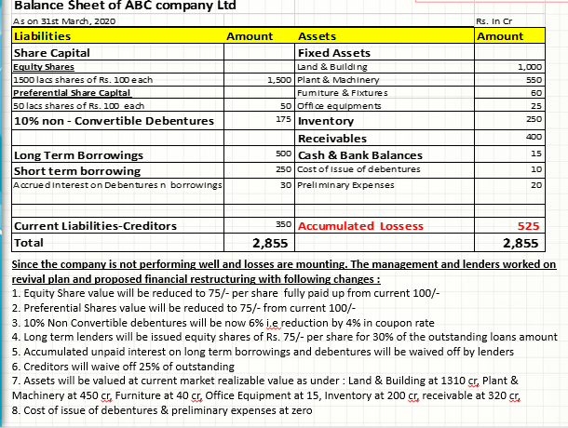

**Questions.4** **(8 Marks)**

Power Grid Corporation, a GoI enterprise made a FPO under the book building route in 2010 for `744.23 crore in a price band of `85–90 per share. The FPO consisted of both a new issue of shares by the company and an offer for sale by the GoI. After excluding employee reservation, the balance of the offer consisted of the NPO. As per the offer document, the offer price at `90 constituted an offer P/E multiple of 20 and an offer price-book value multiple of 2.38 times. The prevailing market price at that time was in the range of `100 per share. The offer received good response in all categories and was oversubscribed almost 15 times overall. Therefore, the cut-off price was fixed at `90. It traded well on listing day and closed at `96. It continued to hold firm in aftermarket trade thereafter well above the FPO price. Through light on the difference between the FPO, IPO, Preferential issue, Bonus issue and right issue.

**Questions.5** **(8 Marks)**

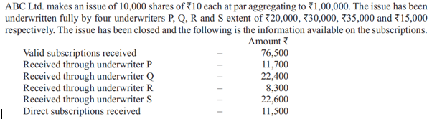

Examine the underwriters’ devolvement.