**JAIPURIA INSTITUTE OF MANAGEMENT, INDORE**

**PGDM**

**SIXTH TRIMESTER (Batch 2019-21)**

**END TERM EXAMINATION, MAY-2021**

|  |  |  |  |
| --- | --- | --- | --- |
| Course Name | **Investment Banking** | Course Code | FIN601 |
| Max. Time | **2 hours** | Max. Marks | **40** |

**INSTRUCTIONS:**

Attempt all the questions

**Questions.1 (8 Marks)**

The international capital market has three main segments – the debt market, the equity market and the derivatives market. Within the debt market, the bond market is very vibrant and is an integral part of the sources of debt capital for foreign issuers. The international bond market has the following sub segments: (i) the Domestic Bond Market of certain countries, (ii) the Foreign Bond Market and (iii) the Euro-Bond Market. Elaborate these bond markets in detail.

**Questions.2 (8 Marks)**

Corporate restructuring refers to the changes in ownership, business mix, asset mix & alliance with a view to enhance the shareholders’ value. Hence, corporate restructuring may involve ownership restructuring, business restructuring, asset restructuring for the purpose of making it more efficient and more profitable. Through some light on the purpose and significance of corporate restructuring.

**Questions.3 (8 Marks)**

A joint venture is a business enterprise under-taken by two or more persons or organizations to share the expense and profit of a particular business project. Eg. Maruthi Suzuki, ING Vishya, Bajaj Allianz, Standard & Charted Bank. A Joint venture is a legal entity formed between two or more parties to under-take economic activity together. The parties agree to create a new entity by both contributing equity, and they then share in the revenues, expenses, and control of the enterprise. The venture can be for one specific project only, or a continuing business relationship such as the Sony Ericsson joint venture. This is in contrast to a strategic alliance, which involves no equity stake by the participants, and is a much less rigid arrangement. Explain the different types of joint ventures and the rationale of joint venture.

**Questions.4** Prepare the restructuring plan **(8 Marks)**

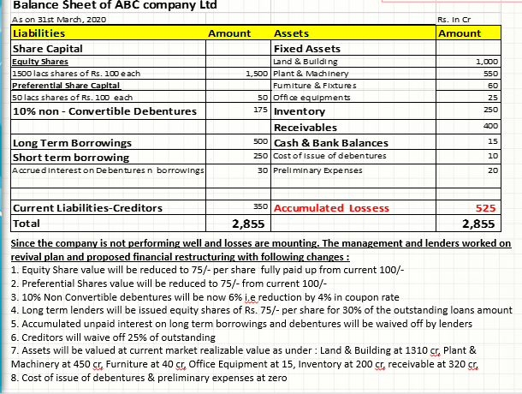

**Questions.5 (8 Marks)**

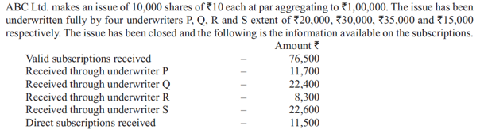

Examine the underwriters’ devolvement.