**JAIPURIA INSTITUTE OF MANAGEMENT, INDORE**

**PGDM**

**SIXTH TRIMESTER (Batch 2019-21)**

**END TERM EXAMINATION, MAY-2021**

|  |  |  |  |
| --- | --- | --- | --- |
| Course Name | **Investment Banking** | Course Code | FIN601 |
| Max. Time | **2 hours** | Max. Marks | **40** |

**INSTRUCTIONS:**

Attempt all the questions

**Questions.1 (8 Marks)**

There are several categories of large investors in Indian capital markets, some of whom are institutional investors and the rest are non-institutional UHNIs/HNIs. In common parlance, large non-institutional investors are those who invest large corpus of funds in the securities market either because they are investment companies or other bodies corporate such as trusts, societies or HUFs which have large investible funds. The distinguishing feature of institutional investors from other large investors is their stature. Usually, institutional investors are financial institutions that have an important role in the financial markets such as banks, institutions and mutual funds. Through light on the various categories of large investors in the Indian capital market.

**Questions.2 (8 Marks)**

Leverage buyout is the acquisition of one company by another, typically with borrowed funds. Usually, the acquired company’s assets are used as collateral for the loans of the acquiring company. The loans are paid back from the acquired company’s cash flow. Another possible form of leveraged buyout occurs when investors borrow from banks, using their own assets as collateral to acquire the other company. Typically, public stockholders receive an amount in excess of the current market value for their shares. Elaborate the different type of leverage buyout.

**Questions.3** Prepare the restructuring plan **(8 Marks)**

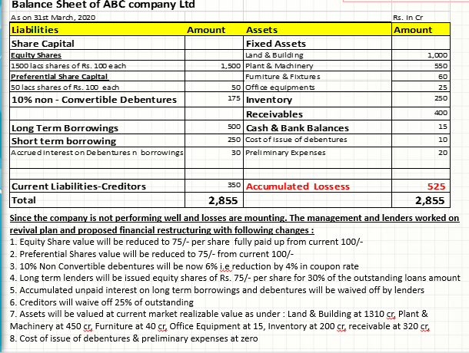

**Questions.4 (8 Marks)**

A joint venture is a business enterprise under-taken by two or more persons or organizations to share the expense and profit of a particular business project. Eg. Maruthi Suzuki, ING Vishya, Bajaj Allianz, Standard & Charted Bank. A Joint venture is a legal entity formed between two or more parties to under-take economic activity together. The parties agree to create a new entity by both contributing equity, and they then share in the revenues, expenses, and control of the enterprise. Elaborate some of the reasons for the failure of joint venture.

**Questions.5 (8 Marks)**

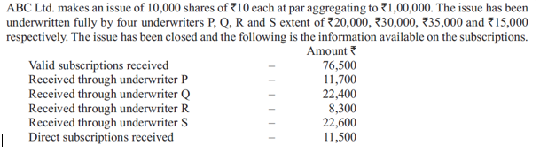

Examine the underwriters’ devolvement.