 | JAIPURIA INSTITUE OF MANAGEMENT, INDORE  Post Graduate Diploma in Management (Batch 2024-26)
Course Title: Data Visualization, (Course Code: 40825)
End-Term Examination, Term - V (January 2026)
Time Duration : 2 Hours Total Marks: 40

General Instructions:
- Answer the questions as directed. The break-up of the marks is given wherever necessary.
- Marks against each question is indicated to its right.
- Answer all the questions of a ‘Section/Question’ at one place in continuation.
- Answers should be brief and to the point.
- Do not write on the question paper except your roll number.

SECTION - A

Q.1 : Provide brief answers focusing on main points only.
- Explain how building a Story in Tableau enhances data interpretation and communication.
- Discuss the role of Gestalt principles “Proximity” and “Similarity” in data visualization.
- Explain how Calculated Fields are used in Tableau to create dynamic visualizations.
- Analyze the usefulness of a Heat Map in identifying patterns within data.
- Discuss the application of Logical Functions in Tableau with an example.
(2 x 5 = 10 Marks)

SECTION - B

Q2. Based on the data set given sample-data-ete.xls. Create a dashboard as given below.
You need to insert the date, time, your name and enrollment number at the appropriate place, as shown in visual 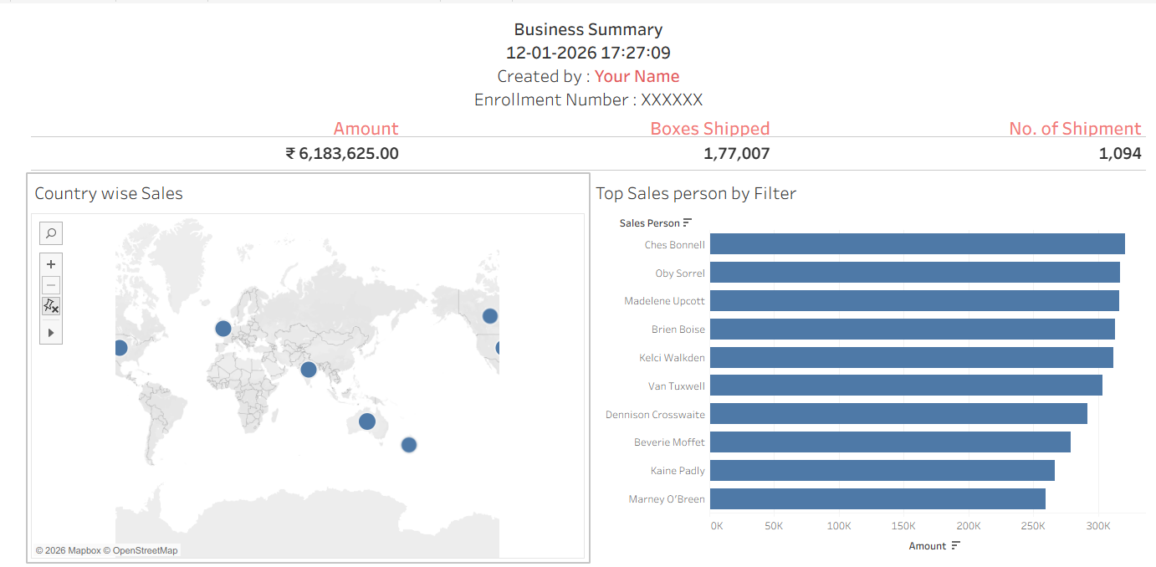

Q3 : Scenario: Strategic Recruitment & Regional Workforce Evaluation
A national retail chain is planning a major expansion for the upcoming fiscal year. The leadership team needs to understand the efficiency of its current talent acquisition model and the distribution of its workforce to make informed scaling decisions. Using the Employee, Hiring, and Store datasets, you are required to build a Tableau Story to present your findings.
- Create the business dashboard for the top management to address
- Major business KPIs required by the management of Retail chain management to monitor the business performance
- Create the dashboard with Parameters, sets. (5x2 = 10 Marks)
- You need to create the story to explain the following along with your recommendations and observations
- Hiring Efficiency Analysis: Create a Calculated Field to determine the "Lead Time" (number of days between Hiring Date and Joining Date). Visualize the average lead time by Hiring Mode to identify which channel provides the fastest talent onboarding.
- Cost-Effectiveness Evaluation: Analyze the relationship between Hiring Cost, Relocation Cost, and Store Size. Use a dual-axis chart or a scatter plot to identify if recruitment expenses are significantly higher for "Large" stores compared to "Small/Medium" stores.
- Regional Workforce Mapping: Create a geographical or regional view showing the distribution of Job Titles and Average Age across different Regions. Highlight any region that appears to have an aging workforce or a lack of specialized executives.
- Narrate the above in Story.
(5x4 = 20 Marks)

