 | JAIPURIA INSTITUE OF MANAGEMENT, INDORE  Post Graduate Diploma in Management (Batch 2025-27)
Course Title: Python for Business Analytics (Course Code: 20822)
End-Term Examination, Term -III (April 2026)
Time Duration : 2 Hours Total Marks: 40

General Instructions:
- Write all the inferences wherever required in the Raw or Markdown cell.
- Write the Question No. and part in comment in the cell where you are writing the code
- Write Inferences after the output
- Write the justification of Q3 part a and b in Jupyter notebook only in Raw or Markdown cell.
- Download the Jupyter notebook as HTML and save it with your Full Name.
- Marks against each question is indicated to its right.
- Do not write on the question paper except your roll number.

Q1. An IPL franchise is preparing for the upcoming auction and wants to adopt a data-driven decision-making approach instead of relying on intuition. The management team believes that player price (SOLD PRICE) is influenced by performance, experience, and player profile. The analytics team has been given historical IPL auction data containing player attributes such as performance (runs, wickets), experience (captaincy), and popularity indicators (sixes). IPL team organizers want to identify key factors influencing player valuation. Accordingly, they will optimize budget allocation to avoid overpaying or underestimating players
- Calculate the average SOLD PRICE for each PLAYING ROLE. Which role has the highest valuation? 2 marks
- Compare the average SOLD PRICE of players with and without captaincy experience. Interpret whether leadership experience impacts pricing. 2 marks
- Identify which team has spent the highest total amount. 2 marks
- Calculate the mean and median of SOLD PRICE, and compare both values. What does this indicate about price distribution? 2 marks
- Create a group of players into Low Sixers (<25), Medium Sixers (25–75), and High Sixers (>75). Calculate the average SOLD PRICE for each group. Interpret the trend and provide recommendations. 3 marks
- Analyze the distribution of players across different playing roles. Create a bar chart. Interpret which role dominates and why. 3 marks
- Examine the relationship between AGE and SOLD PRICE. Create a boxplot, and identify which age group is most valuable. 3 marks
- Analyze the relationship between SIXERS and SOLD PRICE. Create a scatter plot. Interpret whether aggressive players get higher bids. 3 marks
Q2. An IPL franchise aims to adopt a data-driven approach for player selection during auctions. The management believes that batting aggression, measured by the number of SIXERS, may influence a player’s market value. As part of the analytics team, you are required to build a simple linear regression model to examine the relationship between SIXERS (independent variable) and SOLD PRICE (dependent variable), and assess whether aggressive players command higher prices. 10 marks
Q3. Analyse the figures given below:
- Based on the product sales trend chart, analyse the month for which the organisation needs to focus on sales, justify the reason for the same. (5 marks)
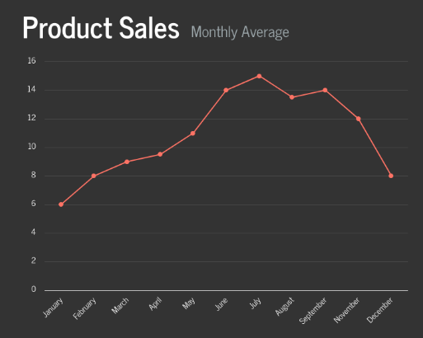
- The following figure depicts the relationship of various e-commerce website parameters. Explain which parameters are more responsible for website ROI, and justify your answer with some statistical facts. (5 marks)
