**JAIPURIA INSTITUTE OF MANAGEMENT, INDORE**

**PGDM**

**FIFTH TRIMESTER (Batch 2020-22)**

**END TERM EXAMINATION, JAN-2022**

|  |  |  |  |
| --- | --- | --- | --- |
| Course Name | **Data Visualization** | Course Code | **IT501** |
| Max. Time | **2 hours** | Max. Marks | **40** |

**INSTRUCTIONS:**

* **All Questions are compulsory**
* **Q1. Please write the explanation in the Answer sheet**
* **Q2, 3 and 4, submit the Tableau file and analysis and interpretation in Answer sheet**

………………………………………………………………...…………………………

**Questions.1** Explain “continuity” and “closure” principle of Gestalt using an example.

**[10 Marks].**

**Questions 2.** Using the “Titanic” dataset, create an interactive dashboard in **Tableau** which explains the death and survivals from various home destinations, gender and age. **[10 Marks]**

**Questions. 3.** Using the Southern Region sheet from the South Superstore excel file:

Create a Story in **Tableau** to show overall sales peaked month and it also visualizes office supplies peaked month. **[10 Marks]**

**Questions 4.** Using the Southern Region sheet from the South Superstore excel file in **Tableau**:

Give the steps that you would take to change the following view so that Furniture is represented by the triangle symbol, also give the screenshot of the same.

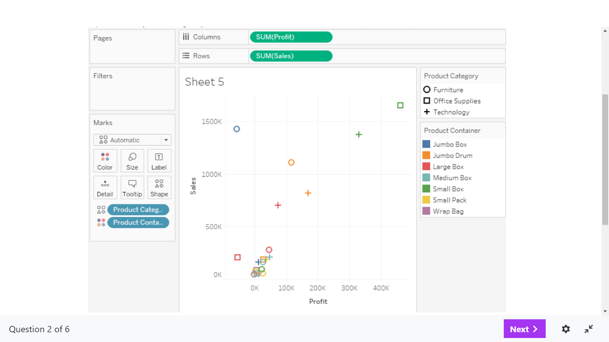

**[10 Marks]**