**JAIPURIA INSTITUTE OF MANAGEMENT, INDORE**

**PGDM**

**FIFTH TRIMESTER (Batch 2020-22)**

**END TERM EXAMINATION, JAN-2022**

|  |  |  |  |
| --- | --- | --- | --- |
| Course Name | **Fixed Income Securities** | Course Code | **FIN 504** |
| Max. Time | **2 hours** | Max. Marks | **40** |

**INSTRUCTIONS:**

1. All answers calculated on Excel must be reproduced in the answer sheet
2. Students may use EXCEL in the allotted computers

……………………………………………………………………………………………………………………………………....…………………………

**Questions.1 (10 Marks)**

Refer to the following table and evaluate the hazard rate if the recovery rate is 30% for “B” grade bond after 5 years. The spread is 270 bps. What is the probability of default in year 5.

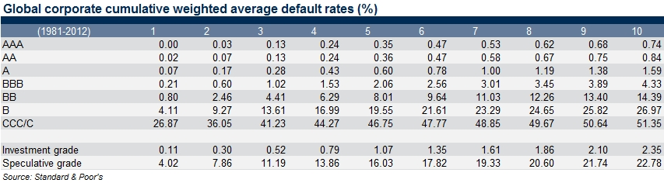

**Questions.2 (10 Marks)**

On April 15, you lend Rs 35 million at LIBOR. The interest payments will be due on July 16, October 16, January 16 and April 16 next year. The LIBOR on April 15 is 8%. You are concerned about falling interest rates. You decide to buy an interest rate floor with a strike of 8% and premium of Rs 60000. Compute and evaluate the cash flows if the LIBORs are 7.9%, 7.7%, 8.1% on July 16, October 16, January 16 respectively.

**Questions.3 (10 Marks)**

It is July 30, 2018. The underlying bond in a September 2018 Treasury bond futures contract is a 13% coupon bond, and delivery is expected to be made on September 30, 2018. Coupon payments on the bond are made on February 4 and August 4 each year. The term structure is flat, and the rate of interest with semiannual compounding is 12% per annum. The conversion factor for the bond is 1.5. The current quoted bond price is Rs 110. Calculate the quoted futures price for the contract.

**Questions.4 (10 Marks)**

A firm wishes to borrow Rs 5 million in 180 days. Loan will be taken at LIBOR and will be repaid 90 days later. The FRA rate is 12%. Determine the effective cost of the loan if the firm goes for FRA assuming the LIBORs will be 5%, 7%, 10%, 11%, 13%, 15%, 16% and 18%. What will be the break even rate?