**JAIPURIA INSTITUTE OF MANAGEMENT, INDORE**

**PGDM**

**FIFTH TRIMESTER (Batch 2020-22)**

**END TERM EXAMINATION, JAN-2022**

|  |  |  |  |
| --- | --- | --- | --- |
| Course Name | **Human Resources Analytics** | Course Code | **HR 502** |
| Max. Time | **2 hours** | Max. Marks | **40** |

**INSTRUCTIONS: All questions are compulsory.** Please read the questions carefully before answering. For questions 2, 3 and 4, data-sets are provided in a separate Excel file. You need to do the analyses using appropriate tools/software, save them in a folder or file with your name and enrollment number (*example: ayushi_JI/2020-22/0024*) and write the inferences in the hard copy answer sheet provided to you. Repidminer also to be used, wherever required as per the question requirement.

**Question.1** In an organisation during appraisal time, it was observed by the top management that an analytical model is to be prepared to evaluate the performance of an employee. As a pilot exercise, five predictors which were considered by core HR team. The appraisal data of the HR department employees was gathered and a model was developed. After data-driven model development, the following output table is provided to you as an outcome of the model development.

You being newly appointed HR analyst is required to evaluate the model and give your inferences to the top management.

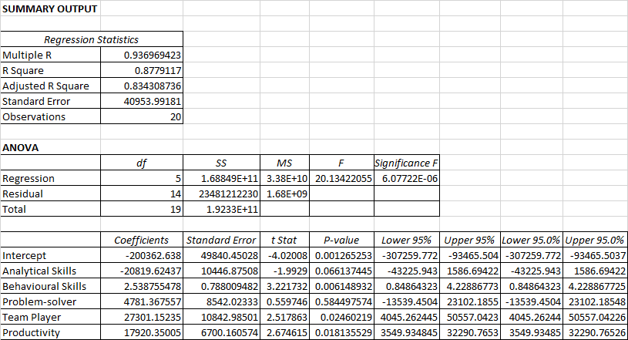

**(10 Marks)**

**Question.2** Please find attached a data set containing month-wise sales figure of laptops (as a separate Excel file). On the basis of sales, manpower plan has to be scheduled for the sales team. For the monthly sales of 50 laptops, one sales representative is generally required. As a HR analyst you are required to find whether dataset contains any missing values and outliers. If yes, then handle missing values and outliers, and do the following tasks -

1. Forecast the number of sales of laptops for the next three months, and
2. Forecast the number of sales representatives required for the following three months.

You may use any suitable method and software for the above mentioned tasks.  **(10 Marks)**

**Question.3** An employee data set has been provided to you (in the Excel File). The data also consists of details of recently left employees. Please analyse the data using appropriate tools and provide your inferences on employee attrition.*(some data has been coded and provided to you as a separate sheet in the same Excel file)*  **(10 Marks)**

**Question.4** A consumer durables company XYZ Pvt. Ltd. has a range of best-selling products that sells across the country. There is a separate sales team that is responsible for each product category. The top management is aware that some employees would like to change their product category. For some, it provides a change, for others it may be multi-skilling, while for some the reasons may be working in a product segment where the company enjoys a better market share as compared to their existing product category. The top management team conducts a survey and solicits employee responses on their movement intentions to a preferred product category. The response rates are being provided in the Excel sheet attached with this paper.

Please analyse the data using appropriate tools. Reflect upon the outcomes of your analyses, and illustrate your recommendations in the report to top management team so that a decision on employee movement across product categories can be taken. **(10 Marks)**

**\*\*\*\*\***