

**JAIPURIA INSTITUTE OF MANAGEMENT, INDORE**

**PGDM**

**Fifth Trimester (Batch 2020-22)**

**END TERM EXAMINATIONS**

|  |  |  |  |
| --- | --- | --- | --- |
| Course Name | Wealth Management | Course Code | FIN504 |
| Max. Time | 2 hours | Max. Marks | 100 |

Instructions: Attempt All Questions Marks in Brackets. Please attempt all Questions in separate Word file. For calculation and working you can use excel file. Both the files need to be uploaded

Q.1) Mr Nitesh Singh age 40 years is married to Natasha age 37 Years and has a daughter age 2 years. He is working in private bank and has annual income of Rs 15 lakhs per annum. He approaches you for his personal financial planning. Family Expenses are assumed to be 70% of Income .Following are his Savings and Investments

He has Endowment Life Insurance Policy of Rs 5 lacs Sum Assured and has recently this year also purchased ULIP plan this year for term of 25 years in which he is paying premium of Rs 50000 per annum with Sum Assured Rs 5 lacs. In that he has opted for Equity fund. He is covered from his employer a family floater Health Insurance plan of Rs 3 lacs. He intend to start purchasing Gold every year on his daughter’s birthday starting from this year worth Rs 20000 till his daughter attain the age of 18 years

His primary goals are protection planning, Retirement Planning and fund his daughter’s education. You have conducted Risk profiler test for him and from that it is concluded he is moderately conservative and has taken limited exposure to equity

Assumption: Inflation rate 6% per annum, Life Expectancy of Mr Nitesh Singh is 80 years and Ms Natasha Singh 82 years. Return from Debt fund 8% p.a, Balanced fund 12% p.a , Equity fund 15% p.a Gold Return 10% p.a

1. Estimate the amount of extra Life Insurance he should have if he wants to ensure that his spouse is covered with inflation linked expenses for her life if the Insurance Corpus is invested in Debt Fund and which type of Life Insurance product will you recommend?
2. Nitesh is seeking your advice on choice between Critical Illness and Medical Reimbursement Plan?
3. Advice Nitesh which among Gold ETF, Gold Coin, Sovereign Gold Bond and Gold Fund will suit his need
4. Nitesh will retire at the age of 60, how much corpus he should accumulate so as to give him inflation linked pension for his retired life to cover is expenses if the retirement corpus is invested in debt fund?
5. Nitesh intends to fund his retirement corpus by ULIP plan in which he will opting for Equity Fund for next 15 years and then will be switching to Balanced fund for next three years and then to debt fund for last two years. Estimate the amount of shortfall/surplus through this

(2+2+2+2+3=11)

Q.2) Mr Gaurav age 40 years working in MNC has forecasted following Income for year 2020-21.He lives in Indore in rented apartment paying a rent of Rs 30000 per month

Salary Income: Basic Salary 600000 DA 600000 HRA 300000 Medical Allowance Rs 20000 Bonus Rs 400000

Investments: Monthly SIP Equity MF Rs 3000 Monthly SIP ELSS Rs 5000, Tution Fees for his child Rs 60000, Purchased Plot Rs 200000 Life Insurance Premium Rs 25000. He contributes Annually Rs 60000 in NPS. He has redeemed Equity Mutual Fund units which he had purchased two years back at gain of Rs 70000

Taken Housing Loan of Rs 30 lac paying EMI Rs 20000 p.m (Principle Repaid Rs 100000 & Interest Rs 140000) for house in Lucknow in which his parents are living. Car Loan of Rs 7 lacs paying EMI of Rs 8000 (Principle Repaid Rs 70000, Interest Rs 26000), Education Loan taken for his higher studies outstanding Rs 4 lacs paying EMI Rs 5000 (Principle Repaid Rs 20000)

He has taken a family Floater Health Insurance premium for Self-Spouse and child Rs 28000 and for his mother age 62 years Rs 20000. He has Donated Rs 10000 to PMCARES fund. Calculate Net Tax payable for Mr Gaurav for the year 2020-21 in both old and new Tax regime and which will be recommended to Mr Gaurav (8)

Q.3) Sonali age 30 years working in private company as a manager had been very conservative investor and till now has been investing in Bank FD’s /NSC/PPF and has been very skeptical about investing in Equity Market. However she is now seeking your advice for asset allocation for long term investing for attainment of financial goals and for that she has been exploring different strategies to overcome volatility of Equity market. She is exploring following investment strategies for same

a) Value Averaging

b) Smart Beta strategies

c) Dynamic Asset Allocation

Advice on these strategies by giving suitable examples for creating long term wealth creation

(2+2.5+2.5=7)

Q.4) Akhand is exploring to invest in one of the two shortlisted Large Cap fund . His advisor has Volatility Measures of both the schemes however Akhand is confused about investing in these schemes

Axis Bluechip fund

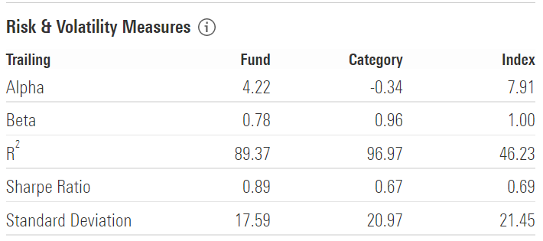

HDFC Top 100 fund

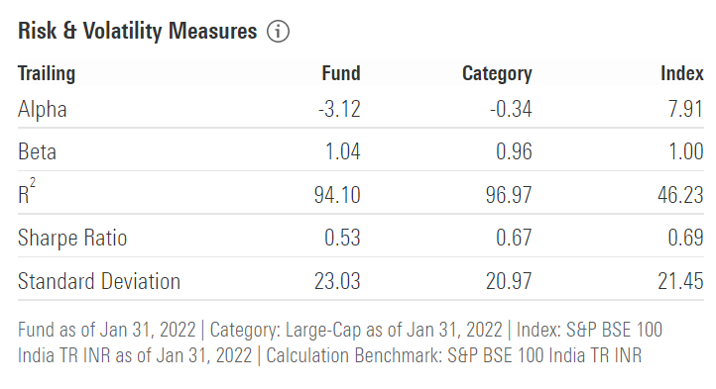

1. What is your opinion about the risk and performance of both schemes and what kind of investors should invest in these schemes?
2. Explain the value of R squared and how it can be related to performance of scheme and role of fund Manager
3. Identify the reasons of difference in performance of both Flexicap scheme
4. Evaluate the Qualitative Factors for choosing Mutual fund schemes
5. Which scheme will you recommend to Akhand and why?

(3+2+2+2+2=11)

Q.5) What are three action points which you will initiate in your life from the learning of this Course ? (3)