**JAIPURIA INSTITUTE OF MANAGEMENT, INDORE**

**PGDM**

**SIXTH TRIMESTER (Batch 2020-21)**

**END TERM EXAMINATION, MAY-2022**

|  |  |  |  |
| --- | --- | --- | --- |
| Course Name | **Applications of AI, ML and IOT in Business** | Course Code | **IT-602** |
| Max. Time | **2 hours** | Max. Marks | **40** |

**INSTRUCTIONS:**

* All the questions are compulsory.………………………………………………………………

**Questions.1:** The digital transformation of agriculture has evolved various aspects of management into artificial intelligent systems for the sake of making value from the ever-increasing data originated from numerous sources. Explain the role of machine learning is handling the challenges in the establishment of knowledge-based farming systems.

**(10 marks)**

**Question-2:** The Da Vinci robotic surgical system developed by Intuitive surgical has revolutionized the field of surgery. The robotic arms of the system mimic a surgeon's hand movements with better precision and has a 3D view and magnification options which allow the surgeon to perform minute incisions. Since 2018, Buoy Health and the Boston children's hospital are collaboratively working on a web interface-based AI system that provides advice to parents for their ill child by answering questions about medications and whether symptoms require a doctor visit. The National Institute of Health (NIH) has created an AiCure App, which monitors the use of medications by the patient via smartphone webcam access and hence reduce nonadherence rates. This robotics innovation creates various concerns related to security regarding patient’s heath data. Comment. **(10 marks)**

**Question-3**

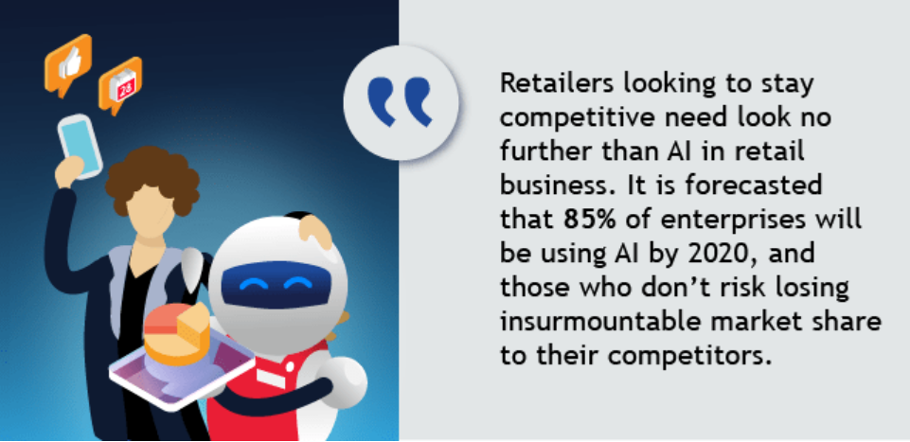

**Figure-1**

As per the above Figure-1, explain why without AI implementation there would be risk of loosing the competition? (**10 Marks)**

**Questions.4** 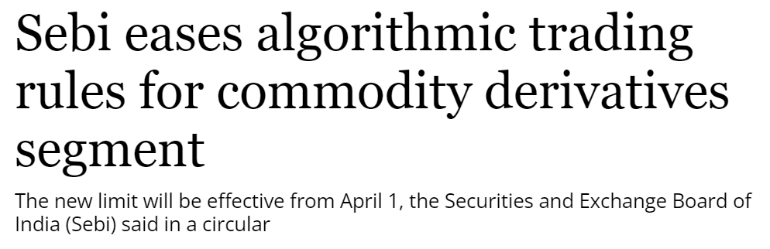

[Algorithmic trading](https://www.business-standard.com/topic/algorithmic-trading) or 'Algo' in market parlance refers to orders generated at a super-fast speed. What are the reasons for the speed and how it is more beneficial for the customers? (**10 Marks)**