**JAIPURIA INSTITUTE OF MANAGEMENT, INDORE**

**PGDM**

**SIXTH TRIMESTER (Batch 2020-21)**

**END TERM IMPROVEMENT EXAMINATION, MAY-2022**

|  |  |  |  |
| --- | --- | --- | --- |
| Course Name | **Applications of AI, ML and IOT in Business** | Course Code | **IT-602** |
| Max. Time | **2 hours** | Max. Marks | **40** |

**INSTRUCTIONS:**

* All the questions are compulsory.………………………………………………………………

**Questions.1:** The below figure depicts the AI and IoT based healthcare infrastructure, is this possible in the country like India, where we have huge financial disparity as well as how can these technologies can penetrate in the rural India. **(10 marks)**

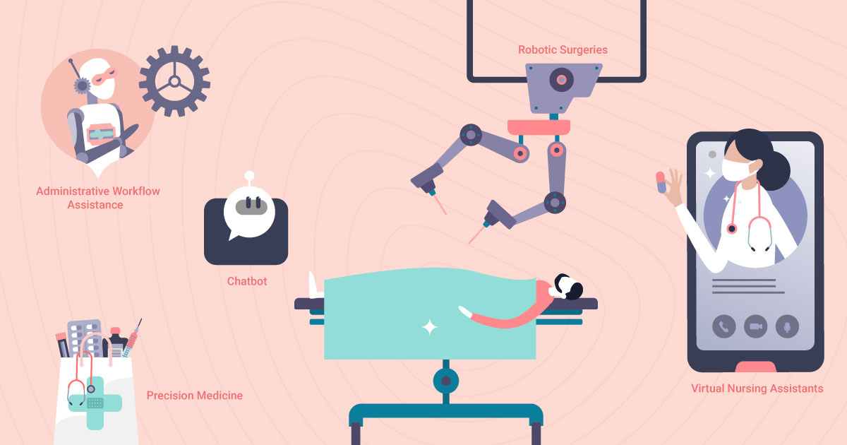

**Question-2:** According to McKinsey, the 4IR technologies are expected to create up to $3.7 trillion in value by 2025. AI alone can generate $1.2-$2 trillion in value for manufacturing and supply chain management. The impact of AI in manufacturing is game-changing. French food manufacturer Danone Group uses machine learning to improve its demand forecast accuracy. This has led to a:

* 20% decrease in forecasting errors
* 30% decrease in lost sales
* 50% reduction in demand planners’ workload

How Danone group can able to gain so much benefits by implementing AI based manufacturing infrastructure. **(10 marks)**

**Question-3** Rising energy costs are driving up the cost of everything from [manufactured goods](https://www.theguardian.com/business/2022/feb/22/uk-manufacturing-price-cbi-bank-of-england-dave-ramsden-interest-rates) to [food](https://theconversation.com/how-the-war-in-ukraine-will-affect-food-prices-178693). The Russia, a large supplier of natural gas and oil, shows few signs of halting its ongoing invasion of Ukraine which has resulted in the US, UK and others restricting Russian fossil fuels energy inflation is[unlikely to subside](https://fortune.com/2022/03/15/gas-prices-top-five-dollars-next-six-months-economic-ripples-even-more-dire/) any time soon, leading to warnings of larger economic fallout and even recession. Manufacturers want to reduce those energy costs as much as anyone else but given economic realities, it seems to some companies that the only response to energy inflation is to hike the prices of products and services, but increasing cost is not the only solution there are other options including the to cut energy consumption, thus reducing the impact of energy inflation on production costs. And among the most efficient and effective ways to do that is with artificial intelligence. Comment. **(10 marks)**

**Questions.4** Artificial intelligence can drive a significant return on investment by managing and maximizing businesses’ marketing strategies. It can help monitor, analyze and understand customer data across all the channels, assisting in better decision making. Comment. **(10 marks)**