**JAIPURIA INSTITUTE OF MANAGEMENT, INDORE**

**PGDM**

**SIXTH TRIMESTER (Batch 2020-21)**

**END TERM EXAMINATION, MAY-2022**

|  |  |  |  |
| --- | --- | --- | --- |
| Course Name | **Cloud Computing and Business Management** | Course Code | **IT-601** |
| Max. Time | **2 hours** | Max. Marks | **40** |

**INSTRUCTIONS:**

* All the questions are compulsory.

**Questions.1** Healthcare Cloud Computing Market to Witness Massive Growth By 2029. The growing trend of digitization in the healthcare sector has benefited the market considerably. When it comes to healthcare, the technology is applied to overcome two major industry challenges: increasing cost-effectiveness and building a self-sufficient health ecosystem. Given the pandemic crisis, these issues became sharp; but cloud computing’s potential is high enough to overcome them.

Summarize the usage of cloud computing in healthcare, and explain how it is used to increase the cost-effectiveness and helpful in building a self-sufficient health ecosystem. **(10 Marks)**

**Questions.2 I**n India, the need for data center infrastructures is growing exponentially, as cloud adoption, as well as data consumption and generation by half a billion digital users, are reaching unprecedented levels.  The finance minister granted infrastructure status to the data center industry while announcing the Budget 2022-23. This would also help Indian companies in this space to compete with its global peers and thus provide more choice and better service to end clients.

Explain the application of cloud infrastructural for Indian companies in order to compete with its global peers? **(10 Marks)**

**Questions.3** SaaS solutions are among the fastest-growing segments in the IT industry. Among cloud options, the outlook for SaaS is arguably the brightest.

*Organizations are advancing their timelines on digital business initiatives and moving rapidly to the cloud in an effort to modernize environments, improve*[system reliability](https://www.bmc.com/blogs/reliability-vs-availability/)*, support hybrid work models and address other new realities compelled by the pandemic,” said*[*Brandon Medford*](https://www.gartner.com/en/newsroom/press-releases/2021-08-02-gartner-says-four-trends-are-shaping-the-future-of-public-cloud)*, senior principal analyst at Gartner*.

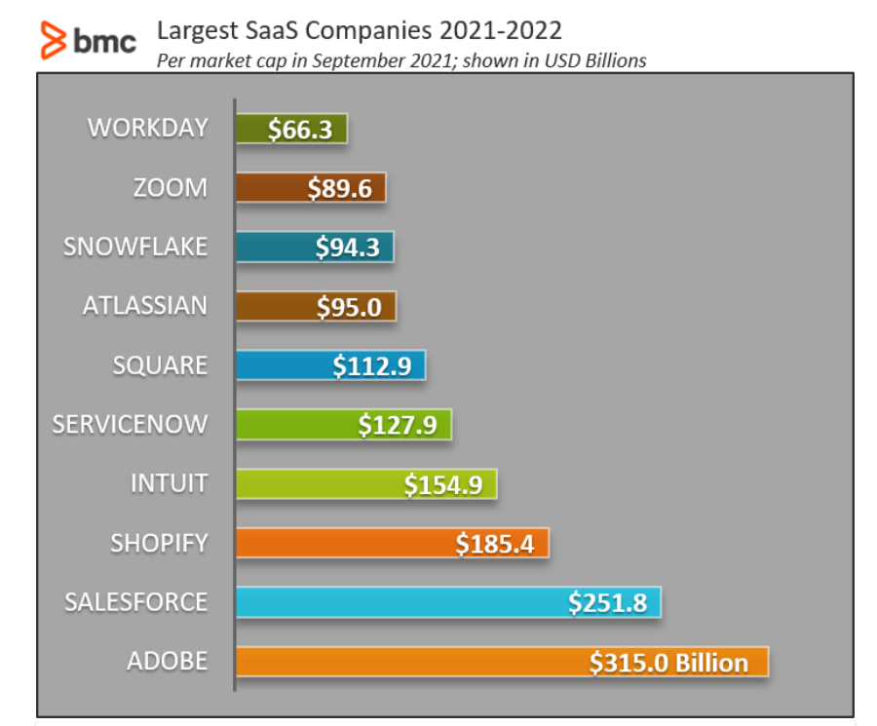

As per the above figure the Salesforce has grown considerably and alone grew from $161 billion in January 2020 to $251 billion in September 2021.

Explain the role of salesforce SaaS software in order to manage the customers and handle their grievances and make them satisfied loyal customers over a period of time. **(10 Marks)**

**Questions.4** As companies continue to migrate to the cloud, understanding the security requirements for keeping data safe has become critical. While third-party cloud computing providers may take on the management of this infrastructure, the responsibility of data asset security and accountability doesn't necessarily shift along with it. In 2019 has been a year of shocking security breaches in the cloud, a trend that will only continue unless businesses make a significant course correction. Gartner recently updated their [evaluation](https://www.gartner.com/smarterwithgartner/is-the-cloud-secure/) of cloud security and concluded: “Through 2025, 99% of cloud security failures will be the customer’s fault.”

Explain the role of customer in managing the security of cloud together with cloud service provider and please share your views on the Personal Data Protection Bill 2019 Joint recently adopted its report Parliamentary Committee (JPC), they might finally be tabled in Parliament for discussion. The passing of the PDP Bill 2019 will represent a major milestone for the cloud industry. **(10 Marks)**