**JAIPURIA INSTITUTE OF MANAGEMENT, INDORE**

**PGDM**

**FIRST TRIMESTER (Batch 2021-23)**

**END TERM EXAMINATION, OCT-2021**

|  |  |  |  |
| --- | --- | --- | --- |
| Course Name | **Marketing Management I** | Course Code | **MKT-X0101** |
| Max. Time | **2 hours** | Max. Marks | **40** |

**INSTRUCTIONS:**

**All questions are compulsory.**

1. **Question 1 to 5 carries 10 Marks each.**
2. **Apply the concepts studied in the class and answer accordingly.**
3. **The Answer should cover the companies assigned during classes.**

**Questions.1 (10)**

**Marketing management wants to design strategies that will build profitable relationships with target consumers? Illustrate, what philosophy(orientation) should guide these marketing strategies? Support your answer with suitable examples.**

There are five alternative concepts under which organizations design and carry out their marketing strategies.

***The Production Concept***

The **production concept** holds that consumers will favor products that are available and highly affordable.

Management should focus on improving production and distribution efficiency.

***The Product Concept***

The **product concept** holds that consumers will favor products that offer the most in quality, performance, and innovative features.

Under this concept, marketing strategy focuses on making continuous product improvements.

***The Selling Concept***

The **selling concept** holds that consumers will not buy enough of the firm’s products unless the firm undertakes a large-scale selling and promotion effort.

The concept is typically practiced with unsought goods—those that buyers do not normally think of buying, such as insurance or blood donations.

These industries must be good at tracking down prospects and selling them on product benefits.

***The Marketing Concept***

The **marketing concept** holds that achieving organizational goals depends on knowing the needs and wants of target markets and delivering the desired satisfactions better than competitors.

Under the marketing concept, customer focus and value are the paths to sales and profits.

Rather than a “make and sell” philosophy, it is a customer-centered “sense and respond” philosophy.

The job is not to find the right customers for your product, but to find the right products for your customers.

Customer-driven companies research current customers deeply to learn about their desires, gather new product and service ideas, and test proposed product improvements.

Customer-driven marketing requires understanding customer needs even better than customers themselves do and creating products and services that meet existing and latent needs.

**Questions.2 (10)**

**Interpret, the environmental forces that affect the company’s ability to serve its customers. How is Kellogg addressing the changing marketing environment?**

**THE MICROENVIRONMENT AND MACROENVIRONMENT**

A company’s **marketing environment** consists of the actors and forces outside marketing that affect marketing management’s ability to build and maintain successful relationships with target customers.

The **microenvironment** consists of the actors close to the company that affect its ability to service its customers.

The **macroenvironment** consists of larger societal forces that affect the microenvironment.

Kellogg, the worldwide cereal leader, has been around for 109 years. Twenty years ago, almost single-handedly, Kellogg grew the entire cereal category by 50 percent in just five years by targeting baby boomers with products positioned on nutrition and convenience.

But in the 21st century, demographic, cultural, and lifestyle changes are moving customers away from Kellogg and its product line.

Kellogg has offered healthier options, including gluten-free and GMO-free products. However, in a seeming conflict of image and appeal, it has also introduced less-healthy product extensions.

**Questions.3 (10)**

**Why is understanding consumer behavior so important for companies? Demonstrate all the steps followed by a consumer before purchasing the final product (explanation must be on this basis of company assigned for the CBB presentation)**

**Consumer Purchase Decision Process**

How customers buy anything? Consumer Purchase Decision process gives us answer to this question. This process consists of five stages:



Problem

Recognition

Information

Search

Evaluation of

Alternatives

Purchase

Decision

Postpurchase

Behaviour

1. **Problem Recognition**

Problem recognition is the start of the buying process. At this stage a buyer recognizes problem or need which gets triggered by stimulus like, it can be trigger by external or internal stimuli. Consumer identifies the need as to why he/she wants to purchase certain product or get certain service.

* + **Internal stimuli of need recognition:** When a need is triggered internally. For example, when a consumer wants to purchase a smart TV because; he doesn’t have any TV; his TV is broken; He want OTT platforms and internet connectivity
  + **External stimuli of need recognition:** When need is triggered externally. For example, when a customer wants to purchase a Smart TV because his friend recently bought a Smart TV or has seen an ad on television.

**Survey Example:**

We asked 2 consumers (say A and B) who recently has bought Panasonic smart TV that why did they purchased Panasonic Smart TV. What triggered them to buy the TV?

|  |  |  |
| --- | --- | --- |
|  | Consumer A | Consumer B |
| Consumer Response | “I wanted to buy Smart TV because I wanted Wi-Fi connectivity in TV and OTT platforms.” | “I purchased smart because my relatives had one and they gave good reviews about the TV.” |
| Stimuli | Internal Stimuli | External Stimuli |

Even when consumer is purchasing same product but their motive of buying or buying behaviour is different.

1. **Information Search**

A buyer before purchasing anything does inform search related to that certain product or service. Some buyers only acquire limited information about a certain product while some

consumers go in depth before buying the same product. There are four type of information search sources:

1. **Personal:** Family, friends, neighbors, peers etc.
2. **Commercial:** Advertising, Websites, dealers, malls, hoarding, Newspaper, television
3. **Public:** Mass Media, Social Media, consumer-rating organizations.
4. **Experimental:** Handling, examining, by using the product.

At this stage consumer acquires information related to price, quality, brands, when to buy, payment methods available, where to buy.

The Consumers A and B, when asked about what information they acquired when before purchasing smart TV, they acquired information about following:

* + **Screen Resolution:** 4k, 8k, UHD, HD
  + **Screen type:** LED, QLED, OLED, Curved, Flat.
  + **Price range and discounts/offers:** whether the TV price is as per their budget or not, what are the different offers available on TV.
  + **Brands:** LG/Samsung/Panasonic/Haier/Sony
  + **Screen Size:** 24-43 in, 43-75 in, over 75 in.
  + **Internet:** Built-In WIFI connectivity, OTT platforms, voice recognition,
  + **Where to Buy:** Dealer store/E-commerce/Shopping Malls/Website
  + **When to buy:** On festive season or normal days or on the days of trade fairs.
  + **How much time to take before buying:** Days/1 month/2 months etc.
  + **Payment method:** COD, debit card, credit card, net banking, UPI.

1. **Evaluation of Alternatives:**

At this Stage, consumer compares the different alternatives available for the product he is buying. Consumer evaluates the alternatives as per the previously acquired information (price, brands, features etc.) so that he can make a best purchase decision.

* Xiaomi
* Sony
* Samsung
* LG
* One Plus TV
* Lloyd TV
* Panasonic
* Phillips
* Haier

Total Set

* Xiaomi
* Panasonic
* Samsung
* LG
* One Plus
* Haier

Awareness Set

* Panasonic
* One Plus
* LG
* Haier

Consideration Set

* Panasonic
* One Plus

Choice Set

* Panasonic

Decision

1. **Purchase Decision:**

This is the important stage because it tells us whether the consumer would by the product or not. During this stage, customer may form an intention to buy most preferred brand or product after evaluating all the alternatives. The final Purchase decision can also be effected by some factors like negative feedback from other users, family decision, or due to any unfortunate event.

|  |  |  |
| --- | --- | --- |
|  | **Consumer A** | **Consumer B** |
| **Decision** | “I bought the TV as it had good review and it was according to my budget.” | “During Lockdown I had to change my decision for purchasing TV but later I bought it.” |

1. **Post Purchase Behavior:**

It is when customer assess about the purchase he made whether he is satisfied or dissatisfied, whether the customer recommend the product to others or not. Customer may also give feedback to seller as per the satisfaction level he obtained by using the product. The post purchase decision is very important for a business to grow more and improving their product.

|  |  |  |
| --- | --- | --- |
|  | Consumer A | Consumer B |
| Satisfaction/Dissatisfaction | I am satisfied with the Smart TV. It is functioning well and met all m requirements | I am satisfied with my purchase. Although I should have taken more time in evaluating alternatives. |
| Review | As I bought it from Amazon, I left a good review there as I was satisfied with my purchase. | I didn’t give any feedback to dealer. |
| Recommendation/Advice | Yes, I would recommend Panasonic Smart TV, if someone asks me to purchase a Smart TV. Other than that the decision depends on that person preference. | I would advise other person who is looking to purchase a Smart TV that take more time in evaluating alternatives and not to rush. |

**Questions.4 (10Marks)**

List and discuss the major bases for segmenting consumer market. Apply bases for segmenting the consumer market in company assigned to you during course.

**MARKET SEGMENTATION**

Through market segmentation, companies divide large, heterogeneous markets into smaller segments that can be reached more efficiently and effectively with products and services that match their unique needs

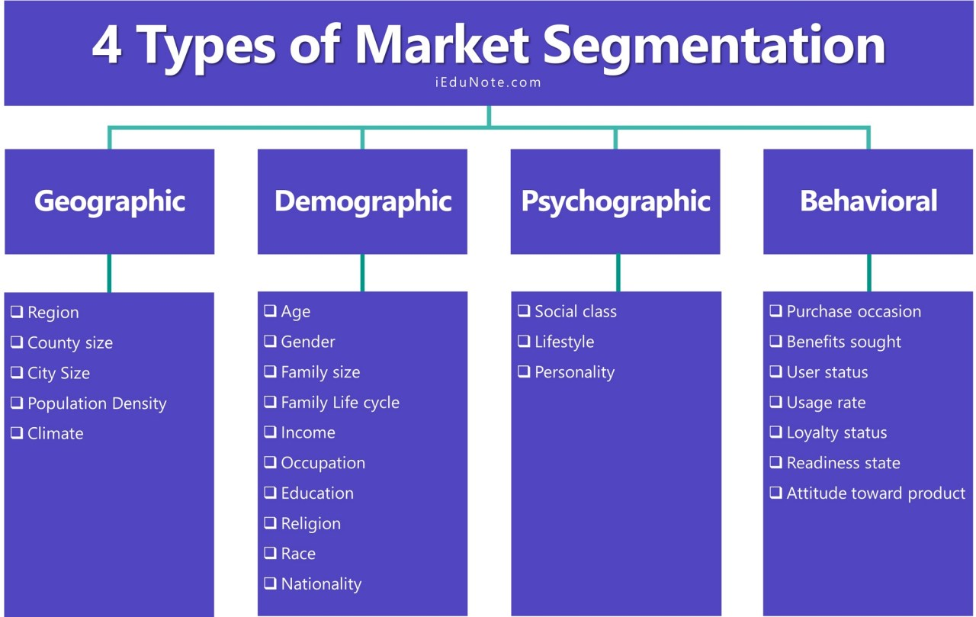

|  |  |  |
| --- | --- | --- |
| * Geographic spread | * JW Marriott located in different cities that are characterized by high tourist rates and high levels of the household income | * Marriott hotels operates in different 72 countries. |
| * Demographic description | * Factors that are taken into account are **income marital status and occupation r**ather than age and gender. * Business people or business travelers are customers that Marriott focus the most. | * + Family and employees working in foreign countries   + frequent foreign travelers   + seasoned travelers |
| * Psychographic description * ( Main Consumer needs, Personality & Lifestyle) | * JW Marriot aim to address different consumer needs with the focus on the purpose of their travelling or visit and with the focus of customer expectations. | * Lifestyle collection of JW Marriot aims to address the specific customer’s interest and needs. |
| * Behavioral description * (Usage level, Level of Brand Loyalty | * Marriott divides consumer into groups based on their knowledge, uses and responses to their services such as Consumer can be grouped according to occasions such as business events, weddings, graduation ceremony etc. | Marriott pays a lot consideration to focus distinctive providers, designs and remarkable experience. |