**JAIPURIA INSTITUTE OF MANAGEMENT, INDORE**

**PGDM**

**FIRST TRIMESTER (Batch 2021-23)**

**END TERM EXAMINATION, OCT-2021**

|  |  |  |  |
| --- | --- | --- | --- |
| Course Name | **Marketing Management I** | Course Code | **MKT-X0101** |
| Max. Time | **2 hours** | Max. Marks | **40** |

**INSTRUCTIONS:**

**All questions are compulsory.**

1. **Question 1 to 5 carries 10 Marks each.**
2. **Apply the concepts studied in the class and answer accordingly.**

**Questions.1 (10)**

Describe bases for segmenting the consumer market. Analyze how company assigned to you during class has segmented and positioned in the market.

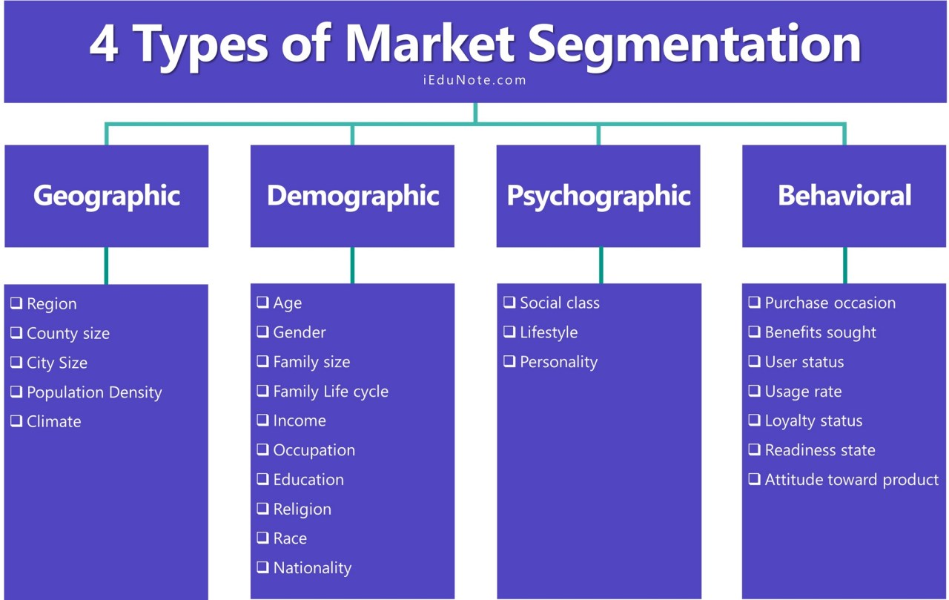

|  |  |
| --- | --- |
|  | **MARKET SEGMENT** |
| **SEGMENTATION DESCRIPTION** | **Market Segmentation for Domestic Courier Services provided by Delhivery** |
| * Geographic spread | Urban, Sub-urban, rural areas of India  are targeted by delhivery because it has  the largest reach in India for consumers  and aims at becoming the largest  company in domestic courier services in  India |
| Demographic description | **Age**:  Gen Z (1997-2012): 9-24 years of age  Millennials (1981-1996): 25-40years of age  Gen X (1965-1980): 41-56 years of age  **Gender**: Targets all Genders (males and females)  **Family Size**: targets all family sizes  **Income**: Delhivery provides services for all the income groups as it is cost efficient |
| * Psychographic description * ( Main Consumer needs, Personality & Lifestyle) | **Social Class**: All Social Classes who ever  uses courier services  **Life style:** Targets all types of lifestyles  but mainly targets Job and Business  oriented lifestyles |
| * Behavioral description * (Usage level, Level of Brand Loyalty | **Regular occasions**: students,  businesses, households  **Special Occasions**: During Festivals  and celebrations |

**Questions.2 (10)**

Explain what is 0,1 & 2 level channel of distribution. Please give product categories and examples where you can use each of these levels of distribution (5)

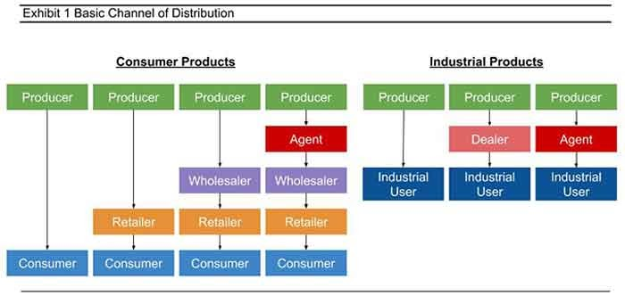

**Questions.3 (10)**

a. Why is understanding consumer behavior so important for companies? Demonstrate all the steps followed by a consumer before purchasing the final product (explanation must be on this basis of company assigned for the CBB presentation) (7)

**Consumer Purchase Decision Process**

How customers buy anything? Consumer Purchase Decision process gives us answer to this question. This process consists of five stages:



Problem

Recognition

Information

Search

Evaluation of

Alternatives

Purchase

Decision

Postpurchase

Behaviour

1. **Problem Recognition**

Problem recognition is the start of the buying process. At this stage a buyer recognizes problem or need which gets triggered by stimulus like, it can be trigger by external or internal stimuli. Consumer identifies the need as to why he/she wants to purchase certain product or get certain service.

* + **Internal stimuli of need recognition:** When a need is triggered internally. For example, when a consumer wants to purchase a smart TV because; he doesn’t have any TV; his TV is broken; He want OTT platforms and internet connectivity
  + **External stimuli of need recognition:** When need is triggered externally. For example, when a customer wants to purchase a Smart TV because his friend recently bought a Smart TV or has seen an ad on television.

**Survey Example:**

We asked 2 consumers (say A and B) who recently has bought Panasonic smart TV that why did they purchased Panasonic Smart TV. What triggered them to buy the TV?

|  |  |  |
| --- | --- | --- |
|  | Consumer A | Consumer B |
| Consumer Response | “I wanted to buy Smart TV because I wanted Wi-Fi connectivity in TV and OTT platforms.” | “I purchased smart because my relatives had one and they gave good reviews about the TV.” |
| Stimuli | Internal Stimuli | External Stimuli |

Even when consumer is purchasing same product but their motive of buying or buying behaviour is different.

1. **Information Search**

A buyer before purchasing anything does inform search related to that certain product or service. Some buyers only acquire limited information about a certain product while some

consumers go in depth before buying the same product. There are four type of information search sources:

1. **Personal:** Family, friends, neighbors, peers etc.
2. **Commercial:** Advertising, Websites, dealers, malls, hoarding, Newspaper, television
3. **Public:** Mass Media, Social Media, consumer-rating organizations.
4. **Experimental:** Handling, examining, by using the product.

At this stage consumer acquires information related to price, quality, brands, when to buy, payment methods available, where to buy.

The Consumers A and B, when asked about what information they acquired when before purchasing smart TV, they acquired information about following:

* + **Screen Resolution:** 4k, 8k, UHD, HD
  + **Screen type:** LED, QLED, OLED, Curved, Flat.
  + **Price range and discounts/offers:** whether the TV price is as per their budget or not, what are the different offers available on TV.
  + **Brands:** LG/Samsung/Panasonic/Haier/Sony
  + **Screen Size:** 24-43 in, 43-75 in, over 75 in.
  + **Internet:** Built-In WIFI connectivity, OTT platforms, voice recognition,
  + **Where to Buy:** Dealer store/E-commerce/Shopping Malls/Website
  + **When to buy:** On festive season or normal days or on the days of trade fairs.
  + **How much time to take before buying:** Days/1 month/2 months etc.
  + **Payment method:** COD, debit card, credit card, net banking, UPI.

1. **Evaluation of Alternatives:**

At this Stage, consumer compares the different alternatives available for the product he is buying. Consumer evaluates the alternatives as per the previously acquired information (price, brands, features etc.) so that he can make a best purchase decision.

* Xiaomi
* Sony
* Samsung
* LG
* One Plus TV
* Lloyd TV
* Panasonic
* Phillips
* Haier

Total Set

* Xiaomi
* Panasonic
* Samsung
* LG
* One Plus
* Haier

Awareness Set

* Panasonic
* One Plus
* LG
* Haier

Consideration Set

* Panasonic
* One Plus

Choice Set

* Panasonic

Decision

1. **Purchase Decision:**

This is the important stage because it tells us whether the consumer would by the product or not. During this stage, customer may form an intention to buy most preferred brand or product after evaluating all the alternatives. The final Purchase decision can also be effected by some factors like negative feedback from other users, family decision, or due to any unfortunate event.

|  |  |  |
| --- | --- | --- |
|  | **Consumer A** | **Consumer B** |
| **Decision** | “I bought the TV as it had good review and it was according to my budget.” | “During Lockdown I had to change my decision for purchasing TV but later I bought it.” |

1. **Post Purchase Behavior:**

It is when customer assess about the purchase he made whether he is satisfied or dissatisfied, whether the customer recommend the product to others or not. Customer may also give feedback to seller as per the satisfaction level he obtained by using the product. The post purchase decision is very important for a business to grow more and improving their product.

|  |  |  |
| --- | --- | --- |
|  | Consumer A | Consumer B |
| Satisfaction/Dissatisfaction | I am satisfied with the Smart TV. It is functioning well and met all m requirements | I am satisfied with my purchase. Although I should have taken more time in evaluating alternatives. |
| Review | As I bought it from Amazon, I left a good review there as I was satisfied with my purchase. | I didn’t give any feedback to dealer. |
| Recommendation/Advice | Yes, I would recommend Panasonic Smart TV, if someone asks me to purchase a Smart TV. Other than that the decision depends on that person preference. | I would advise other person who is looking to purchase a Smart TV that take more time in evaluating alternatives and not to rush. |

b. Apply organizational buying behavior concept to complete the following chart (3)

|  |  |  |  |  |
| --- | --- | --- | --- | --- |
|  | | **Buy Classes** | | |
| New | Modified | Straight |
| Task | Rebuy | Rebuy |
| **Buy phases** | Problem Recognition |  |  |  |
| General need description |  |  |  |
| Product specification |  |  |  |
| Supplier Search |  |  |  |
| Proposal Solicitation |  |  |  |
| Supplier Selection |  |  |  |
| Order routine specification |  |  |  |
| Performance review |  |  |  |

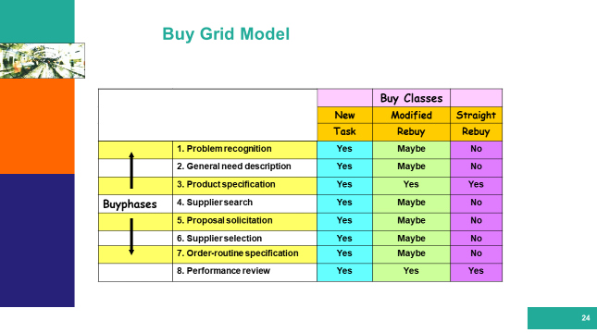

**Questions.4 (10Marks)**

**Effective use of relevant media or promotional tools**

