**JAIPURIA INSTITUTE OF MANAGEMENT, INDORE**

**PGDM**

**THIRD TRIMESTER (Batch 2021-23)**

**END TERM IMPROVEMENT EXAMINATION, AUG-2022**

|  |  |  |  |
| --- | --- | --- | --- |
| Course Name | **Business Research Methods** | Course Code | **40503** |
| Max. Time | **2 hours** | Max. Marks | **40** |

**INSTRUCTIONS:**

* Please write in clear handwriting.
* This is an open-book, open-notes exam.
* All five questions are compulsory.

**Question-1**

A cell phone manufacturer wants to conduct a feature research study among students of higher education in Indore. The company wants to understand the features that the students use, features they would like to see, and the price that they are willing to pay. You have been asked for help in gathering data for this purpose. What advice would you give about sampling? What method or combination of methods would generate the best results?  **(10 Marks)**

**Question-2**

A breakfast cereal producer realized that sales of their product have dropped recently. To understand customers’ experience and purchase decision about the cereal, the company asked you to conduct a focus group interview. Prepare a focus group outline(s) or a moderator guide to accomplish this task. **(10 Marks)**

**Attempt question three based on the following scenario:**

The Swamp Palace Museum is an interactive museum that teaches visitors the ways of life on the swamps of the Central India. It contains over 100 exhibits demonstrating the ecology of the swamp and the habits of the animals and insects inhabiting it. Additionally, there are restaurants, swimming, and thrill rides in the forty plus acres and miles of pathways. The park was originally government-funded, but now it is self-supporting. While there are enough visitors, the park has struggled just to break even. The Swamp Palace sought the help of Marketivity Group, a research initiative by students of Jaipuria Indore to conduct a study to provide information useful to management actions that would lead to increased visitors.

**Question-3**

As a member of the Marketivity Group:

1. What role should you play in this project?
2. Highlight the research question(s) you have identified in the scenario above.
3. Based on the research questions identified, prepare a brief proposal to the Swamp Palace Park.

**(10 Marks)**

**Question-4**

Following collection of relevant data for the Swamp Palace Museum, as seen in the Question No. 3, the Marketivity Group conducted multiple regression analysis to address potential relationships of the factors with value perceptions. The SPSS output is shown below:

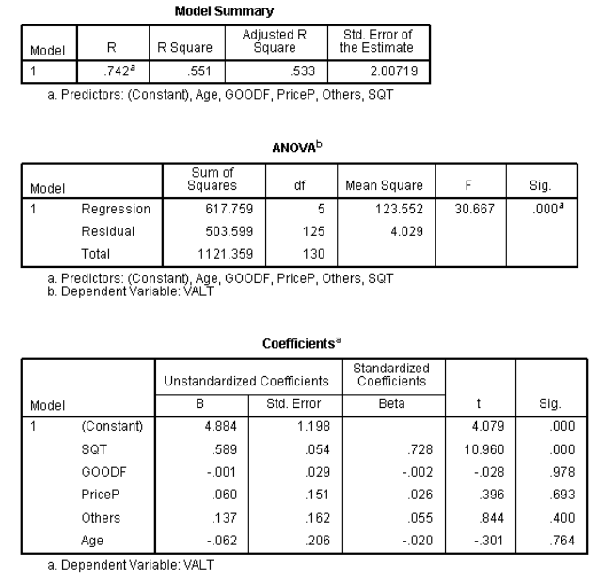

Notation used: SQT= Service Quality; Good F= Good Feeling; PriceP= Price Perception; VALT= Value Perception; Age= Age of the Respondent.

Based on the output above, give recommendation to the management. **(5 Marks)**

**Question-5**

Interpret the following factor analysis results. The variables represent sample results of self-reported emotions while viewing a film, Why are only two factors reported below? What would you name the two summated scales which could be produced based on these results?

Total Variance Explained

|  |  |  |  |  |  |  |
| --- | --- | --- | --- | --- | --- | --- |
| Component | Initial Eigenvalues  Total | % of Variance | Cumulative % | Extraction Sums of Squared Loadings Total | % of Variance | Cumulative % |
| 1 | 2.94 | 36.74 | 36.74 | 2.94 | 36.74 | 36.74 |
| 2 | 2.51 | 31.34 | 68.08 | 2.51 | 31.34 | 68.08 |
| 3 | 0.71 | 8.84 | 76.92 |  |  |  |
| 4p | 0.60 | 7.53 | 84.45 |  |  |  |
| 5 | 0.42 | 5.20 | 89.65 |  |  |  |
| 6 | 0.29 | 3.67 | 93.32 |  |  |  |
| 7 | 0.29 | 3.64 | 96.96 |  |  |  |
| 8 | 0.24 | 3.04 | 100.0 |  |  |  |

Extraction Method: Principal Component Analysis

Rotated Component Matrix (a)

|  |  |  |
| --- | --- | --- |
|  | Factor 1 | Factor 2 |
| Interesting | 0.739 | -0.024 |
| Anxious | 0.194 | 0.648 |
| Enthusiastic | 0.904 | 0.044 |
| Worried | -0.073 | 0.876 |
| Exciting | 0.825 | 0.147 |
| Tired | -0.100 | 0.872 |
| Happy | 0.872 | -0.025 |
| Guilty | 0.084 | 0.779 |

Extraction Method: Principal Component Analysis

Rotation Method: Varimax with Kaiser Normalization.

1. Rotation converged in 3 iterations. **(5 Marks)**