**JAIPURIA INSTITUTE OF MANAGEMENT, INDORE**

**PGDM**

**THIRD TRIMESTER (Batch 2021-23)**

**END TERM EXAMINATION, MAY-2022**

|  |  |  |  |
| --- | --- | --- | --- |
| Course Name | **Business Research Methods** | Course Code | **40503** |
| Max. Time | **2 hours** | Max. Marks | **40** |

**INSTRUCTIONS:**

* Please write specific answers, in clear handwriting.
* This is an open-book, open-notes exam.
* All questions are compulsory.

**Question-1**

Imagine that an NGO has asked you for help in gathering data about the number of women entrepreneurs in Indore. What advice would you give about sampling? What method or combination of methods would generate the best results? **(10 Marks)**

**Question-2**

Management of a kirana store realized that male customers are the ones who patronize them more than women. In order to attract women customers, they asked you to conduct a research to understand the behaviour of female buyers in shopping at kirana stores. Prepare a focus group outline(s) to accomplish this task. **(10 Marks)**

**Attempt question three based on the following scenario:**

Panorama Associates, a Jaipuria Indore-based research consulting firm, has received a government grant to undertake a study on how aspects of a student’s college experiences relate to his or her job performance. The grant is the result of a long-held belief that employers are discriminating against people who do not like quantitative courses such as Math, Accounts, Statistics etc., by giving them lower salaries. The findings of the study will support the Government in passing a legislation on making illegal, any kind of discrimination and/or developing discriminatory policies against those students who do not like quantitative courses.

**Question-3**

As a member of the Panorama Associates:

1. What role should you play in this project?
2. Highlight the research questions you have identified in the scenario above.
3. Based on the research questions identified, prepare a brief proposal to the Government office. **(10 Marks)**

**Question-4**

The findings of a study on staying intention on the job presented here is based on a survey of employees at HBAT, a B2B company. Research questions are (1) What factors influence staying intention on the job? (2) Is job satisfaction related to an employee’s likelihood of looking for another job? The dataset consists of 19 variables and their descriptions are seen below:

Data Description:

Organizational Commitment

OC1= My work at HBAT gives me a sense of accomplishment

OC2= I am willing to put in a great deal of effort beyond that normally expected to help HBAT be successful.

OC3= I have a sense of loyalty to HBAT

OC4=I am proud to tell others that I work for HBAT.

Staying Intentions

SI1=I am not actively searching for another job.

SI2 = It is very likely that I will be working at HBAT one year from today.

Attitudes towards co-workers

AC1=I am happy with the work of my co-workers.

AC2=I feel good about my co-workers.

AC3=I often do things with my co-workers on my days off

AC4= My co-workers are very similar to me.

Environmental perceptions

EP1= I am very comfortable about my physical work environment at HBAT.

EP2=The place I work in is designed to help me do my job better.

EP3=There are few obstacles to make me less productive in my workplace

EP4=HBAT best describes my work environment.

Job satisfaction

JS1= All things considered, I feel very satisfied when I think about my job.

JS2= When I think of my job, I feel very satisfied.

JS3= I am satisfied about my current job at HBAT

JS4=I am highly satisfied with HBAT as my employer.

JS5=Please indicate your satisfaction with your current job with HBAT by placing a percentage in the blank, with 0% =not satisfied at all and 100%=highly satisfied.

SPSS output of Factor analysis, Reliability analysis, and Regression Analysis are presented below:

**Factor Analysis**

|  |  |  |
| --- | --- | --- |
| **Communalities** | | |
|  | Initial | Extraction |
| JS1 | 1.000 | .652 |
| OC1 | 1.000 | .600 |
| OC2 | 1.000 | .766 |
| EP1 | 1.000 | .641 |
| OC3 | 1.000 | .614 |
| OC4 | 1.000 | .741 |
| EP2 | 1.000 | .730 |
| EP3 | 1.000 | .711 |
| AC1 | 1.000 | .761 |
| EP4 | 1.000 | .744 |
| JS2 | 1.000 | .650 |
| JS3 | 1.000 | .574 |
| AC2 | 1.000 | .757 |
| JS4 | 1.000 | .606 |
| JS5 | 1.000 | .631 |
| AC3 | 1.000 | .772 |
| AC4 | 1.000 | .746 |
| Extraction Method: Principal Component Analysis. | | |

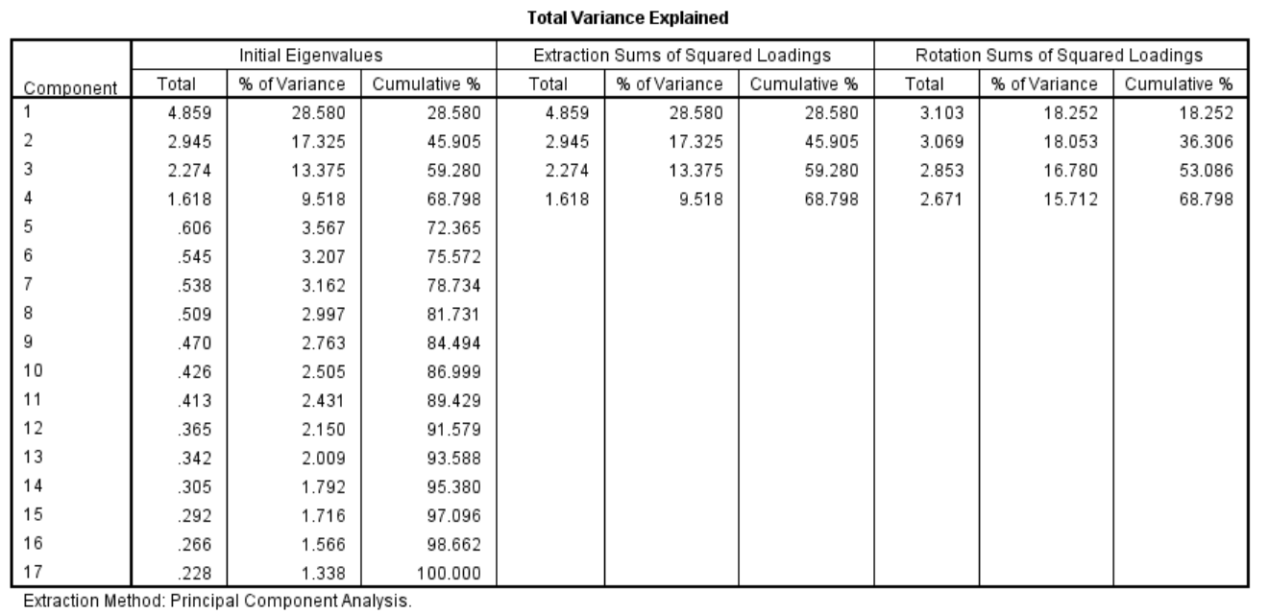

|  |  |  |  |  |
| --- | --- | --- | --- | --- |
| **Rotated Component Matrixa** | | | | |
|  | Component | | | |
| 1 | 2 | 3 | 4 |
| JS1 | .800 | -.011 | .001 | .111 |
| OC1 | .021 | .015 | .022 | .774 |
| OC2 | .089 | .205 | .207 | .821 |
| EP1 | .089 | .096 | .787 | .071 |
| OC3 | .087 | .038 | .255 | .735 |
| OC4 | .086 | .130 | .210 | .820 |
| EP2 | .077 | .110 | .808 | .244 |
| EP3 | .103 | .083 | .820 | .144 |
| AC1 | .039 | .865 | .085 | .059 |
| EP4 | .081 | .069 | .830 | .208 |
| JS2 | .794 | -.046 | .131 | .006 |
| JS3 | .752 | .009 | .085 | .038 |
| AC2 | -.004 | .864 | .083 | .054 |
| JS4 | .776 | .029 | .046 | .035 |
| JS5 | .780 | .076 | .096 | .089 |
| AC3 | -.019 | .870 | .067 | .100 |
| AC4 | .035 | .845 | .114 | .136 |
| Extraction Method: Principal Component Analysis.  Rotation Method: Varimax with Kaiser Normalization. | | | | |
| a. Rotation converged in 5 iterations. | | | | |

Reliability Analysis

|  |  |  |  |  |  |  |  |  |  |  |  |  |  |
| --- | --- | --- | --- | --- | --- | --- | --- | --- | --- | --- | --- | --- | --- |
| |  |  | | --- | --- | | **Reliability Statistics (OC1-OC4)** | | | Cronbach's Alpha | N of Items | | .823 | 4 | | |  |  | | --- | --- | | **Reliability Statistics (JS1-JS5)** | | | Cronbach's Alpha | N of Items | | .281 | 5 | |
| |  |  | | --- | --- | | **Reliability Statistics (AC1-AC4)** | | | Cronbach's Alpha | N of Items | | .891 | 4 | | |  |  | | --- | --- | | **Reliability Statistics (EP1-EP4)** | | | Cronbach's Alpha | N of Items | | .850 | 4 | |

Regression Analysis

|  |  |  |  |  |
| --- | --- | --- | --- | --- |
| **Model Summary** | | | | |
| Model | R | R Square | Adjusted R Square | Std. Error of the Estimate |
| 1 | .551a | .304 | .297 | .813 |
| a. Predictors: (Constant), Environmental Perception, Attitude towards Co-workers, Organizational Committment, Job Satisfaction | | | | |

|  |  |  |  |  |  |  |
| --- | --- | --- | --- | --- | --- | --- |
| **ANOVAa** | | | | | | |
| Model | | Sum of Squares | df | Mean Square | F | Sig. |
| 1 | Regression | 113.511 | 4 | 28.378 | 42.922 | .000b |
| Residual | 259.828 | 393 | .661 |  |  |
| Total | 373.339 | 397 |  |  |  |
| a. Dependent Variable: SI2 | | | | | | |
| b. Predictors: (Constant), Environmental Perception, Attitude towards Co-workers, Organizational Committment, Job Satisfaction | | | | | | |

|  |  |  |  |  |  |  |
| --- | --- | --- | --- | --- | --- | --- |
| **Coefficientsa** | | | | | | |
| Model | | Unstandardized Coefficients | | Standardized Coefficients | t | Sig. |
| B | Std. Error | Beta |
| 1 | (Constant) | 3.480 | .041 |  | 85.381 | .000 |
| Job Satisfaction | .154 | .041 | .159 | 3.770 | .000 |
| Organizational Committment | .286 | .041 | .295 | 7.013 | .000 |
| Attitude towards Co-workers | .192 | .041 | .198 | 4.708 | .000 |
| Environmental Perception | .379 | .041 | .391 | 9.280 | .000 |
| a. Dependent Variable: SI2 | | | | | | |

|  |  |  |  |
| --- | --- | --- | --- |
| **Correlations** | | | |
|  | | Job Satisfaction | SI1 |
| Job Satisfaction | Pearson Correlation | 1 | .122* |
| Sig. (2-tailed) |  | .015 |
| N | 398 | 398 |
| SI1 | Pearson Correlation | .122* | 1 |
| Sig. (2-tailed) | .015 |  |
| N | 398 | 400 |
| *. Correlation is significant at the 0.05 level (2-tailed). | | | |

Summarize the findings of the study**. (10 Marks)**