**JAIPURIA INSTITUTE OF MANAGEMENT, INDORE**

**PGDM**

**FOUTH TRIMESTER (Batch 2021-23)**

**END TERM EXAMINATION, NOV-2022**

|  |  |  |  |
| --- | --- | --- | --- |
| Course Name | **Customer Relationship Management (CRM)** | Course Code | **40127** |
| Max. Time | **2 hours** | Max. Marks | **40** |

**Instructions:** All the questions are compulsory

1. Between the internet and social media, customers and brands are connected 24/7, opening more avenues for customers to offer their feedback. Since customers are aware that businesses are privy to their complaints, ignoring them is always worse than acknowledging them. A lack of response signals to customers that the company not only doesn't care about their opinion but, also doesn't value their contribution to the business. Some airlines have a notorious reputation for mishandling customer feedback. In one case, a customer tweeted at the airline about lost luggage, and it took about eight hours for their social media team to respond. Additionally, their response was confusing and demonstrated a lack of competency for the social media site.

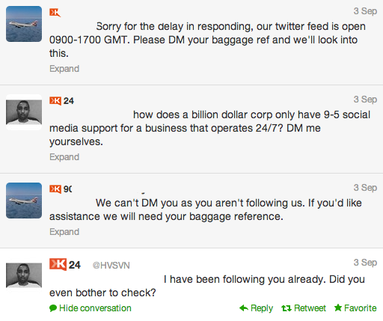

**1A**). Discuss how you would have handled this complaint if you were the customer relationship manager at this airline company.  **(5 Marks)**

**1B).** Suggest ways how airlines can listen, respond and improve their services for enhancing relationships with its customers. **(10 Marks)**

1. Gaining a competitive advantage in one’s market used to be fairly straightforward. Build a good product or service, find the right price point and put out the occasional advertisement, and you were golden. However, enterprises have their work cut out for them in the cutthroat landscape of the 21st century. The wide variety of products, services and communication channels, combined with the increasing irrelevance of geography has made the world a battleground for brands hoping to not only survive but also thrive in their respective industries. Research conducted by Frederick Reichheld of Bain & Company found that increasing customer retention rates by 5% can lead to a 25% to 95% increase in an organisation’s profits. Combine this with the fact that acquiring a new customer can cost five times more than retaining an existing one, and it’s a no-brainer why businesses are banking on building customer engagement and loyalty.

**2A)** Discuss various dimensions of profit that can be realized by the company if customers are loyal to the company over a long period of time **(5 Marks)**

**2B)** Discuss some myths associated with Customer Relationship management and what according to you could be the barriers inhibiting the implementation of CRM in any organization. **(5 Marks)**

1. Decathalon regularly asks customers to give a rating to the company after they have made a purchase. While calculating their rating Decathalon observed that 600 customers had given a rating of 5, 100 had given a rating of 8, 450 had given a rating of 3, 750 had given a rating of 9, 200 had rated the company 10 while 350 had given a rating of 6.

Further the organization observed the following:

|  |  |  |
| --- | --- | --- |
| Particulars | Customer Category A | Customer category B |
| Advertisement expenses for acquiring customers | 3500 | 3500 |
| Cost of goods sold | 1500 | 1500 |
| Cost of servicing each customer | 350 | 1000 |
| Average Revenue per customer | 4500 | 6500 |
| Retention Rate | 80% | 80% |

**3A)** Assuming that you are the manager at Decathlon, how would you calculate and interpret the net promoter score for the company? **(5 Marks)**

**3B)** Calculate the customer lifetime values of both the categories of customers. **(5 Marks)**

**3C)** The cost of serving customers of category B is high. Should you serve such customers? What would be your criteria to decide on serving such high cost to serve customers?  **(1+4 Marks)**