|  |  |
| --- | --- |
| **C:\Users\ADMIN\Desktop\j.png** | **JAIPURIA INSTITUE OF MANAGEMENT, INDORE**  Post Graduate Diploma in Management |
| **Course Title: Data Visualisation, (Course Code: 40882)**  **End-Term Examination, Term – V (Batch 2021-23) (February 2023)** | |
| **Tim Duration : 2 Hours Total Marks: 40** | |

***General Instructions*:**

* *Dataset for the questions is available in Moodle*
* *Please submit separate Dashboard as per the Question Number.*
* *Refer to the world indicators dataset for Q1, the screen time dataset for Q2, and the Q4 Forbes ranking dataset.*
* *Q2-Q4 analysis would be given in Tableau, and Q1 needs to be submitted in an answer sheet.*

**Q1.** Explain the principle of Gestalt applicable in each of the figure and analyses its business utility of the same by sharing an example. (**10 Marks)**

** ** 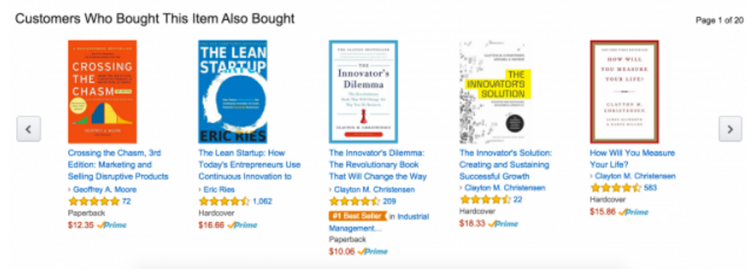

**Q2** Indicators of India organisation shared information about the world indicators, it comprises of various factors like CO2 emission, ease of business, life expectancy etc. They have to share the detailed report based of below mentioned points, please help them to take informed decisions. **(Refer world indicators dataset) (10 Marks)**

1. As we are all aware, energy usage has a very strong relationship with CO2 emissions. Comment on CO2 emissions and energy consumption in different regions. Is it good to generalize the statement that higher energy consumption would lead to higher CO2 emissions?
2. A new mobile network company wants to launch its network. The company has shortlisted four geographical regions, namely Europe, Middle East, Africa and Asia. They have data on mobile usage over the last ten years in the aforementioned regions; list the reasons why they will launch their network in which region first.

**Q3.** YogaForYou is an online yoga training portal that shared data about their subscribers, including information on daily minutes of screen time habits, categorized by type of usage, as well as the effect of yoga on these habits. The idea of sharing this information is useful for gaining insights into an individual's screen time habits and their variability with respect to doing yoga. **(Refer Screen Time dataset) (8 Marks)**

|  |  |
| --- | --- |
| **Data Description** | |
| **Column name** | **Description** |
| Date | The date of the data entry. (Date) |
| Week Day | The day of the week of the data entry(String) |
| Social Networking | The amount of time spent on social networking. (Integer) |
| Reading and Reference | The amount of time spent on reading and reference activities. (Integer) |
| Other | The amount of time spent on other activities. (Integer) |
| Productivity | The amount of time spent on productive activities such as work or school tasks. (Integer) |
| Health and Fitness | The amount of time spent working out. (Integer) |
| Entertainment | The amount of time spent watching movies/videos or playing games. (Integer) |
| Creativity | The amount of time spent creating art/music etc. (Integer) |
| Yoga | Indicates if I did yoga that particular day or not. (Integer) |

Analyse the data for them in order to share insights about the percentage of social networking site usage in relation to total screen time usage and the weekday with the highest percentage of social media usage. Comment on the lifestyle of YogaForYou subscribers in terms of time spent in doing productive work, reading versus health and fitness.

As YogaForYou seeks to expand their subscriber base, analyze the data and make recommendations.

**Q4.** The Forbes List can refer to one of the lists published annually by the American magazine Forbes. "The Global 2000" annual ranking is assembled by Forbes using a weighted assessment of various metrics like revenue, profit, assets, and market value. ValueOne, a Pune-based market research firm, needs to prepare some reports that would help them pitch their company and get some market research clients. The report is based on the below-mentioned points: **(12 marks)**

**(Refer world indicators dataset) (Refer Forbes ranking dataset)**

1. Analyze the relationship between the Forbes 2000 ranking and the rank given by Indian ranking agencies?
2. List down the cities based on highest to lowest market value in different states and analyse the metro and non-metro cities.
3. Analyse the profit of non-metropolitan cities' consumer goods, banking, retail, and telecommunications industries.
4. Compares the status of Adani and Reliance Industries in terms of revenue and market value.
5. Analyse the relationship between assets and profit for top 5 ranked companies.