|  |  |
| --- | --- |
| **C:\Users\ADMIN\Desktop\j.png** | **JAIPURIA INSTITUE OF MANAGEMENT, INDORE**  Post Graduate Diploma in Management |
| **Course Title: Data Visualisation, (Course Code: 40882)**  **End-Term Improvement Examination, Term - V (Batch 2021-23) (March, 2023)** | |
| **Time Duration : 2 Hours Total Marks: 40** | |

***General Instructions*:**

* *Dataset for the questions is available in Moodle*
* *Submit separate Dashboard as per the Question Number.*
* *Use “South_Superstore” dataset for Q2 and “Human Resources” dataset for Q3*
* *Q2-Q3 analysis would be given in Tableau, and Q1 and Q4 needs to be submitted in the answer sheet*

**Q1.** Analyze the significance of “Continuity” Gestalt principle of visualization in the e- commerce website? (**10 Marks)**

**Q2.** Zycon, an online retail store, wants to plan annual sales on different product categories to clear out their inventory and reduce their inventory carrying cost; for this, they need to identify some peak months. Create a story that analyzes overall sales peak months and visualizes various categories for these peak months. **(10 Marks)**

**Q3.** HumanFirst Consultancy wants to prepare a gender equality report focusing on different cities and states in the US. The report focuses on the number of females and males working in different industries, both in remote and office work locations, and, secondly, on gender equality in different states of the US and acceptance of gender equality among races as well. Develop a dashboard which would help Human First Consultancy in preparing their report. **(10 Marks)**

**Q4.** Analyze the below-mentioned visuals

(a)

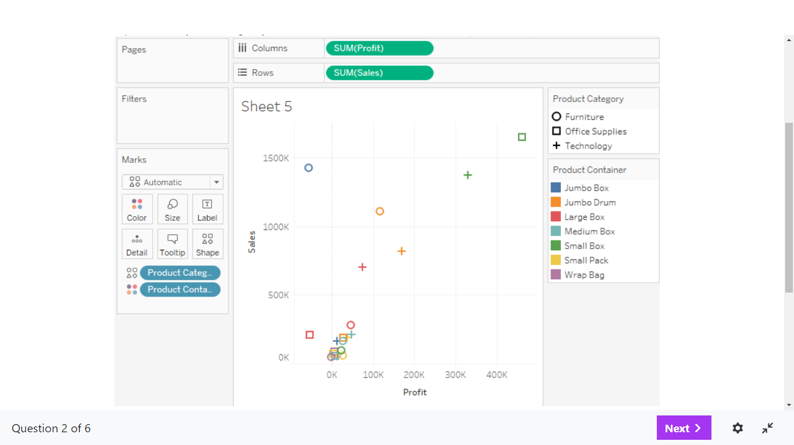

# (b)

**(10 Marks)**