|  |  |
| --- | --- |
| **C:\Users\ADMIN\Desktop\j.png** | **JAIPURIA INSTITUE OF MANAGEMENT, INDORE**  Post Graduate Diploma in Management |
| **Course Title: E-Commerce, (Course Code: 40825)**  **End-Term Improvement Examination, Term - V (Batch 2021-23) (March, 2023)** | |
| **Time Duration : 2 Hours Total Marks: 40** | |

***General Instructions*:**

1. *Answer the questions as directed. The break-up of the marks is given wherever necessary.*
2. *Marks against each question is indicated to its right.*
3. *Answer all the questions of a ‘Section/Question’ at one place in continuation.*
4. *Answers should be brief and to the point.*
5. *Do not write on the question paper except your roll number.*

**Note: MovieDatabase.xls is provided for Q4. Submit two files in part 1 upload word file with all answers and in part 2 upload Excel file with solutions.**

**SECTION - A**

**Q1.** Given below are the items that co-occur in transactions. It allows the e-commerce recommender system to identify relationships between the items that people buy together.

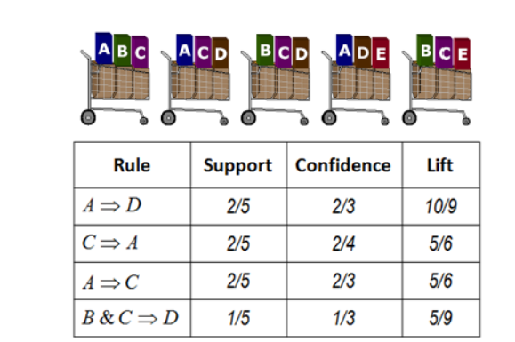

Find the Support & Confidence (percentage) for transactions for

1. A->D,
2. C->A
3. A->C
4. B&C->D **[2.5*4=10 Marks]**

**Q2.** **[5+5=10 Marks]**

a). Give an example of security breaches related given three dimensions of e-commerce security

* Nonrepudiation
* Authenticity
* Availability

b). Calculate the winner as per the given scenario:

A B2B organization got the order from different clients, if they have 100 units to sell, how they decide the winner. Which of the bidder would not able to get his demand completely fulfilled and why?

|  |  |
| --- | --- |
| Bidder | Price / Quantity |
| 1 | (30, 20) |
| 2 | (25, 15) |
| 3 | (45, 30) |
| 4 | (40, 30) |
| 5 | (12, 28) |

**Q3.**

a). Most e-commerce stores clear seasonal inventory by reducing prices. How business analytics components descriptive, predictive and prescriptive contribute in e-commerce markdown decision of when to reduce the price and by how much?

b). Ms. Asha Lata is a housewife based at Jaipur, after her kids were settled, she got lots of free time. Being a computer engineer by qualification she is very much comfortable with technology. Someone suggested her to start some online business based on Jaipur handicraft and apparels. To know more about the e-commerce business, she contacted her college classmate who was working as a marketing manager in an e-commerce organization. Her friend suggested her to start her venture with minimum investment. What sort of e-commerce model her friend had suggested her and what are the reasons for the same and also explain features of suggested the model?

**[5+5 =10 Marks]**

**SECTION - B**

**Q4.** For Movie Data case study (Excel Sheet), complete (show) the following:

1. How many Japanese movies in the database were produced in English?

2. How much gross revenue did "The Celebration" generate?

3. How much revenue was generated by Comedy films in Finland?

**[3.5 +3.5 + 3=10 Marks]**