|  |  |
| --- | --- |
| **C:\Users\ADMIN\Desktop\j.png** | **JAIPURIA INSTITUE OF MANAGEMENT, INDORE**  Post Graduate Diploma in Management |
| **Course Title: Social Media Analytics, (Course Code:** **40830)**  **End-Term Examination, Term – V (Batch 2021-23) (February, 2023)** | |
| **Time Duration : 2 Hours Total Marks: 40** | |

***General Instructions*:**

* *All questions are compulsory.*
* *Read the questions carefully and provide precise and point-wise answers.*
* *You have to save the file with your name and enrollment no. and upload it on Moodle.*

**Q1.** The NRC sentiment analysis of Online learning platform in India “Pro academy” versus “Fido Learning”, as derived from all tweets from the Twitter platform is presented below (Figure1 and Figure2). Explain how any new entrant into the Online learning can use these sentiment scores. Explain what other insights can be obtained by using text analytics to examine the reviews on a granular level, by making assumptions on the data. Describe the challenges in sentiment analysis faced by companies. **(5+2+3 Marks)**

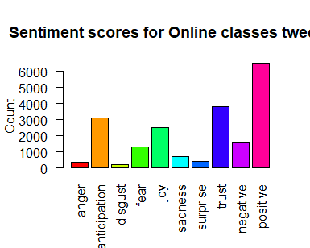

**Figure1: Sentiment score of Proacademy**

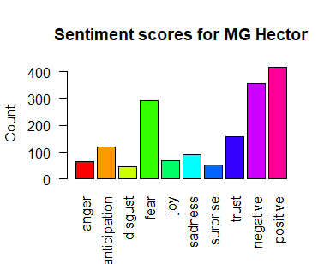

**Figure2: Sentiment score of Fido Learning**

# Q2. An international shoe brand wants to know how it can give knowledgeable buyers individualized recommendations by going beyond star ratings for the shoes. It's difficult to stay up with shifting trends in this industry when there's so much competition and so many discriminating clients. They are interested to analyze their reviews and plan an advertising campaign in order to differentiate them from other brands like Puma. “Use the product Nike Mens Air Zoom Pegasus 39 Shield Running Shoe”. Analyse the customer reviews and provide them report covering all the aspects of reviews. (10 Marks)

**Q3.** Network analytics are the building blocks of social media and can carry usefulbusiness insights. Social media network analytics thus deals with constructing,analyzing, and understanding social media networks. Social network analyticscan be used for a variety of purposes. It can be employed to identify influentialpeople and organizations, their position in the network, or the overall structure of a network. The network diagram below depicts a network diagram analyze it to explain the concepts of node, connection, cluster etc. use any online learning business as a reference for the given network diagram.  **(10 Marks)**

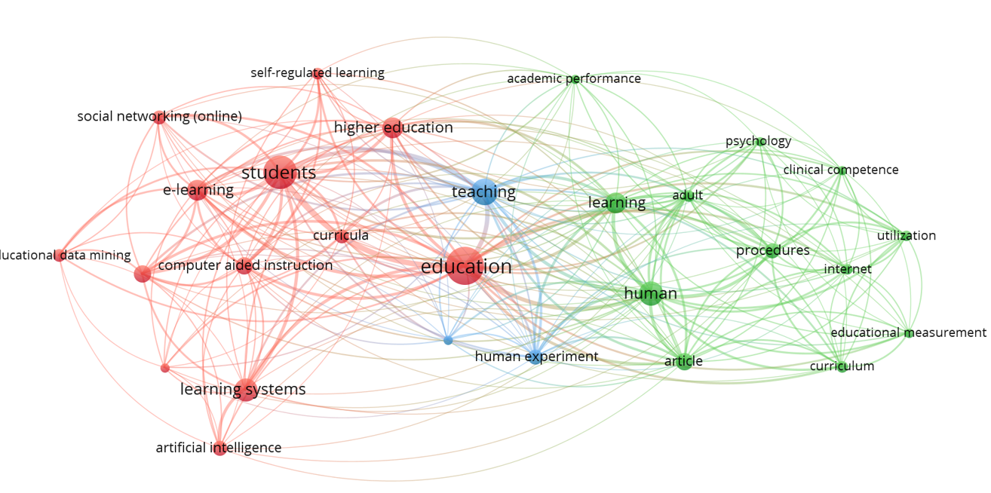

**Q4.**  Founded in 1986, Frequent Flyer Services (Flyertalk.com) has created a unique niche for itself within the travel industry as a company that conceives, develops and markets products and services exclusively for the frequent traveller. Worldwide, these frequent traveller programs in the airline, hotel, car rental and credit card industries have more than 75 million members who earn an excess of 650 billion miles per year.

Flyertalk.com is one of the most highly trafficked travel domains. It features chat boards and discussions that cover the most up-to-date traveller information, as well as loyalty programs for both airlines and hotels. With millions of users generating millions of posts and comments, it wanted to tap into the explosion of customer opinions expressed online. Flyertalk.com knew that the feedback that current and potential customers provide on their website provides a rich source of feedback and was looking for ways to mine it. Develop a text analytics strategy for the Flyertalk.com. **(10 Marks)**