|  |  |
| --- | --- |
| **C:\Users\ADMIN\Desktop\j.png** | **JAIPURIA INSTITUE OF MANAGEMENT, INDORE**  Post Graduate Diploma in Management |
| **Course Title: Social Media Analytics, (Course Code:** **40830)**  **End-Term Improvement Examination, Term – V (Batch 2021-23) (March 2023)** | |
| **Time Duration: 2 Hours Total Marks: 40** | |

***General Instructions*:**

* *All questions are compulsory.*
* *Read the questions carefully and provide precise and point-wise answers.*
* *You have to save the file with your name and enrollment no. and upload it on Moodle.*

Q1. Mr. Vikas is the CEO of Elite Users, a sizable corporation that produces personal computing products like desktop and laptop computers, cellphones, and tablets. There is a lot of discussion about their brand and products on social media because they are a well-known company that has a big impact on a lot of people. Vikas, on the other hand, is not happy and requires his staff to review all of the social media mentions of her brand right now. It takes a while for them to get to the important problems because this is a lot of work. It's great when customers use you’re @ account to send you direct messages on Twitter, but a lot of complaints and issues are just between two people talking about something, and Vikas wants to make sure they're aware of these conversations so they can intervene if necessary, naturally without being creepy. To make matters worse, Vikas's boss has given his only five minutes to react to adverse customer comments. Would having anything that includes text analytics be beneficial for her??

List out points that Vikas can address in the aforementioned scenario, on applying text analytics

to deliver insights. **(10 Marks)**

**Q2.** Design social media campaign for an B2B analytics company and explain what are the

benefits of using social media analytics in its consultancy endeavors? How are different companies using social media analytics? Points to be considered for designing social media campaign are as

follows: **(10 Marks)**

1. Company is new entrant in the market.
2. Funds are limited.
3. Consider all possible social media platforms

**Q3.** Hyperlinks are the pathways of social media traffic. Hyperlinks are references to web resources (such as a website, document, and files) that users can access by clicking on it. Analyze the in-links and out-links for an e-commerce website which deals with apparels. **(10 Marks)**

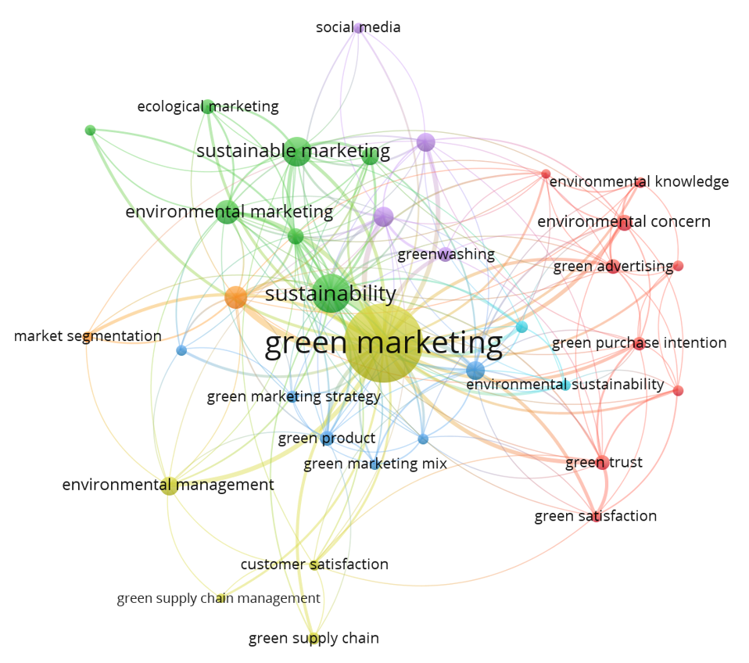

**Q4.** An international cosmetics company is claiming that approximately all of their customers are giving 5-star ratings to their products, analyzing their Amazon reviews, and creating a dashboard that would help them plan their upcoming advertising campaign. Please consider any well-known cosmetic brand's product for the same.   **(10 Marks)**