**JAIPURIA INSTITUTE OF MANAGEMENT, INDORE**

**PGDM**

**FIFTH TRIMESTER (Batch 2021-23)**

**MID TERM EXAMINATION, DEC-2022**

|  |  |  |  |
| --- | --- | --- | --- |
| Course Name | **E-commerce** | Course Code | **IT40825** |
| Max. Time | **1 hour** | Max. Marks | **20** |

**INSTRUCTIONS:**

* All the questions including all the parts are compulsory.
* Please do not create extra column in the dataset
* Dataset KnowYourCustomer_ABCDataset.xls is provided for **Q4**. Upload two files: in part 1 upload word file with all answers and in part 2 upload Excel file with solution of Q4.
* Note: Q4 answers and inference’s need to be there in word file also.

**Q.1:**  E-Commerce gives individual the power to grow with what they have instead of worrying about what they need.

You (Mr. Jones) want to sell Apple Pies that looks like you made it, but you don’t have a recipe or the ability to mass-produce apple pies. You contract with a manufacturer who specializes in making delicious apple pies. They take their apple pie, bake it, package it, and put your label Mr. Jones Apple Pies on it.  They ship Mr. Jones Apple pies to you. You can either: Sell Mr. Jones Apple Pies to Wholesalers who then sell it to retail grocers, or you sell Mr. Jones Apple Pies at [www.mrjonesapplepies.com](http://www.mrjonesapplepies.com).

What sort of e-commerce model is it, give its features What do you like/dislike about it?

**[5 Marks]**

**Q.2:** According to a Business Insider report, consumers have been using the main four messaging apps like Facebook Messenger, WhatsApp, WeChat, Viber more frequently than the main four social networks like Facebook, Twitter, Instagram, and LinkedIn since 2015. The global chatbot market is expected to reach $1.23 billion by 2025 with a compounding annual growth rate of 24.3%, according to a Grand View Research report. Comment.

How chatbots have handled customer query during lockdown? Develop a use case narrative/specification for conversation related to query handling of buying specific size and color Men’s Shirt (do not put the whole system processes into the narrative).

**[2.5 Marks]**

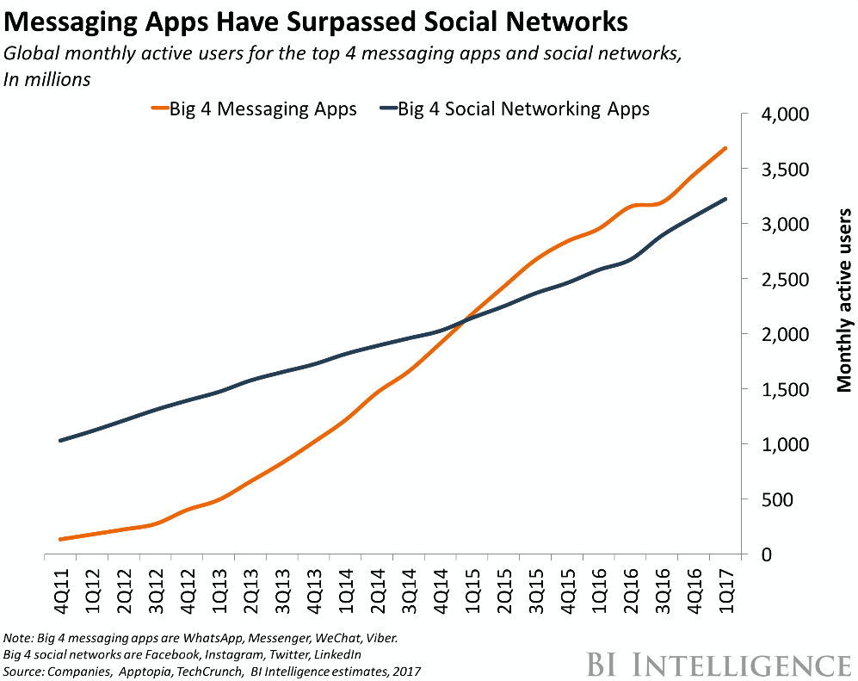

**Q 3** Why there is floating menu bar and order delivery status option on food delivery apps?

|  |  |
| --- | --- |
|  |  |

**[Marks 2.5 Marks]**

**Q.4.** As per the given excel dataset (KnowYourCustomer_ABCDataset.xls), prepare a dashboard so that below mentioned decisions can be taken.

1. How male and females from different states impacts the mobile purchasing?
2. Is any relationship between “Abandon their shopping carts” and various devices used for shopping?
3. How marital status impacts the cosmetics purchasing?

**[Marks 3.5+3+3.5=10]**