|  |  |
| --- | --- |
| **C:\Users\ADMIN\Desktop\j.png** | **JAIPURIA INSTITUE OF MANAGEMENT, INDORE**  Post Graduate Diploma in Management (Batch 2021-23) |
| **Course Title: Project Management, (Course Code: 40532)**  **End-Term Examination, Term - VI (April, 2023)** | |
| **Time Duration : 2 Hours Total Marks: 40** | |

***General Instructions*:**

1. *Answer the questions as directed. The break-up of the marks is given wherever necessary.*
2. *Marks against each question is indicated to its right.*
3. *Answer all the questions of a ‘Section/Question’ at one place in continuation.*
4. *Answers should be brief and to the point.*
5. *Do not write on the question paper except your roll number.*

**SECTION - A**

**Q1 Answer the following questions in less than 100 words, and in bullet points only. (8 Marks)**

* 1. **Why should an organization not rely only on the Financial Criteria for project selection?**
* Financial criteria alone do not consider the strategic objectives of the organization, such as market share, customer satisfaction, or brand recognition.
* Financial criteria do not take into account the intangible benefits of a project, such as increased employee morale or improved stakeholder relationships.
* Financial criteria do not consider the long-term impact of a project, such as its environmental impact or its sustainability.
* Financial criteria may not provide a complete picture of the costs and benefits of a project, as some costs or benefits may not be easily quantifiable.
* Financial criteria may not reflect the risk associated with a project, such as its potential impact on the organization's reputation or legal compliance.
  1. **Why do projects often fail to deliver within the estimated timeline and budget, despite careful planning and execution?**
* Scope creep or changes in project requirements.
* Underestimating the complexity of the project.
* Lack of communication or collaboration among stakeholders.
* Unforeseen events or circumstances, such as natural disasters or economic downturns.
* Inefficient use of resources or poor project management.
* Inadequate risk management and contingency planning.
* Inaccurate project estimates or unrealistic expectations.
* Poorly defined roles and responsibilities.
* Insufficient project resources or funding.
* Inadequate training or lack of expertise among the project team.
* Ineffective change management processes or resistance to change.
* Poor quality control or inadequate testing processes.
* Unanticipated external factors, such as changes in regulations or market conditions.
* Over-reliance on technology or tools that are not suitable for the project.
* Political or cultural factors that affect the project's success.
  1. **Why is it important for project managers to focus on stakeholder engagement and communication throughout the project lifecycle?**
* Stakeholder engagement helps to ensure that stakeholders are actively involved in the project and feel invested in its success.
* Effective communication ensures that stakeholders have a clear understanding of project goals, timelines, and progress.
* Engaged stakeholders can provide valuable input and feedback, which can help to improve project outcomes.
* Communication and engagement can help to prevent misunderstandings, conflicts, and resistance to change.
* Engaged stakeholders are more likely to provide support and resources, which can help to ensure project success.
* Effective communication and engagement can help to build trust and credibility with stakeholders, which can be beneficial for future projects.
* Stakeholder engagement can help to identify potential risks and opportunities, which can be addressed proactively.
* Engagement and communication can help to ensure that project outcomes align with the needs and expectations of stakeholders.
* Effective stakeholder engagement and communication are essential for managing project scope, schedule, and budget.
  1. **Why is it important to establish clear project objectives and goals at the outset of a project, and how can project managers ensure they remain aligned with these objectives throughout the project lifecycle?**

It is important to establish clear project objectives and goals at the outset of a project because:

* Clear objectives provide a roadmap for the project and help to ensure that all stakeholders have a common understanding of the project's purpose and direction.
* Objectives help to define project scope, schedule, and budget, and guide decision-making throughout the project lifecycle.
* Clear objectives help to align project activities with organizational goals and strategic objectives.
* Objectives help to establish criteria for measuring project success and can be used to evaluate project outcomes and identify areas for improvement.
* Objectives provide a basis for effective communication and stakeholder engagement.

To ensure project objectives remain aligned throughout the project lifecycle, project managers can:

* Monitor progress regularly and compare it against established objectives.
* Identify and address any deviations or changes in project scope or requirements.
* Engage stakeholders throughout the project lifecycle to ensure that their needs and expectations remain aligned with project objectives.
* Ensure that project decisions are guided by established objectives and are made in consultation with relevant stakeholders.
* Ensure that project documentation reflects established objectives and is updated regularly to reflect changes in project status.

**Q2. Answer the following questions in 250 words each. (8 Marks)**

**2.1 Explain the concept of earned value management (EVM) and how it can be used to measure project performance. Provide an example of how EVM can help project managers identify and address issues related to project scope, schedule, and cost.**

**Ans.** Earned Value Management (EVM) is a project management technique used to measure project performance and progress. EVM integrates measurements of scope, schedule, and cost to provide a comprehensive view of a project’s performance.

EVM uses three key metrics to measure project performance: planned value (PV), actual cost (AC), and earned value (EV). Planned value is the planned cost of work scheduled to be completed, actual cost is the actual cost incurred for the work completed, and earned value is the value of the work actually completed.

By comparing the planned value, actual cost, and earned value, EVM provides project managers with insight into the status of the project. If the earned value is less than the planned value, the project is behind schedule, over budget, or not performing as expected. If the earned value is greater than the planned value, the project is ahead of schedule, under budget, or performing better than expected.

For example, let's say a construction project has a planned budget of $500,000 and is scheduled to be completed in six months. After three months, the project manager determines that $300,000 has been spent, and the contractor has completed 40% of the work. Using EVM, the project manager can calculate the following:

* Planned value (PV): $250,000 (50% of the budget, reflecting the planned progress at the three-month mark)
* Actual cost (AC): $300,000
* Earned value (EV): $200,000 (40% of the budget, reflecting the actual progress at the three-month mark)

From this calculation, the project manager can determine that the project is behind schedule and over budget. The project is only 40% complete, but 50% of the budget has been spent. This indicates that the project is not performing as planned and requires corrective action to get back on track.

**2.2 Describe the risk management process in project management and explain the key steps involved. Discuss the importance of risk management in ensuring project success and provide an example of how a project manager can effectively use risk register to manage risks throughout the project lifecycle.**

**Ans**. Project risk management is a crucial aspect of project management that involves identifying, assessing, and mitigating risks that could impact project outcomes. The risk management process typically involves several key steps, including risk identification, risk analysis, risk response planning, and risk monitoring and control.

The key steps involved in risk management are:

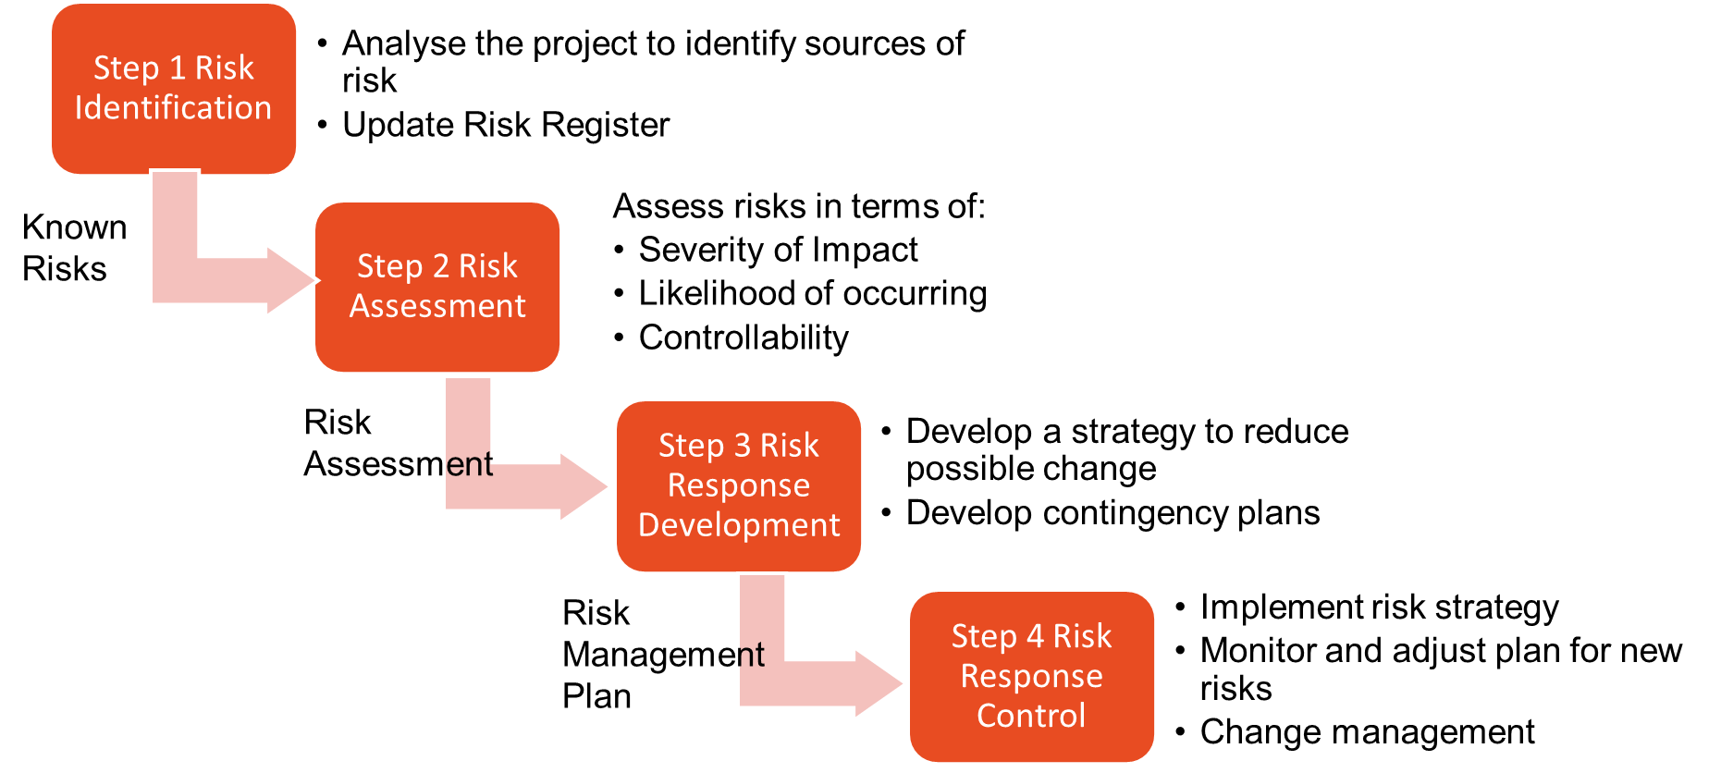

The benefits of project risk management are:

* A proactive rather than reactive approach that reduces the impact on the performance
* Reduces surprises and negative consequences.
* Prepares the project manager to take advantage of opportunities.
* Provides better control over the future.
* Improves chances of reaching project performance objectives within budget and on time.

For instance, a construction project may face risks related to weather, labor, and supply chain disruptions. By identifying and addressing these risks, project managers can take proactive measures to manage them and ensure the project is completed within the estimated timeline and budget.

Project manager can use the risk register to document the identified risks, their likelihood, impact and risk response. The project manager should regularly monitor the risks throughout the lifecyle in the risk register, track the progress of risk response activities, and take corrective action when necessary. This will help ensure that risks are managed effectively and that the project stays on track.

**Q3.** **Solve the following problems:**  **(10 Marks)**

**3.1 A CRM (Customer Relationship Management) software development project involves the scope of managing customer leads, orders, confirmation of order delivery, communicating the status of orders and performance reporting. The project team estimated the following function point complexity matrix:**

|  |  |  |
| --- | --- | --- |
| **Elements** | **Numbers** | **Estimated Complexity** |
| **Data Input Screens** | **10** | **Low** |
| **Data Output Screens** | **20** | **Medium** |
| **Queries** | **10** | **Medium** |
| **Files** | **30** | **High** |
| **API Interfaces** | **50** | **High** |

**Assume that complexity weights are: Low – 1, Medium – 2, High -3. One Man-month is equivalent to 5 Function Points and there are 6 people in the project team.**

1. **Estimate number of months it will take to complete the project.**
2. **If the project is to be completed in maximum 6 months, how many people will be required in the project team?**

**Ans**

|  |  |  |  |  |
| --- | --- | --- | --- | --- |
| **Elements** | **Numbers** | **Estimated Complexity** | **Complexity Weight** | **Weighted Function Points** |
| Data Input Screens | 10 | Low | 1 | 10 |
| Data Output Screens | 20 | Medium | 2 | 40 |
| Queries | 10 | Medium | 2 | 20 |
| Files | 30 | High | 3 | 90 |
| API Interfaces | 50 | High | 3 | 150 |
|  |  |  |  | 310 |
|  |  |  | Number of functions points per Mann Month | 5 |
|  |  |  | Man months | 62 |
|  |  |  | Number of people | 6 |
|  |  |  | Number of months required | 10.3 |
|  |  |  |  |  |
|  |  |  | Number of Months | 6 |
|  |  |  | Number of People reqd | 11 |

**3.2 Assume the network and data that follow. Compute the total direct cost for each project duration of 19, 18, 17, 16, 15 weeks.**

|  |  |  |  |  |
| --- | --- | --- | --- | --- |
| **Activity** | **Crash Slope/week** | **Max Crash Time** | **Normal Time** | **Normal Cost** |
| A | 20 | 1 | 3 | 50 |
| B | 60 | 2 | 5 | 60 |
| C | 40 | 1 | 3 | 70 |
| D | 0 | 0 | 10 | 50 |
| E | 50 | 3 | 6 | 100 |
| F | 100 | 3 | 7 | 90 |
| G | 70 | 1 | 5 | 50 |

**Ans.**

1. Duration 19 Weeks

Cost = 50+60+70+50+100+90+50 = 470

1. Duration 18 Weeks

|  |  |  |  |  |  |
| --- | --- | --- | --- | --- | --- |
| **Activity** | **Crash Slope/week** | **Max Crash Time** | **Normal Time** | **Normal Cost** | **Crash Cost** |
| A | 20 | 1 | 3 | 50 |  |
| B | 60 | 2 | 5 | 60 |  |
| C | 40 | 1 | 3 | 70 |  |
| D | 0 | 0 | 10 | 50 |  |
| **E** | **50** | **3** | **6** | **100** | 50 |
| F | 100 | 3 | 7 | 90 |  |
| G | 70 | 1 | 5 | 50 |  |

Total Cost = 470+50 = 520

1. Duration 17 weeks

|  |  |  |  |  |  |
| --- | --- | --- | --- | --- | --- |
| **Activity** | **Crash Slope/week** | **Max Crash Time** | **Normal Time** | **Normal Cost** | **Crash Cost** |
| **A** | **20** | **1** | **3** | **50** | 20 |
| B | 60 | 2 | 5 | 60 |  |
| C | 40 | 1 | 3 | 70 |  |
| D | 0 | 0 | 10 | 50 |  |
| **E** | **50** | **3** | **6** | **100** | 50 |
| F | 100 | 3 | 7 | 90 |  |
| G | 70 | 1 | 5 | 50 |  |

Total Cost = 470+50+20 = 540

1. Duration 16 weeks

|  |  |  |  |  |  |
| --- | --- | --- | --- | --- | --- |
| **Activity** | **Crash Slope/week** | **Max Crash Time** | **Normal Time** | **Normal Cost** | **Crash Cost** |
| **A** | **20** | **1** | **3** | **50** | 20 |
| B | 60 | 2 | 5 | 60 |  |
| C | 40 | 1 | 3 | 70 |  |
| D | 0 | 0 | 10 | 50 |  |
| **E** | **50** | **3** | **6** | **100** | 50 |
| F | 100 | 3 | 7 | 90 |  |
| **G** | **70** | **1** | **5** | **50** | 70 |

Total Cost = 540+70 = 610

1. Duration = 15 Weeks

Not possible to crash to 15 weeks as A, G crashed to max limit 1 week each. After crashing E by 1 week, 3 paths i.e. BE, CF & D are all on critical path (10 days for each path). Since D cannot be crashed, there will be no gain in the schedule by crashing other activities.

**SECTION – B (14 Marks)**

**Q4.** The optical disk project team has started gathering the information necessary to develop the project network—predecessor activities and activity times in weeks. The results of their meeting are found in the following table.

|  |  |  |  |
| --- | --- | --- | --- |
| **S. No.** | **Activity** | **Time** | **Predecessor** |
| A | Define scope | 6 | None |
| B | Define customer problems | 3 | A |
| C | Define data records and relationships | 5 | A |
| D | Mass storage requirements | 5 | B,C |
| E | Consultant needs analysis | 10 | B,C |
| F | Prepare installation network | 3 | D,E |
| I | Write request proposal | 5 | D,E |
| J | Compile vendor list | 3 | D,E |
| K | Prepare mgmt. control system | 5 | F |
| L | Prepare comparison report | 5 | I,J |
| M | Compare system “philosophies” | 3 | L |
| P | Compare customer satisfaction level | 10 | L |
| Q | Assign philosophies points | 1 | M |
| U | Select best system | 1 | K,Q,P |

The project team has requested that you create a network for the project, and determine

1. Draw the network diagram and label with all the information provided
2. Estimated time to complete the entire project
3. Identify the critical path activities
4. Determine the slack available on each activity
5. If all activities have same crash cost, which **one** activity you will crash and by how many days?

Ans.

1. Network Diagram:



1. Time taken to complete the project is 42 weeks
2. Critical Path is A🡪C🡪E🡪I🡪L🡪P🡪U
3. Slacks:
   1. B: 2
   2. D: 5
   3. F: 12
   4. J: 2
   5. K: 12
   6. M:6
   7. Q: 6
4. Activity P by 6 days