 | JAIPURIA INSTITUE OF MANAGEMENT, INDORE  Post Graduate Diploma in Management (Batch 2021-23)
Course Title: Project Management, (Course Code: 40532)
End-Term Examination, Term - VI (April, 2023)
Time Duration : 2 Hours Total Marks: 40

General Instructions:
- Answer the questions as directed. The break-up of the marks is given wherever necessary.
- Marks against each question is indicated to its right.
- Answer all the questions of a ‘Section/Question’ at one place in continuation.
- Answers should be brief and to the point.
- Do not write on the question paper except your roll number.

SECTION - A

Q1 Answer the following questions in less than 100 words, and in bullet points only. (10 Marks)
1.1 Why should an organization not rely only on the Financial Criteria for project selection?
1.2 Why do projects often fail to deliver within the estimated timeline and budget, despite careful planning and execution?
1.3 Why is it important for project managers to focus on stakeholder engagement and communication throughout the project lifecycle?
1.4 Why is it important to establish clear project objectives and goals at the outset of a project, and how can project managers ensure they remain aligned with these objectives throughout the project lifecycle?
Q2. Answer the following questions in 250 words each. (10 Marks)
2.1 Explain the concept of earned value management (EVM) and how it can be used to measure project performance. Provide an example of how EVM can help project managers identify and address issues related to project scope, schedule, and cost.
2.2 Describe the risk management process in project management and explain the key steps involved. Discuss the importance of risk management in ensuring project success and provide an example of how a project manager can effectively manage risks throughout the project lifecycle.

Q3. Solve the following problems: (5+5 Marks)
3.1 A CRM (Customer Relationship Management) software development project involves the scope of managing customer leads, orders, confirmation of order delivery, communicating the status of orders and performance reporting. The project team estimated the following function point complexity matrix:
Elements | Numbers | Estimated Complexity
Data Input Screens | 10 | Low
Data Output Screens | 20 | Medium
Queries | 10 | Medium
Files | 30 | High
API Interfaces | 50 | High

Assume that complexity weights are: Low – 1, Medium – 2, High -3. One Man-month is equivalent to 5 Function Points and there are 6 people in the project team.
- Estimate number of months it will take to complete the project.
- If the project is to be completed in maximum 6 months, how many people will be required in the project team?
3.2 Assume the network and data that follow. Compute the total direct cost foreach project duration of 19, 18, 17, 16, 15 weeks.

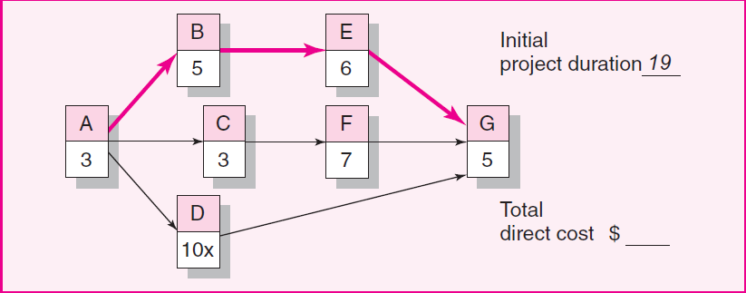
Activity | Crash Slope/week | Max Crash Time | Normal Time | Normal Cost
A | 20 | 1 | 3 | 50
B | 60 | 2 | 5 | 60
C | 40 | 1 | 3 | 70
D | 0 | 0 | 10 | 50
E | 50 | 3 | 6 | 100
F | 100 | 3 | 7 | 90
G | 70 | 1 | 5 | 50

SECTION – B
Q4. The optical disk project team has started gathering the information necessary to develop the project network—predecessor activities and activity times in weeks. The results of their meeting are found in the following table. (10 Marks)

S. No. | Activity | Time | Predecessor
A | Define scope | 6 | None
B | Define customer problems | 3 | A
C | Define data records and relationships | 5 | A
D | Mass storage requirements | 5 | B,C
E | Consultant needs analysis | 10 | B,C
F | Prepare installation network | 3 | D,E
I | Write request proposal | 5 | D,E
J | Compile vendor list | 3 | D,E
K | Prepare mgmt. control system | 5 | F
L | Prepare comparison report | 5 | I,J
M | Compare system “philosophies” | 3 | L
P | Compare customer satisfaction level | 10 | L
Q | Assign philosophies points | 1 | M
U | Select best system | 1 | K,Q,P

The project team has requested that you create a network for the project, and determine
- Draw the network diagram and label with all the information provided
- Estimated time to complete the entire project
- Identify the critical path activities
- Determine the slack available on each activity
- If all activities have same crash cost, which one activity you will crash and by how many days?

