|  |  |
| --- | --- |
| **C:\Users\ADMIN\Desktop\j.png** | **JAIPURIA INSTITUE OF MANAGEMENT, INDORE**  Post Graduate Diploma in Management |
| **Course Title: Entrepreneurship, (Course Code: 40102)**  **Special Improvement Examination, Term - II (Batch 2022-24) (March 2023)** | |
| **Time Duration: 2 Hours Total Marks: 50** | |

**INSTRUCTIONS:**

All questions are compulsory. All questions carry equal marks.

**Case study: MEESHO INDIA**

Vidit Aatrey and Sanjeev Barnwal graduated from IIT Delhi in Electrical Engineering in 2012. While studying, they shared the same hostel, were good friends, and worked on many projects together. However, after graduation, they drifted apart. Barnwal took a job at Sony as a software developer and moved to Tokyo. At the same time, Aatrey joined InMobi as manager of Original Equipment Manufacturer (OEM) Partnerships after a short stint at ITC as a supply chain manager.

In 2015, Barnwal was approached by a Bangalore-based startup with a job offer. He immediately thought of his old friend, Aatrey, who was working in Bangalore and reached out to him to discuss the proposal. Aatrey was well plugged into the local startup ecosystem. They discussed the vibrant startup ecosystem in Bangalore and the plethora of opportunities opening up in India. It turned out to be a pivotal call because soon after, they decided to launch their startup. Over the next month, they both resigned from their well-paying jobs, and Barnwal moved to Bangalore. Looking back, Barnwal said: It was more like now or never. It seemed like a good idea to start young with fewer liabilities, set aside a few years, and try something new. That’s better than testing in the later stages of life when there are more responsibilities.

## GOING HYPERLOCAL

The founders wanted to start a venture but disagreed on what they would do. Barnwal recalled: We were indifferent to the problem statement and the market, but our goal was always to start a venture that solves a complex problem and makes a long-lasting impact. They researched various businesses attracting venture capital investment and figured that hyperlocal was an emerging space. The term “hyperlocal” refers to a small geographic area. The hyperlocal delivery model is a business model in which the service provider acquires the required product locally from neighborhood establishments and delivers it to the customer in the same geographic area.1 The unique value proposition of hyperlocal businesses is that they can deliver products and services to their customers in a short time. This speed of delivery was convenient for consumers in a fast-paced world. The hyperlocal model was reorganizing many categories of the retail sector2 - food, groceries, pharma, and others. Several hyperlocal startups had been funded and seemed like a model that worked for India. Barnwal said:

We immediately sensed an opportunity. Neither of us liked to go shopping. The same was true for our friends. Nobody wanted to step outside to shop. We noted that there was no hyperlocal solution for fashion and thought, would it not be great if the shop came to us? Like a Swiggy for Fashion.

**FASHNEAR FOR THE UNBRANDED**

FashNear was a mobile application that would let consumers browse all the neighborhood stores selling apparels in their locality. Consumers had the option of choosing products that they wished to try. This would trigger a request to the store, which would send a sales boy to the consumer’s house with the requested products. The consumer could try on the apparels and buy whatever they liked and send the remaining apparels back with the sales boy to the store (see image below). Aatrey observed . This was new in the retail space; something no one had explored previously in India. For consumers, this was like getting the best of both worlds – FashNear was giving them a mall experience from the convenience of their home. They could browse the collection from multiple stores but at the same time, try out the outfits in their homes. It was making fashion available at their fingertips.

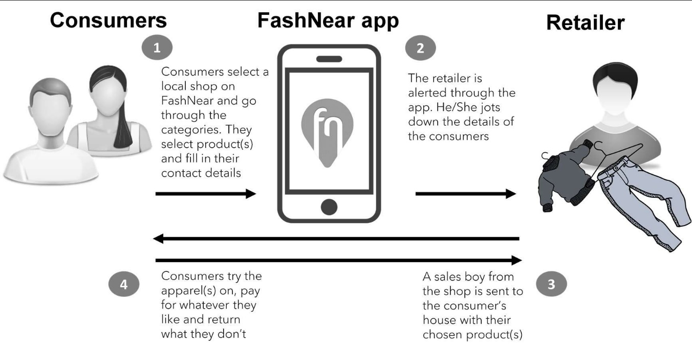

In the first month, which coincided with the ‘end of season’ sale in offline retail, FashNear had received 56 home trial orders and sold 40 products, accounting for a gross merchandize value (GMV) of $673 (INR 50,000). However, as the sale ended and discounts disappeared, the orders dried up too. The second month onward, there were fewer orders coming in and by December 2015, Aatrey and Barnwal realized that FashNear was not gaining the kind of traction they hoped for.

Aatrey leveraged his network and spoke to several active acquaintances in the startup ecosystem. They agreed with the assessment that hyperlocal was the way to go, and fashion seemed to be a good category.

Market research confirmed that there was an opportunity in this space. Apparels were the largest segment within the fashion industry. The total apparel market size in India was $33.41 billion (INR 2,48,250 crore) (cr - crore) in 2014 and was estimated to grow at a CAGR of 9.9% to reach $86.23 billion3 (INR 6,40,800 crore) in 2024.4 Further, branded apparel accounted for only 25% of the overall market in 2012, and the rest was unbranded. This strong demand for unbranded apparel was expected to continue in the future.

**Answer the following All questions carry equal marks (10 Marks Each)**

**Q1**. Identify the Enntreprurial opportunity in the market identified in the case. Discuss why Messho can recognize it as a business opportunity.

**Q 2** Create a Lean canvas for Meesho and explain various elements?

**Q 3** What problem that FashNear is trying to solve? Did it has a problem-solution fit?

**Q 4** what did the founder do differently? What did they wrong?

**Q5** Analyze the company's growth potential. How could they compete with existing players?