|  |  |
| --- | --- |
| **C:\Users\ADMIN\Desktop\j.png** | **JAIPURIA INSTITUE OF MANAGEMENT, INDORE**  Post Graduate Diploma in Management (Batch 2022-24) |
| **Course Title: Business Research Method (Course Code: 40503)**  **End Term Examination, Term - III (May 2023)** | |
| **Time Duration: 2 Hours Total Marks: 40** | |

***General Instructions*:**

1. *Answer the questions as directed. The break-up of the marks is given wherever necessary.*
2. *Marks against each question are indicated to its right.*
3. *Answer all the questions of a 'Section/Question' in one place in continuation.*
4. *Answers should be brief and to the point.*
5. *Do not write on the question paper except your roll number.*
6. *It’s an open book exam, You can refer text book and personal lecture notes.*

**SECTION - A**

**Q1.** Saksham Verma is a newly appointed summer intern in the Tata Motors dealership in Indore, and he is so happy to join the large automobile giant. As he read somewhere, India's electric vehicle market size was USD 1.45 billion in 2021 and is projected to grow from USD 3.21 billion in 2022 to USD 113.99 billion in 2029, growing at a CAGR of 66.52% during the 2022-2029 forecast period. Contrary to that, At his first interaction with his manager, he realized his rising concern over profitability. The sales at Indore are not promising enough to sustain in the market amongst the existing four dealerships in city limits**.** India's greatest auto assembling organization began creating new vehicles by surveying future interest in electric vehicles. Tata Motors, in December 2019, divulged one of the predominant items Tata Nexon EV, an electric vehicle with three variations in 3 shades having great millage and execution contrast with the other rival vehicle in a reasonable value range.

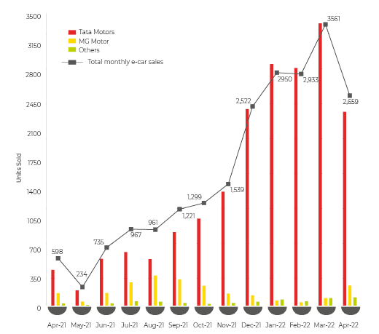

But the records speak of the concern of the manager. As the only candidate selected in TATA Motors across four campuses for a market research profile, he decided to crack the code and investigate the product market fit. He remembers the Value proposition canvas and integrities of product market fit. So finally, he decided to take it as his research project.

1. **Identify and state what the underlined research problem is. (2 Marks)**
2. **What should be the research objectives for Saksham? (2 Marks )**
3. **Formulate three research questions that will help him investigate the issue identified.**

**(2 Marks)**

**Q2** Manjeet Singh, a young wanna-be businessman, came across a web article mentioning an Indian startup fighting against plastic garbage accumulation by turning it into shoes. The " Thaely " company claims that shoes are made from 10 bags and 12 bottles. Launched in July 2021, Thaely is named after the Hindi word for plastic bags. The 23-year-old founder Ashay Bhave claimed that the business is already profitable and that the environment-first startup ships the shoes worldwide for $110 (About ₹8,000).**"** Manjeet is thrilled by the Idea but also suspicious about the success of such a product. He wants to understand the market potential for such green products. Develop the following research design for Thaely shoes from below designs to understand the acceptance of the product (Any two) **(5 Marks)**

* 1. Qualitative Research Design
  2. Quantitative Research Design
  3. Causal Research Design
  4. Experimental Research Design

**Q3.** Ms. Sweety loves sugar cane juice to the extent that she wants to establish a high-capacity production plant to give the taste of Indian sugar cane to the world. The high-quality hygienic bottled version of sugar cane juice was inspired by the packed version of Coconut water and the success of other bottled beverages sold in the market. She is looking for a market study to support her Idea.

Develop your research survey questionnaire for prospective consumers of packaged sugar cane juice. Map your survey questionnaire with the underline research questions and hypothesis for each question asked. Limit your questionnaire to the maximum of five most relevant questions.

*(Every relevant question mapped with a Research question and formed hypothesis carries* ***2 Mark*** */****Total 10 Marks*** *)*

**Q4**. A ) Retail companies often use clustering to identify similar household groups. For example, a retail company may collect the following information on households: **(4 Marks)**

* Household income
* Household size
* Head of Household Occupation
* Distance from the nearest urban area

If you will be using any of the clustering algorithms, identify at least four possible clusters obtained from the above-collected data.

**Q5** Rahul Kumar is an MBA aspirant looking for a B school that will transform his life. Management consulting has some data sheets of responses collected from various B School students. The questionnaire inquiries the following information head, and data is collected on a importance scale [1Min to 5 Max.] **(6 Marks)** Family Income

1. Occupation of father
2. Program Fee
3. Placement Package
4. Infrastructure
5. Faculty
6. Sport facility
7. Hostel & Canteen
8. Year of establishment
9. Intake Batch size
10. Alumni Count.
11. NIRF Institute Rank

Analyze the tentative research outcomes when he tries to run the following analysis using the above data heads:

1. Factor analysis
2. Cluster analysis
3. Conjoint analysis
4. Discriminant analysis