|  |  |
| --- | --- |
| **C:\Users\ADMIN\Desktop\j.png** | **JAIPURIA INSTITUE OF MANAGEMENT, INDORE**  Post Graduate Diploma in Management |
| **Course Title: Data Visualization, (Course Code: X0825)**  **End-Term Examination, Term - V (January, 2024)** | |
| **Time Duration : 2 Hours Total Marks: 40** | |

***General Instructions*:**

1. *Answer the questions as directed. The break-up of the marks is given wherever necessary.*
2. *Marks against each question is indicated to its right.*
3. *Answer all the questions of a ‘Section/Question’ at one place in continuation.*
4. *Answers should be brief and to the point.*
5. *Do not write on the question paper except your roll number.*

***Please Note :***

* + - 1. Create a New Tableau file and inside it need to create the separate worksheet for each of the following questions.
      2. Save the Final file (containing both Section A and Section B) as per the following TermV.Rollno(last 4 figures). Section A/B.
      3. For example for the Roll No. JI/2022-24/0021 with Section B, the file to be saved as

V. 0021.B

**SECTION - A**

**Q1. Interpret the data set DVSet1.xls and carryout the analysis in tableau, to support data visualization, based on the following queries. (2 x 10 = 20 Marks)**

1. Analyze people are in each job?
2. Interpret Gender Distribution
3. Interpret Age distribution of the staff
4. Analyse high paying jobs
5. Interpret top earners in each job
6. Interpret relationship between Qualification and Salary
7. Interpret headcount trend over time
8. Interpret Employee numbers with Job Title
9. Leave balance analysis for Male and Female
10. Interpret Age and Leave Balance

**Q2. Design a Dashboard (as per the picture) to analyze the e commerce enterprise business KPIs. Please refer the data set** **DVSet1.xls. (2 x 10 = 20 Marks)**

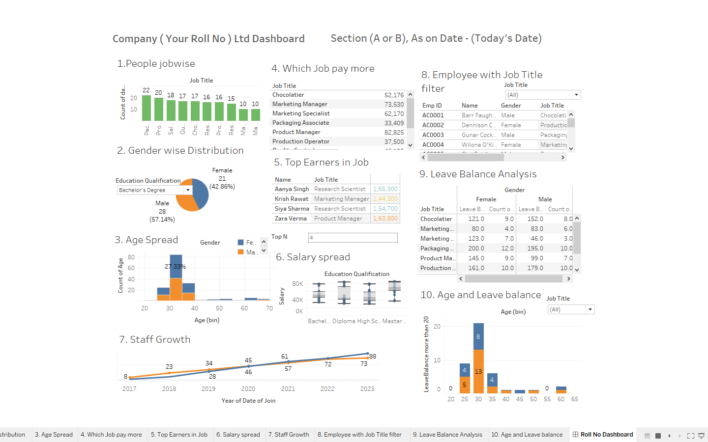

**Note :**

On the dashboard title you need to Declare your Roll Number as your Company Name and mention your section in the next text box with today’s date.

**_____________________________________________________________________________**