|  |  |
| --- | --- |
| **C:\Users\ADMIN\Desktop\j.png** | **JAIPURIA INSTITUE OF MANAGEMENT, INDORE**  Post Graduate Diploma in Management (Batch 2022-24) |
| **Course Title: Business Research Methods (Course Code: 40503)**  **End Term Examination, Term - III (April 2024)** | |
| **Time Duration: 2 Hours Total Marks: 40** | |

***General Instructions*:**

1. *Answer the questions as directed. The break-up of the marks is given wherever necessary.*
2. *Marks against each question are indicated to its right.*
3. *Answer all the questions of a 'Section/Question' in one place in continuation.*
4. *Answers should be brief and to the point.*
5. *Do not write on the question paper except your roll number.*

**SECTION - A**

Q1 Priya Sharma is a recent graduate with a degree in Marketing. She's thrilled to land an internship at a popular sportswear brand's retail store in Mumbai. Priya is passionate about fitness and the brand aligns with her values. However, upon starting her internship, Priya noticed a decline in customer foot traffic compared to last year. The store manager expresses concern about reaching sales targets, especially for their new yoga apparel line.

According to a recent report by Industry Research Firm: MMR, the Indian activewear market is booming, expected to reach a value of ₹22,940 Crore (US$3.1 Billion) by 2025. This growth is fueled by a rising focus on health and wellness, particularly among young adults in urban areas.

However, within the activewear segment, yoga apparel is facing increased competition. A Market Research Institute MMR shows a trend of consumers favoring performance-driven yoga wear with sustainable and technological features. Determined to help, she investigates the reasons behind the slow sales of the new yoga apparel line.

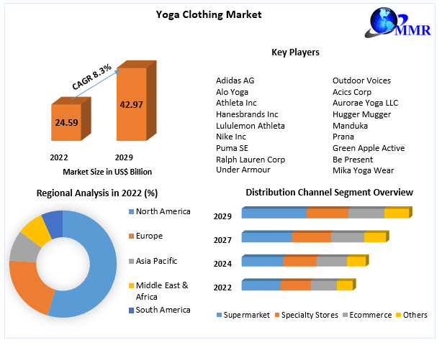

***Answer the following :***

1.A. Identify and state the underlined research problem. **(2 Marks)**

1.B. What should be Priya's research objectives? **(2 Marks)**

1.C. Formulate three research questions that will help her investigate the issue identified.

**(6 Marks)**

**Q2** In the heart of a bustling metropolis, Urban Air Labs waged a silent war for clean air, armed with sleek, innovative air purifiers. Designed with cutting-edge technology, these purifiers filtered out dust, smoke, and allergens, targeting homes and businesses suffocating under pollution. Despite skepticism in a crowded market, Urban Air Labs educated the public about indoor air pollution's health risks and the benefits of clean air. News reports and a growing eco-conscious population boosted demand for their purifiers. Partnerships with healthcare providers and contractors strengthened their position. Aditya Madanapalle and his team at CARA Machines (later Urban Air Labs) launched the uBreathe in 2018, a stylish air purifier using "Breathing Roots" technology to enhance plant air-filtering capabilities. Despite initial doubts, uBreathe gained recognition for its effectiveness and sustainability by 2021, leading to expanded product lines and ventures into air quality audits.

***Design and formulate research for UBreathe investigating venues to focus and boost sales (Any two frameworks)* (10 Marks)**

* 1. Qualitative Research Design
  2. Quantitative Research Design
  3. Causal Research Design
  4. Experimental Research Design

**Q3.** Mateo, an eco-conscious entrepreneur, is intrigued by lab-grown meat and envisions a future where fashion embraces sustainability with lab-grown leather. Before investing in this innovative venture, he wants to understand consumer sentiment. Develop a research survey questionnaire for prospective consumers of lab-grown leather. Limit the questionnaire to five relevant questions, mapping each with the underlying research questions and hypothesis.

***(Every relevant question mapped with a Research question and formed hypothesis carries 2 Mark /Total 10 marks )* (10 Marks)**

**Q4.** An organization wants to investigate tourists' satisfaction with certain sustainability factors (Hypothesis Section). They collected data from 228 tourists visiting 26 sustainable tourism destinations across 8 states in India. The research team analyzed the data, and the output table for the same is provided below: Interpret the provided output table.

|  |  |  |  |  |  |
| --- | --- | --- | --- | --- | --- |
| **Hypothesis** | **β** | **SE** | **T-statistics** | **p-values** | **Decision** |
| (H1) Economic sustainability -> tourist’s satisfaction | 0.057 | 0.062 | 0.92 | .361 | ? |
| (H2) Environment sustainability -> tourist’s satisfaction | 0.357 | 0.054 | 6.61 | .000 | ? |
| (H3) Institutional sustainability -> tourist’s satisfaction | 0.158 | 0.079 | 1.99 | .043 | ? |
| (H4) Sociocultural sustainability -> tourist’s satisfaction | 0.447 | 0.075 | 5.94 | .000 | ? |

***Answer any 3 from of the following: (2 marks each Total 6 Marks )* (10 Marks)**

a) Based on the coefficient values (β), what can be inferred about the strength and direction of the relationships between each sustainability factor (economic, environmental, institutional, sociocultural) and tourists' satisfaction?

b) Interpret the standard errors (SE) in the output table. How do these values affect the reliability of the regression coefficients?

c) Analyze the t-statistics provided in the output table. What do these values indicate about the significance of each sustainability factor in influencing tourists' satisfaction?

d) Discuss the p-values presented in the output table. How do these values help determine the significance of the relationships between sustainability factors and tourists' satisfaction?

e) Based on the decisions provided in the output table, what conclusions can be drawn regarding the hypotheses related to economic sustainability, environmental sustainability, institutional sustainability, and sociocultural sustainability in relation to tourists' satisfaction?

***Compulsory Answer the below question***

f) Summarize the overall findings of the regression analysis and their implications for sustainable tourism destinations in India. **(4 marks)**