**Jaipuria Institute of Management, Indore**

*QT Formula sheet*

*Arithmatic Mean for ungrouped data*

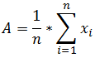

*Arithmatic Mean for grouped data*

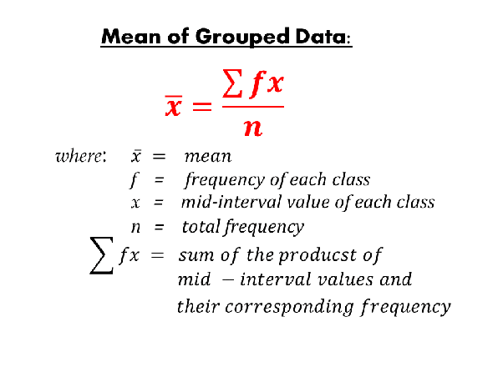

*_*________________________________________________________________________________________________________________

*Median*

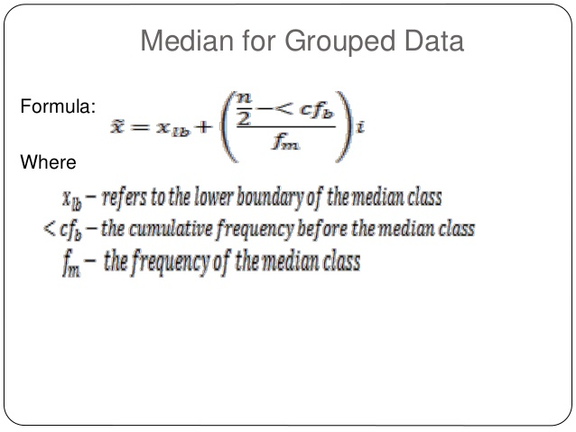

*Mode*

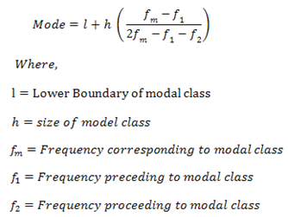

**_________________________________________________________________________________________________________________**

*Standard Deviation for Sample Data*

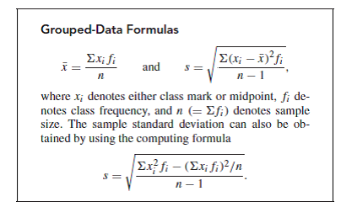

_________________________________________________________________________________________________________________

*Standard Normal Curve*

