|  |  |
| --- | --- |
| **C:\Users\ADMIN\Desktop\j.png** | **JAIPURIA INSTITUE OF MANAGEMENT, INDORE**  Post Graduate Diploma in Management |
| **Course Title: Essentials of Business Analytics, (Course Code: 40801)**  **End-Term Examination, Term - II (January 2025)** | |
| **Time Duration: 2 Hours Total Marks: 40** | |

***General Instructions*:**

1. *Marks against each question are indicated to its right.*
2. *For question 1, MS Excel sheet is to be submitted containing questions, possible solution and business inferences.*
3. *For question 3, save the PowerBI Dashboard with your Full Enrollment NO.*
4. *Q2 and the analysis of each part of Q3have to be written in the answer sheet.*
5. *Do not write on the question paper except your roll number.*

**Q.1 Problem Statement (20 Marks)**

Vikram, the forward-thinking CEO of a tech company, seeks to leverage data analytics to gain a competitive advantage. He enlists **Betaal**, an analytics guru, to guide him through this transformation. **Betaal** is the world’s number one analytical guru, but before he was hired, he put one condition that on a daily basis he needs TWENTY business questions from Vikram that should be useful for business decision-making. In case TWENTY different valid questions to be solved by different methods are not provided by Vikram, then **Betaal** will destroy the complete dataset and datacenter.

Betaal always emphasizes the importance of collecting high-quality data and setting up robust data management systems to ensure accuracy and accessibility.

They use descriptive analytics to understand past performance, identifying trends and patterns that have impacted the business.

Through diagnostic analytics, they delve into the reasons behind declining sales, uncovering hidden issues in the supply chain.



Using predictive analytics, they forecast future market demands, enabling Vikram to make informed strategic decisions. With prescriptive analytics, they devise actionable strategies, optimizing pricing and marketing efforts to maximize profits.

By integrating analytics across all business functions, Vikram, guided by Betaal, successfully transforms the company into a data-driven leader in the industry.

You are very close to Vikam, and Vikram always takes suggestions from you regarding the growth of the business.

On the last working day of the contract with Betaal, Vikram is out of questions. During the last 364 days, Betaal was a very useful resource for Vikram’s organization, and they achieved high. Now He requested you to provide TWENTY unique questions with solutions.

Your job is to provide TWENTY unique questions with solutions. The solution to each question should be performed by different/unique MS Excel functions/tools/formulas. These solutions should be used for actionable business decision-making for the future. Hence, you are also required to explain how these questions and their solutions are useful for future decision-making.

Vikram provided you with a data set of Supply Chain; currently, Vikram and his team are working on this data set to derive some business insights for their clients.



**Your evaluation will be based on the quality of questions asked, solutions provided by applying suitable MS-Excel function/s, and how these questions and solutions will be useful for future business decision-making.**

**Q.2** Explain the ethics in data visualization by explaining the issue in terms of ethics in the image below. **(5 Marks)**

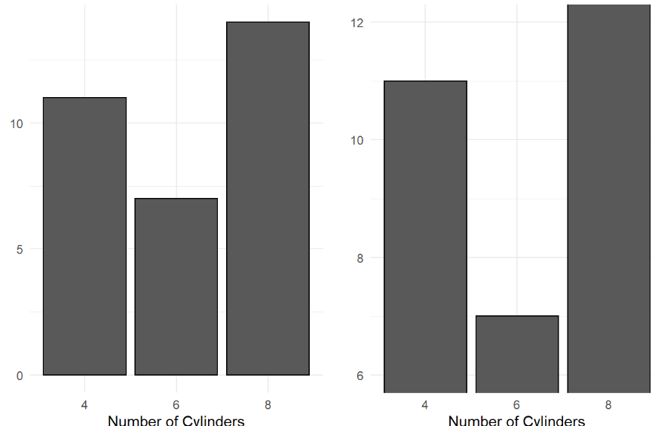

**Q.3** A financial institution issues a variety of debit and credit cards, catering to customers across different regions. The management has access to a comprehensive customer dataset, including demographic information, card type preferences, spending patterns, satisfaction scores, and points earned. The company aims to enhance customer retention, tailor card benefits, increase revenue, and target new customer segments using insights derived from the data. The leadership team leverages tools like Power BI to visualize and analyse trends, enabling data-driven decisions to improve their products and customer engagement strategies. **(15 Marks)**

1. Describe the age distribution of cardholders across different regions. Analyze the age demographics to design region-specific promotions and card features.
2. Find out which type of card has the highest satisfaction score. Evaluate satisfaction by card type to prioritize improvements for underperforming products.
3. Explain how the tenure of customers influences card activity and points earned. Identify trends in long-tenured customer behavior to design loyalty rewards for inactive members.
4. Comment on the relationship between credit score and preferred card type.
5. Is there any relation between the gender and point earned, if so please explain which gender we should target more to improve the revenue.