|  |  |
| --- | --- |
| **C:\Users\ADMIN\Desktop\j.png** | **JAIPURIA INSTITUE OF MANAGEMENT, INDORE**  Post Graduate Diploma in Management (Batch 2023-25) |
| **Course Title: Digital Marketing (Course Code: 40411)**  **Term-End Examination, Term – IV (October 2024)** | |
| **Time Duration: 2 Hours Total Marks: 40** | |

***General Instructions*:**

1. *All questions are mandatory*
2. *Brief and up to the point answers are desired*

*___________________________________________________________________________*

**Section A (30 Marks)**

**Q.1 A social commerce company selling personalised gifts in Delhi is planning to use Google Adwords to enhance its search results. What tools and possible keyword you will suggest to the company for better results (Marks-10)**

**Q.2 You are a digital Manager for Netflix.com, a new series featuring a reality show called daredevils where participants are going to face dare and will be facing extreme challenges for their survival in the show. is about to get launched the TG for the show are teens between the age group of 14-19. Draft a blog about this show in not more than 500 words. (Marks-10)**

**Q.3 Zomato is in the food ordering business, they wish to expand their reach in college campuses where you have established mess and canteen. What possible affiliate marketing or other tools they can adopt to increase reach among college students. (Marks-10)**

**About the company:**

**Helping people discover great places around them.**

Our team gathers information from every restaurant on a regular basis to ensure our data is fresh. Our vast community of food lovers share their reviews and photos, so you have all that you need to make an informed choice.

**Building amazing experiences around dining.**

Starting with information for over 1 million restaurants (and counting) globally, we're making dining smoother and more enjoyable with services like online ordering and table reservations.

**Enabling restaurants to create amazing experiences.**

With dedicated engagement and management tools, we're enabling restaurants to spend more time focusing on food itself, which translates directly to better dining experiences.

**Section B (10 Marks)**

**Case Analysis:**

**Marketing fail: Flipkart 'sexist' customer emails go viral on Twitter**

In August 2015, Flipkart was forced to apologise for sending a sexist promotional email after a customer took to Twitter to criticise India's largest online retailer. This case study looks at the fallout from the marketing blunder, and why brands should think before they click 'send'.

• Indian retailer sends mass email claiming 'beauty breeds success' for women

• Email is posted on Twitter and goes viral-provoking outrage and negative media coverage

• Company forced to make quick apology with deep review of content strategy

Following a mass mailing by Flipkart to targeted female customers, Twitter user Richa Kaul Padte posted a screenshot of the email that cited "research" to market women's fashion products.

Thanks for this piece of sexist shit email @Flipkart pic.twitter.com/EHdI5PefcF

— Richa Kaul Padte (@hirishitalkies) August 29, 2015

This is the text of the email it sent to potential customers:

“Research shows that beautiful women are more successful in their lives. This is because when women improve their appearances, they get noticed, listened to and eventually respected for their opinion. Such women not only become confident but also remain motivated to perform even better in life.”

The tone of the text, implying women can only be successful of they are beautiful, provoked outrage on Twitter.

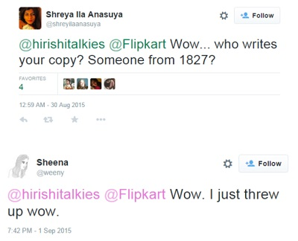Here's an example of some of the responses:

Flipkart replied to the tweet saying it does not endorse the content of the email and will investigate and take action. Punit Soni, Flipkart's chief product officer, admitted that this was a big faux-pas and and apologised on the company's behalf.

[https://pbs.twimg.com/profile_images/991197876377174016/gesHb4K8_normal.jpg](https://twitter.com/punitsoni)

[punitsoni](https://twitter.com/punitsoni)

**[✔](https://twitter.com/punitsoni)** [@punitsoni](https://twitter.com/punitsoni)

[Replying to @hirishitalkies](https://twitter.com/_/status/637676976128430081)

[@hirishitalkies](https://twitter.com/hirishitalkies) [@Flipkart](https://twitter.com/Flipkart) we are kicking off a deep review to see what happened. Will fix and will revert with an update. Apologies.

[9:00 PM - Aug 30, 2015](https://twitter.com/punitsoni/status/638010850603724800) · [Bengaluru South, India](https://twitter.com/search?q=place%3A5f55bb82cf16ac81)

"Unconditional apologies. We do not endorse the insensitive remarks in the email. This is a big fail, will not happen again," tweeted Soni.

He also said that the company was kicking off a deep review to see what happened and will fix things.

However, this isn't the first instance of glaring sexism that Flipkart has resorted to, as has been pointed out by certain users on social media:

[Flipkart](https://twitter.com/Flipkart)

**[✔](https://twitter.com/Flipkart)** [@Flipkart](https://twitter.com/Flipkart)

 · [Aug 30, 2015](https://twitter.com/Flipkart/status/637976120638369793)

[Replying to @hirishitalkies](https://twitter.com/_/status/637676976128430081)

[@hirishitalkies](https://twitter.com/hirishitalkies), thanks for bringing this to our notice. We do not endorse the content of this email. We will investigate this & take action

[https://pbs.twimg.com/profile_images/957689826114981893/bh3KU3Dq_normal.jpg](https://twitter.com/saifalfalah)

[Saif Al Falah @saifalfalah](https://twitter.com/saifalfalah)

[@Flipkart](https://twitter.com/Flipkart) [@hirishitalkies](https://twitter.com/hirishitalkies) it looks like you do endorse this by selling it on your platform? [pic.twitter.com/hgATa3DFXK](http://t.co/hgATa3DFXK)

[8:16 PM - Aug 3, 2015](https://twitter.com/saifalfalah/status/637999800026165248)

[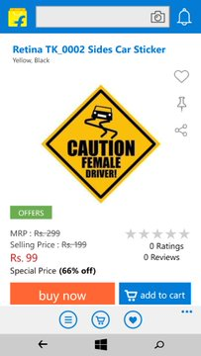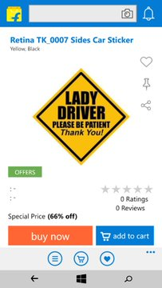](https://twitter.com/saifalfalah/status/637999800026165248/photo/1)x

**Questions: (5 marks each)**

**Q.1 What went wrong in the whole controversy, how should companies handle these kind of incidences**

**Q.2 Why twitter as a platform can make or break a brand take clues from the case above and write your answer.**