 | JAIPURIA INSTITUE OF MANAGEMENT, INDORE  Post Graduate Diploma in Management
Course Title: Data Visualization (Course Code: 40825)
End-Term Examination, Term - V (January, 2025)
Time Duration : 2 Hours Total Marks: 40

General Instructions:
- Answer the questions as directed. The break-up of the marks is given wherever necessary.
- Marks against each question is indicated to its right.
- Answer all the questions of a ‘Section/Question’ at one place in continuation.
- Answers should be brief and to the point.
- Do not write on the question paper except your roll number.

Data Set : People Data excel datasheet provided

SECTION – A

Q1. Short Questions, answer briefly and main points only
- Explain how Dashboard in Tableau enhances the effectiveness of data visualization
- Discuss the role of Gestalt principles “Continuity” and “Closure” in data visualization.
- Discuss the role of Parameter in data visualization.
- Analyze the usefulness of “Geographical Chart” in data visualization.
- Discuss the use of “Function” used in calculations in tableau. Give an example.
(2x 5 = 10 Marks)

Q2. Given the data, you need to create a dashboard as under, for each sheet, use caption to make your analysis/ observations.
- KPI’s – Employee Count, Attrition Count, Average Age of Employees, Attrition Rate, Attrition Count (5 Marks)
- Attrition by Gender as per the following chart
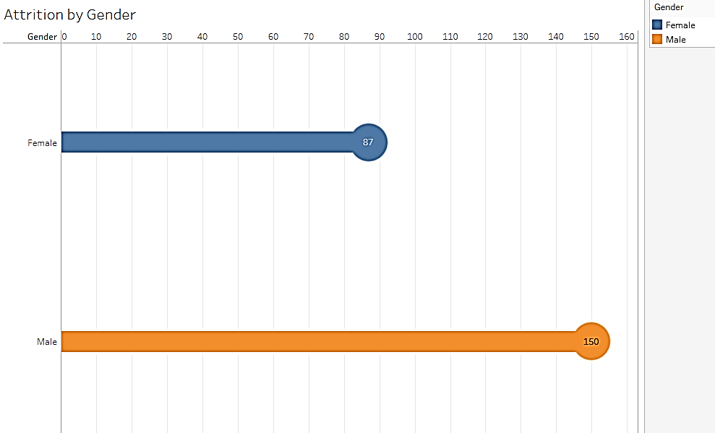
(5 Marks)
SECTION – B

Q3. Create a Story from the given data set, explaining the following
- Which Department has the highest Attrition.
- Number of Employees by Age Group.
- Donut chart – Attrition by Age wise and Gender
- Job Satisfaction by Rating.
(5 x 4 = 20 Marks)
____________________________________________________________________________

