**JAIPURIA INSTITUTE OF MANAGEMENT, INDORE**

**PGDM**

**THIRD TRIMESTER (Batch 2019-21)**

**END TERM EXAMINATION, APRIL-2020**

|  |  |  |  |
| --- | --- | --- | --- |
| Course Name | **Advanced Excel for Decision Making** | Course Code | **IT 302** |
| Max. Time | **2.5 hours** | Max. Marks | **40** |

**Instructions:**

1. Attempt all **three cases** and complete the steps in sequence to get the desired results.
2. Fill the answers in the **white space** provided along with each question in this answer sheet - Only value and description needs to be filled.

Values along with charts should be there on the excel sheet also.

1. Submit single **excel workbook** after proper naming to show your results along with this **word document**.

**________________________________________________________________________**

**Case 1:** You are owner of an office supply company. Dataset of sales for the year 2014 and 2015 is with you**.** You are required to do the following steps (as questions) to get insights form the given dataset. (***Max. 20 Marks***)

**Dataset is available as shown below.**

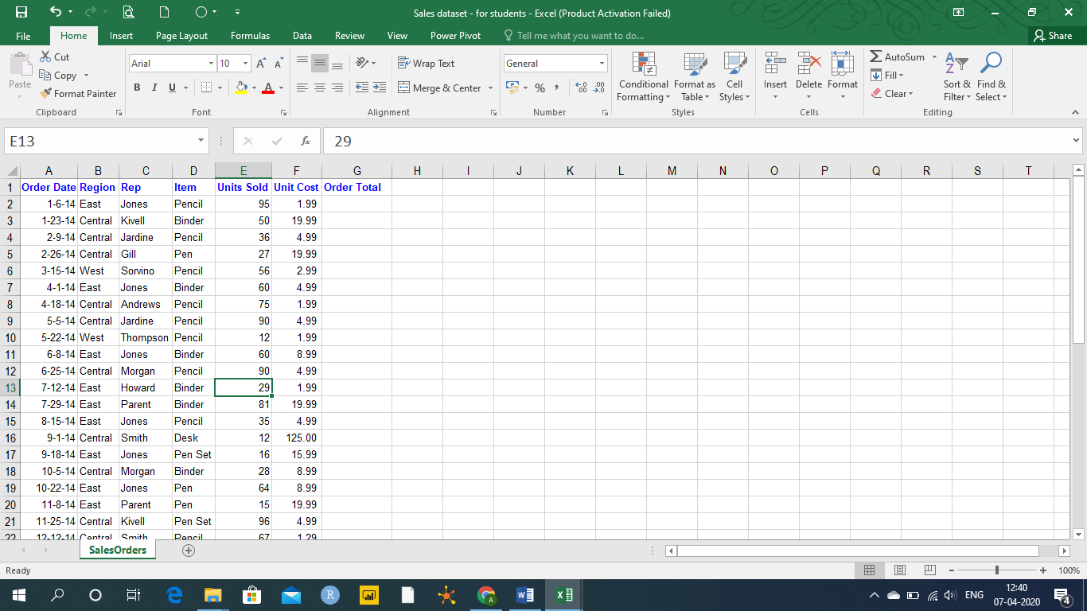

**Step 1:**

(a) Calculate Order Total (as dollars) for each order. Calculate the average order (in dollars) and fill it. (***Max. 2 Marks***)

(b) Identify the errors, if any and handle them appropriately. Mention the kind of error you observed in the given data set and how did you handle it? (***Max. 2 Marks***)

© Draw a frequency distribution chart for number of unit solds with a bin size of 10. (Bins may be like 0-9,10-19,11-29,…..). Which bin is having highest frequency. (Hint: Use histogram). (***Max. 3 Marks***)

(d) Which item is frequently sold in the given data? - Draw proper chart to show it.

Hint: Use **countif** function and then draw a chart. (***Max. 3 Marks***)

**Step 2:**

Answer the following queries using pivot table and appropriate visualization.

To do: Before moving ahead, use **insert table** feature to convert dataset as table for further usage in your pivot. (***Max***. ***1 Mark***)

1. Which item is doing well in terms of total revenue (in dollars) in central region. Add a pie chart for its contribution. Fill the answer here. (***Max. 3 Marks***)

Item ____________________________

Contribution in %age_______________

1. For Binders item, who is selling most numbers. Use conditional formatting (data bars) to show it. (***Max. 3 Marks***)

Name of Sales rep______________________

No of binders sold______________________

1. Which month (across 2014 and 2015) registers maximum sales (in terms of unit sold). Draw appropriate chart to highlight it. (***Max. 3 Marks***)

Month Name_______________________

Sales in units______________________

**________________________________________________________________________**

**Case 2**: Considering the data from a restaurant you own. You have your menu data stored in two excel worksheets.  (***Max. 10 Marks***)

* One sheet contains the **nutritional facts** (Enter no. of rows______________) and
* the other sheet says which **menu item** goes in which section of the menu. (Enter no. of rows______________)

***Step 1.***

You will notice that on the Menu sheet, the Item Name and the Item Code share a column, as shown below.

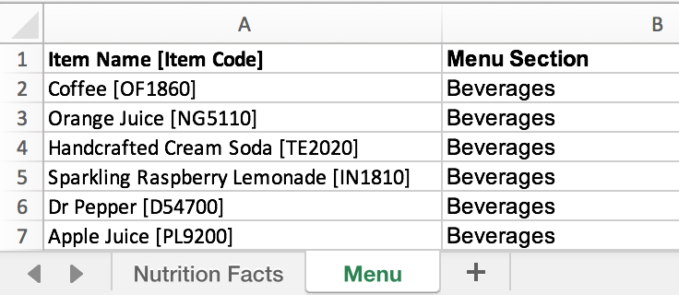

Use the tools to separate out the Name from the Code, as shown below.

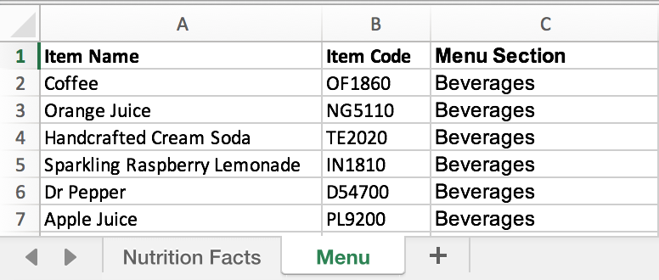

We realize that there is more than one way to achieve this- use any method and list the major steps used.

(Hint- Use Text-to-columns and additional functions **OR** use Text functions like LEFT, FIND, MID etc.). (***Max. 4 Marks***)

***Step 2.***

Now that you've separated the Item Names and the Item Codes out on the Menu sheet, note that the columns in the Menu sheet is in the order shown below (i.e. sorted by Menu Section)



It's time to bring the Item Names into the Nutrition Facts sheet, as shown below

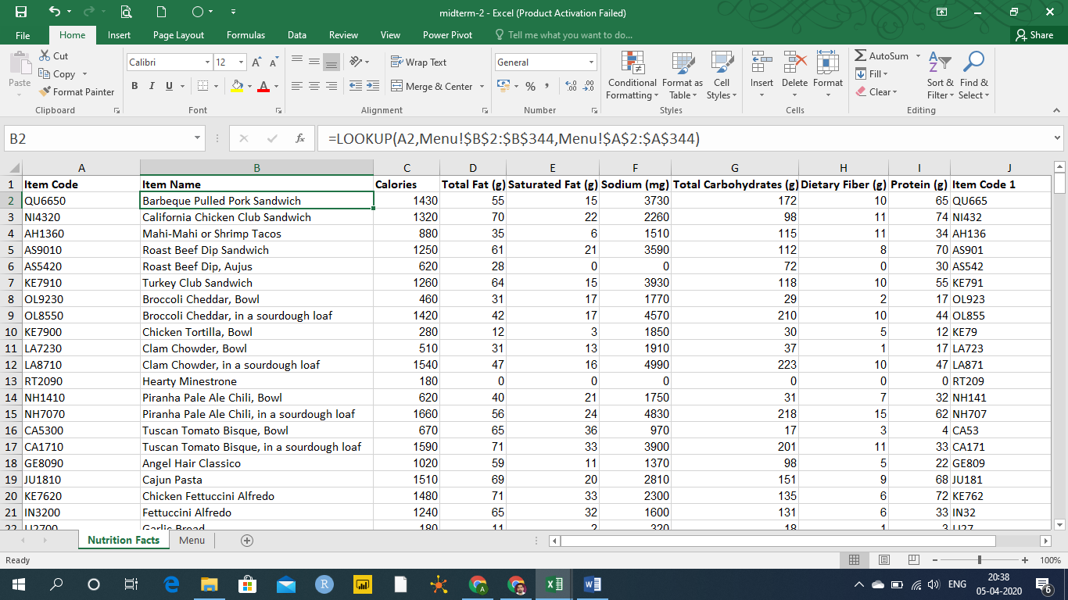

We realize that there is more than one way to achieve this- use any method and list the major steps used. (***Max. 4 Marks***)

(Hint- Use the suitable lookup function **OR** use INDEX, MATCH function.)

Step 3:

Create pivot tables to answer the following:

* 1. Using a pivot table on the Nutrition Facts sheet: There are several menu items with more than 70g of protein in them. Of these items, which has the **least** amount of Total Fat? (***Max. 2 Marks***)

**________________________________________________________________________**

**Case 3:** You are a HR manager in a company. You need to create a form to get the personal details of the candidates for recruitment. Create a form as shown below and apply various data validation rules. Mention all the rules description along with the cell in excel worksheet. (***Max. 10 Marks***)

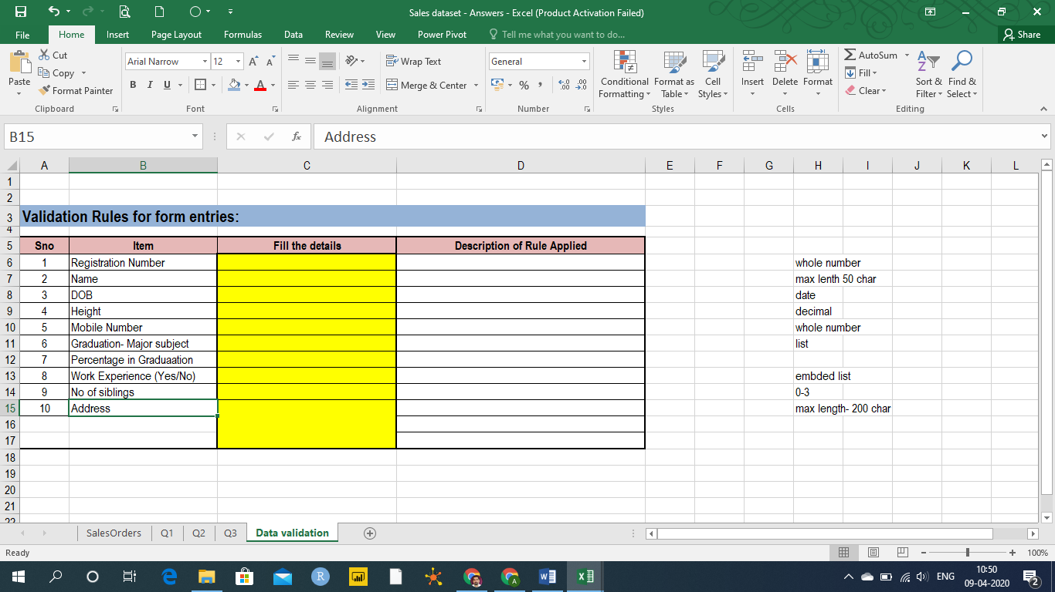

Use your own thinking to decide the rules. Such as

1. Range of values
2. Various entries- such as commerce, science, arts, management for entry 6
3. Data types
4. Sizes

**Note: For case 3, only excel worksheet should contain the complete answer. No need to mention here on this page.**

**________________________________________________________________________**