

**JAIPURIA INSTITUTE OF MANAGEMENT, INDORE**

**POST GRADUATE DIPLOMA IN MANAGEMENT**

**FOURTH TRIMESTER (Batch 2019-21)**

**END TERM EXAMINATIONS**

|  |  |  |  |
| --- | --- | --- | --- |
| Course Name | Consumer Behaviour (CB) | Course Code | MKT401 |
| Max. Time | 2 hours | Max. Marks | 40 |

Instructions: All the questions are compulsory

1. Go through the advertisement of the products given below. Apply the Gestalt’s principle to interpret each of these advertisements. Justify your interpretation by linking it to Gestalt’s Principle. **(3X2= 6 Marks)**
2. Discuss the marketing implications of Gestalt’s Principle. (**AVOID COPY PASTE FROM INTERNET**) **(3X2=6 marks)**
3. 

The above advertisements can be accessed by clicking on the below mentioned links:

* <https://in.pinterest.com/pin/234890936784743464/>
* <https://in.pinterest.com/pin/303007881159483425/>
* <https://pizzaindia.wordpress.com/tag/dominos-buy-one-get-one-offer/>

1. Mr. Malviya belongs to a middle class socio economic category and works in an automobile manufacturing factory at Manesar (Delhi NCR Region). His can just about meet the family requirements and education of his two kids. He has always curtailed his expenses to make some savings. Over last 15 years he has been able to save 10 lacs. He desires to purchase the latest Hyundai car i20 which would cost him 6.25 Lacs. He felt that buying the car would raise his self- esteem and would also be reflective of his social status. This was a long cherished dream to possess a brand new car. He discusses the same with his wife and friends. He gets mixed responses from his friends and his wife expressed her disagreement towards this luxury spending. She categorized it as mindless spending and instead advised him to invest money in some mutual funds or invest in some fixed assets like land or shop space which would appreciate in value over a period of time. Mr. Malviya kept pondering over the advice from his wife and friends and started evaluating the options of purchasing a car, land, shop space or investment in mutual funds. After a lot of analysis Mr. Malviya gave up his desire to purchase the car and started investing in mutual funds and also booked a shop space.

**Using Theory of Reasoned Action (TRA) model given below to analyse and interpret the buying behavior of Mr. Malviya (8 marks)**

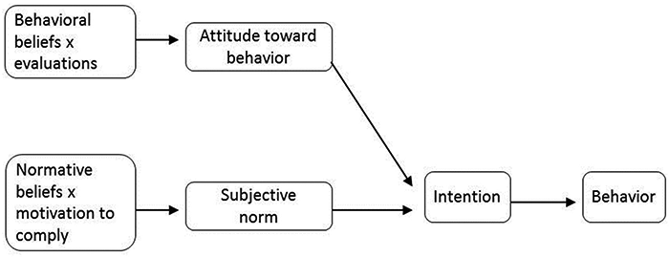

* 1. In India, fake products are a big menace as consumers love showing off the top world brands by purchasing counterfeit brands. Multinationals like Hindustan Lever, Nestle and Proctor & Gamble have initiated hundreds of court cases to contain this fraud. Pirated CDs of Hollywood and Bollywood films are also significant. **Apply the concept of consumer learning to identify the root cause of origin of “Me Too” brands. (6 marks)**
  2. In a discussion with your superior on the topic of increasing the marketing communication budget so that increased advertisements can lead to better brand association just like “Thanda Matlab Coca Cola”. Your superior is however not very convinced with the idea and is expressing that just for building brand association it is not wise to commit huge amount of funds. **Appraise your superior about the benefits increased advertisement will have for the organization and consumer purchase behavior.** **(6 marks)**
  3. Assume that you are working for Netflix. You need more and more people to start subscribing to Netflix. Illustrate your plan to find opinion leaders. **(Linkage of your plan with conceptual knowledge should not be ignored) (8 marks)**