

**JAIPURIA INSTITUTE OF MANAGEMENT, INDORE**

**POST GRADUATE DIPLOMA IN MANAGEMENT**

**FOURTH TRIMESTER (Batch 2019-21)**

**END TERM EXAMINATIONS**

|  |  |  |  |
| --- | --- | --- | --- |
| Course Name | Consumer Behaviour (CB) | Course Code | MKT401 |
| Max. Time | 2 hours | Max. Marks | 40 |

Instructions: All the questions are compulsory

1. Go through the advertisement of some products given below. The products as per the numbering are 1) Patanjali Chyawanprash 2) Dabur Chyawanprash 3) Listerine Mouthwash 4) Dabur Chyawanprash and 5) SBI

Apply the concepts of consumer behavior to interpret which customer category are each of these advertisements targeted at. Justify your interpretation for each of the print ad by linking it with theory. **(5X3=15 marks)**

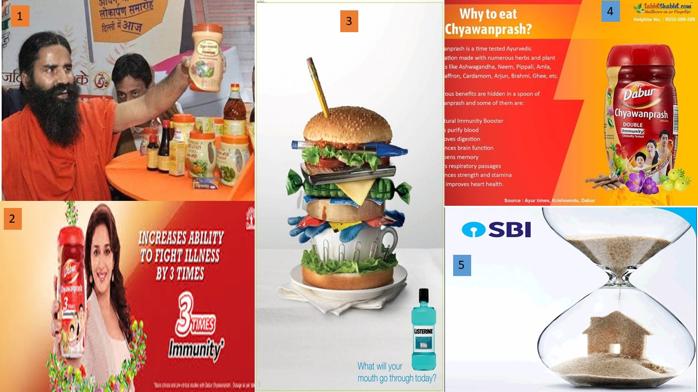

You can access the full advertisements by clinking on links for ads given below:

* <https://www.outlookindia.com/website/story/hc-restrains-patanjali-from-airing-ads-to-promote-chyawanprash/301432>
* <https://followthefact.wordpress.com/tag/dabur-chyawanprash/>
* <https://in.pinterest.com/pin/493847915363010760/>
* <https://in.pinterest.com/pin/607211962244978507/>
* <https://www.advertgallery.com/newspaper/sbi-home-loans-home-affairs-2018-ad-in-times-of-india-bangalore/>

1. 200 customers were interviewed during a survey to identify the important features/parameters they considered while selecting an organized retail outlet for purchase of apparels and accessories (10 points was for most important parameter while 1 was for least important parameter). Further the respondents were asked to rate the four retail outlets- Shoppers Stop, Pantaloons, Reliance Trends and Lifestyle on the 10 parameters. Following table depicts the parameters and the rating received for Shoppers Stop and Pantaloons for each parameter on a 10 point scale (where rating of 1 meant poor for the parameter while a rating of 10 meant excellent for that parameter) emerged as a result of this survey (parameters are listed as per their importance to the customer). The importance of each parameter is also listed in the table below.

|  |  |  |  |  |  |
| --- | --- | --- | --- | --- | --- |
| **Parameters** | **Importance** | **Shoppers Stop** | **Pantaloons** | **Reliance Trends** | **Lifestyle** |
| Air Conditioning | 5 | 6 | 5 | 4 | 8 |
| Store Layout | 6 | 8 | 7 | 4 | 8 |
| Sales Assistance | 9 | 9 | 5 | 5 | 6 |
| Variety | 10 | 9 | 6 | 4 | 7 |
| Billing Convenience | 3 | 8 | 8 | 5 | 8 |
| Sales Promotions | 8 | 3 | 4 | 8 | 5 |
| Loyalty Schemes | 2 | 4 | 6 | 7 | 5 |
| Online Availability | 1 | 6 | 8 | 5 | 4 |
| Store Atmospherics | 7 | 8 | 5 | 4 | 8 |
| Accessories | 4 | 4 | 7 | 5 | 6 |

1. Based on your calculation using Fishbein’s Multi-attribute Model, analyze which store is more preferred and which one is least preferred by the customers. Justify your interpretation. (**carry out relevant calculation in tabular form by inserting necessary columns for calculation**. **(1+3 marks)**
2. Suggest what caution should the above mentioned retail organizations observe while interpreting their scores **(3 marks)**
3. List areas for improvement for each of the retail store mentioned above

**(4X2=8 marks)**

* 1. Marketers usually highlight positive product improvements or reduced prices and not the negative product features such as change of ingredients, slight changes in logo, reduction of package size, increase of prices etc. **Analyze this marketing strategy and express your viewpoint on whether such an action by the marketers is justified by linking your explanation with consumer behavior concept studied. (5marks)**
  2. Assume that you have to purchase any fast moving consumer durable (FMCD). Since the money involved for the purchase would be close to 40,000/- to 45,000/- there are many thoughts coming in your mind and you want to reduce the risk involved in such purchase. **Appraise how you would try to minimize your risk in such a purchase situation. Justify** **(5marks)**