**Jaipuria Institute of Management Indore**

**Investment Management – End Term Examination**

**PGDM – Tern IV Batch 1921**

MM: 40

*All questions are compulsory

Q1 a). Interpret the following chart of SBI (6 Marks)

Chart- Indiabulls Housing Finance Ltd

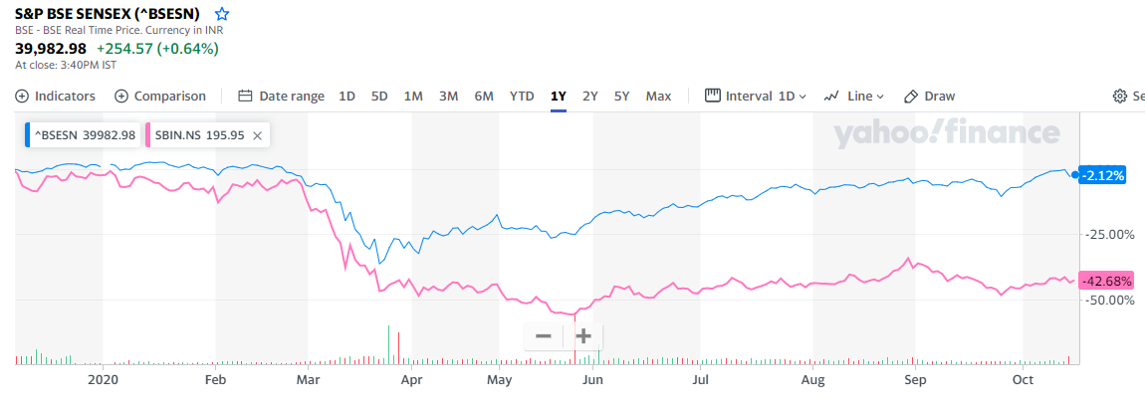

Chart- State Bank of India

Q1 b) Refer: Chart of IndiaBulls Housing Finance Ltd. How it can be used for investment decision. Is there any trading signal on this chart, Justify? (6 Marks)

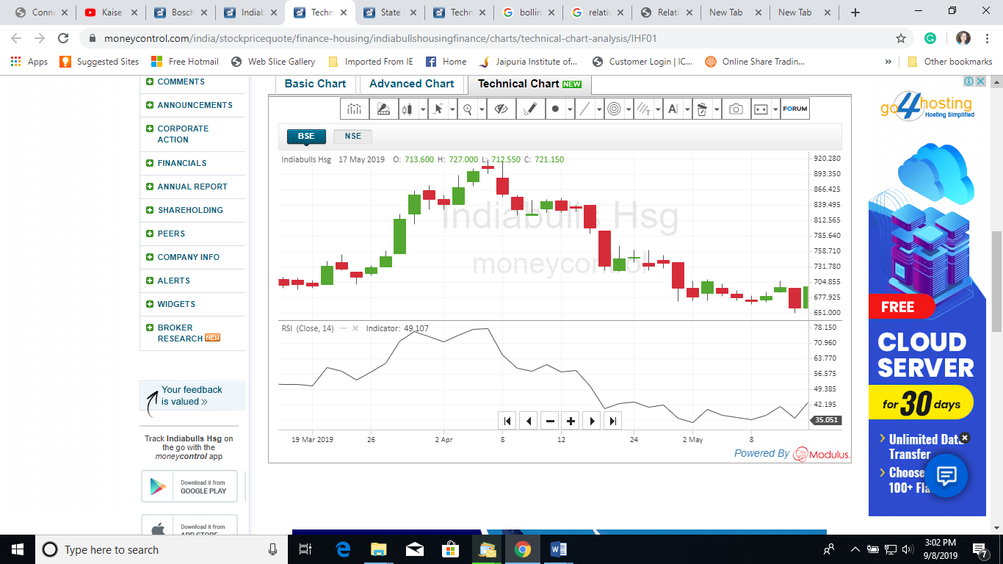

Chart- Indiabulls Housing Finance Ltd

Q2. Fill the blanks from the data in Excel Sheet and answer the following:

The growth in per share FCFE of ABC Company is expected to be -------- %/year for the next two years, followed by a growth rate of ---------%/year for three years; after this five year period, the growth in per share FCFE is expected to be --------%/year, indefinitely.

The required rate of return on ABC Company is --------%. Last year's per share FCFE was --------.

What should be the price at which the stock should sell for today? (12 Marks)

Q3. Fill the blanks from the data in Excel Sheet and answer the following:

The bond carrying the ………% coupon rate matures exactly in ……….. years and market interest rate is ……..%. Face value of a bond is Rs. 100. Calculate the following:

1. Duration (5 Marks)
2. Modified Duration and (5 Marks)
3. compute change in price if market rate changes to ………%(8Marks)