|  |  |
| --- | --- |
| **C:\Users\ADMIN\Desktop\j.png** | **JAIPURIA INSTITUTE OF MANAGEMENT, INDORE**  Post Graduate Diploma in Management (2024-26) |
| **Course Title: Python for Business Analytics (Course Code: 40822)**  **End-Term Examination, Term - III (April-May, 2025)** | |
| **Time Duration: 2 Hours Total Marks: 40** | |

***General Instructions*:**

1. *All the questions have to be answered in the Jupyter Notebook.*
2. *Please write the analysis in the markdown or as a comment in the Jupyter Notebook only.*
3. *Please download the file as a Jupyter Notebook file (.ipynb extension) and save it with your full name and the last four digits of your enrollment number.*
4. *Do not write on the question paper except your roll number.*
5. *Use the product_sales.csv files.*

**SECTION – A**

Q1. BigMart, a prominent retail chain, has been a cornerstone of the retail industry for decades. With a vast network of stores spread across various cities, BigMart prides itself on offering its customers a diverse range of products. However, as competition in the retail sector intensifies, BigMart is keen on leveraging data analytics to gain a competitive edge and optimize its operations.

**Introduction:** To achieve this goal, BigMart's data science team has meticulously collected and compiled comprehensive sales data for the year 2013. Each entry in the dataset contains various attributes, including product characteristics, store details, and sales figures.

**The Challenge:** BigMart's management recognizes the immense potential hidden within this wealth of data. However, they face the challenge of deciphering and extracting actionable insights from the dataset. The ultimate goal is to formulate a data-driven retail strategy that enhances customer satisfaction, boosts sales revenue, and optimizes operational efficiency.

Variables:

|  |  |
| --- | --- |
| **Variable name** | **Description** |
| Item_identifier | Product Id |
| Item_weight | Weight of product |
| Item_fat_content | Content of product (low fat or regular) |
| Item_visibility | The percentage of all products in the store that are assigned to a specific product in the total display area |
| Item_type | Category of product |
| Item_MRP | Maximum retail price of product |
| Outlet_identifier | Store Id |
| Outlet_establishment_year | Year the store was established |
| Outlet_size | Size of the store |
| Outllet_location | City the store is located |
| Outlet_type | Type of the store |
| Item_outlet_sales | Sales of product |

**Analyze the data and write the answers to the following questions:**

1. Anisha, the marketing analyst, is preparing to present a campaign proposal. After importing the dataset, how would you communicate its structure to guide campaign planning? Anisha is creating a sales performance dashboard. How would she identify and treat missing values or anomalies to ensure accurate insights? While reviewing ‘Outlet Sales’ and ‘Outlet Size’, how would you determine if extreme values need special handling? **(3 marks)**
2. To help prioritize marketing focus, how would Anisha classify variables as numeric or categorical? Based on performance, which product categories deserve more attention in upcoming promotions? **(3 marks)**
3. During a strategy session, Anisha needs to demonstrate how product-level attributes influence sales. How would Anisha assess the impact of visibility and weight on sales figures? What patterns might guide future product placement or design? **(4 marks)**
4. A logistics team is planning warehouse adjustments. Which product categories are likely to require special handling based on weight? Which store location demonstrates strong sales and could serve as a model for expansion? **(3 marks)**
5. The leadership team has requested further insights beyond basic sales metrics. What two additional data-driven findings would you bring to the table to support strategic decision-making? **(4 marks)**
6. To guide store size planning, how would Anisha visualize and explain variations in sales performance across store sizes? **(3 marks)**
7. The marketing team is personalizing campaigns based on store age. How would Anisha categorize stores using their year of establishment to support targeted strategies? Merchandising teams want to align product offerings to store formats. How would Anisha summarize the relationship between product types, store sizes, and store locations?

**(4 marks)**

1. Leadership is reviewing the performance of older outlets. How would Anisha evaluate whether store age influences sales? Are there performance differences based on the type of store? Inventory planners are optimizing the product range. How would Anisha identify all unique product categories in the dataset to ensure comprehensive catalogue planning?

**(4 marks)**

**Q2 (a)** Is age is having relation with the total_sales done by any organization. Comment based on below mentioned heatmap. **(6 marks)**

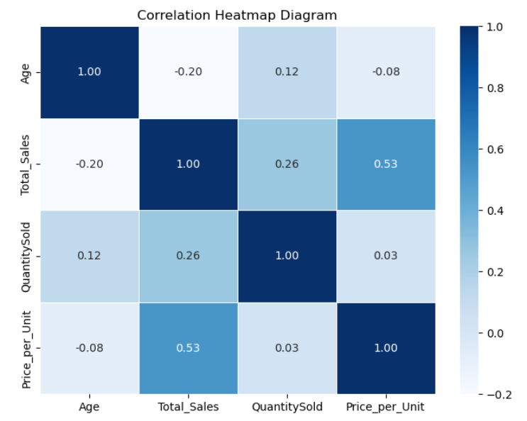

**Q2 (b)** Based on the below-mentioned box-plot chart, which gender should the organization target to get the benefits? Justify **(6 marks)**

