|  |  |
| --- | --- |
| **C:\Users\ADMIN\Desktop\j.png** | **JAIPURIA INSTITUE OF MANAGEMENT, INDORE**  Post Graduate Diploma in Management (Batch 2024-26) |
| **Course Title: Business Research Methods (Course Code: 40503)**  **End Term Examination, Term - III (April-May, 2025)** | |
| **Time Duration: 2 Hours Total Marks: 40** | |

***General Instructions*:**

1. *Answer the questions as directed. The break-up of the marks is given wherever necessary.*
2. *Marks against each question are indicated to its right.*
3. *Answer all the questions of a 'Section/Question' in one place in continuation.*
4. *Answers should be brief and to the point.*
5. *Do not write on the question paper except your roll number.*

**Q1 Case: The Analyst’s Dilemma**

Rohan Mehta leaned back in his chair; his eyes fixed on the market report glowing on his laptop screen. As a senior research analyst at Zenith Insights, his job was to provide actionable strategies to clients in the retail sector. Today, his focus was the **Indian kids' footwear market**—a rapidly growing industry, but one riddled with challenges. The latest data was clear: the market was projected to grow at a **CAGR of 8.54%**, reaching **USD 2.61 billion by 2030**. On the surface, it seemed like a promising space for brands to expand, but a deeper dive into the numbers revealed a harsh reality—**85% of the market was controlled by unorganized players**.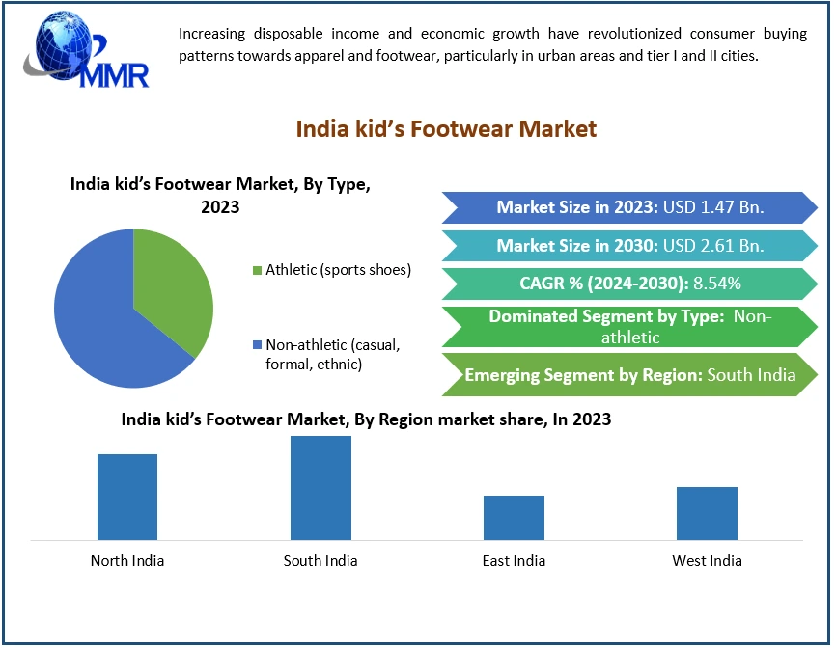

***Answer the following:***

1.A. Identify and state the underlined research problem. **(2 Marks)**

1.B. What should the research objectives of the analyst be? **(2 Marks)**

1.C. Explain the research procedure which will be used in this research problem  **(6 Marks)**

**Q2** Arjun Khanna looked at the market report. The commercial two-wheeler EV market in India was growing fast, and many delivery companies were interested. But things were not moving as quickly as expected.

His phone buzzed. A message from a client, an EV manufacturer:

*"Arjun, fleet owners are unsure. Need your insights before our meeting tomorrow."*

He sighed, thinking about the trends. The market was full of potential, but something was slowing things down.

Tomorrow’s meeting would be important. The right plan could make all the difference.

***Design and formulate research for investigating the problem (Any two frameworks), explain using factors from real world scenario* (10 Marks)**

* 1. Qualitative Research Design
  2. Quantitative Research Design
  3. Causal Research Design
  4. Experimental Research Design

**Q3.** **Case:** A market research firm has been hired by a retail chain to study customer satisfaction across its 50 stores in India. The firm needs to design a sampling plan to collect accurate and representative data without surveying every customer.

**Question:  
As a researcher, explain:**  
a) What sampling technique (probability or non-probability) you would recommend and why.

**(5 marks)**  
b) How you would determine the sample size and ensure it represents the population well.

**(5 marks)**

**Q4.** **Title: The Analyst’s Equation**

Aarav, a performance analyst at **EliteTech Solutions**, had a challenge—predicting **Job Performance Ratings** for the sales team. His boss, Mr. Kapoor, wanted insights before the annual review.

**Aarav gathered the key variables:**

* **Average Sales (S)** – Higher sales meant better numbers, but was it enough?
* **Average Margin (M)** – Some sales reps closed big deals, but were they profitable?
* **Training Expense (T)** – The company invested in skill-building, but did it pay off?
* **Years of Experience (Y)** – Were seasoned employees really outperforming fresh hires?
* **Contact Hours (C)** – More client interaction often led to success, but was it a game-changer?

He fed the data into his model, watching as patterns emerged. Some high sales performers had **low margins**, while others with more training seemed to have **higher ratings** despite fewer years of experience.

Mr. Kapoor walked in. "So, what’s the key to top performance?"

|  |  |  |  |
| --- | --- | --- | --- |
| **Descriptive Statistics** | | | |
|  | **Mean** | **Std. Deviation** | **N** |
| Job Performance Rating | 81.2347 | 2.88174 | 40 |
| Average Sales | 16183.2784 | 1998.47578 | 40 |
| Average Margin | 475.5246 | 77.54254 | 40 |
| Training Expense | -507.3194 | 103.34601 | 40 |
| Years Experience | 22.4496 | 8.63176 | 40 |
| Contact Hours | 492.6806 | 103.34601 | 40 |

|  |  |  |  |  |  |  |  |  |
| --- | --- | --- | --- | --- | --- | --- | --- | --- |
| **ANOVAa** | | | | | | |  |  |
| **Model** | | **Sum of Squares** | **df** | **Mean Square** | **F** | **Sig.** | **R Square** | **Adjusted R Square** |
| 1 | Regression | 58.501 | 4 | 14.625 | 1.929 | .127b | .181 | .087 |
| Residual | 265.372 | 35 | 7.582 |  |  |  |  |
| Total | 323.872 | 39 |  |  |  |  |  |
| a. Dependent Variable: Job Performance Rating | | | | | | |  |  |
| b. Predictors: (Constant), Contact Hours, Years Experience, Average Margin, Average Sales | | | | | | |  |  |

|  |  |  |  |  |  |  |
| --- | --- | --- | --- | --- | --- | --- |
| **Coefficients** | | | | | | |
| **Model** | |  | |  | **t** | **Sig.** |
| **B** | **Std. Error** | **Beta** |
| 1 | (Constant) | 59.811 | 9.393 |  | 6.368 | .000 |
| Average Sales | .001 | .000 | .688 | 2.399 | .022 |
| Average Margin | .000 | .009 | -.007 | -.031 | .976 |
| Years Experience | -.024 | .052 | -.072 | -.465 | .645 |
| Contact Hours | .012 | .007 | .439 | 1.637 | .111 |
| a. Dependent Variable: Job Performance Rating | | | | | | |

a) Based on the coefficient values (β), what can be inferred **(2 Marks)**

b) Based on ANOVA formulate the hypothesis and explain the output **(2 Marks)**

c) Analyze the t-statistics provided in the output table. What do these values indicate about the significance of each factor? **(2 Marks)**

d) Discuss the R-square and adjusted R-Square **(2 Marks)**

e) Based on the decisions provided in the output table, Summarize the overall findings of the regression analysis and their implications **(2 Marks)**