**JAIPURIA INSTITUTE OF MANAGEMENT, INDORE**

**PGDM**

**FIFTH TRIMESTER (Batch 2019-21)**

**END TERM IMPROVEMENT EXAMINATION, FEB-2021**

|  |  |  |  |
| --- | --- | --- | --- |
| Course Name | **Web Analytics and Social Media** | Course Code | **IT503** |
| Max. Time | **2 hours** | Max. Marks | **40** |

**INSTRUCTIONS:**

All questions are compulsory.

**Questions.1:** The sentiment analysis of Nike and Puma is given below, how this sentiment score can be used by any new entrant in the market dealing with sports shoes. **(10 Marks)**

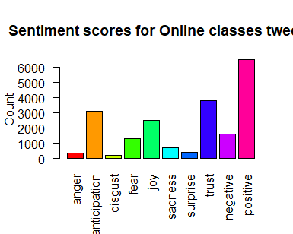

**Sentiment scores of Nike**

**Figure1: Sentiment score of Nike**

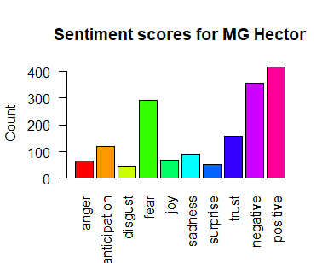

**Sentiment scores of Puma**

**Figure2: Sentiment score of Puma**

**Questions.2 (a):** A brand that has helped us deliver delight to our soldiers at the border. Read about our many amazing sellers on [#AmazonStoryboxes](https://twitter.com/hashtag/AmazonStoryboxes?src=hash) and upload photos of them for a chance to win big! [#IAmAmazon](https://twitter.com/hashtag/IAmAmazon?src=hash).

Why Amazon have this sort of post, how this post can help Amazon? **(5 Marks)**

**Questions.2 (b):** Instagram analytics plays an important role in e-commerce for retrieving the useful information of a product or service. Customer Analysis has become the key function of social media analytics. How the customer analytics on social media is utilizes in order to improve business decision making? **(5 Marks)**

**Questions.3 (a).** The I&B ministry has now decided to set up a social media communication hub and deploy executives to monitor online content across each of India’s 716 districts. The monitoring mechanism, once in place, will be able to read, contextualise and respond to content in most Indian and foreign languages across India, and will get a “360degree view of the customers by integrating customer relationship management data with social profiles. The platform will personalize the responses on the basis of customer loyalty and past behaviors and also help industry to find out the influencers basis attributes like follower count.Explain the concept of influencers, followers count and how this platform would help Government. **(5 Marks)**

**Questions.3 (b).** Ananta Hospital is a new hospital started in Udaipur (Raj). The hospital needs to promote themselves on various social media platforms like LinkedIn, Facebook and Instagram. They want to measure, analyze and understand metrics on their social networks to provide them meaningful insights. Explain different social metrics, which they will get, and how they would utilize these insights in generating awareness among their target customers. **(10 Marks)**

**Questions.4.** If a website owner has given you the detailed report of google analytics, how would you help him to plan for higher ROI as well as higher uses views on the website? Comment**.**

**(5 Marks)**