**JAIPURIA INSTITUTE OF MANAGEMENT, INDORE**

**PGDM**

**FIFTH TRIMESTER (Batch 2019-21)**

**END TERM EXAMINATION, JAN-2021**

**IMPROVEMENT**

|  |  |  |  |
| --- | --- | --- | --- |
| Course Name | **Web Analytics and Social Media** | Course Code | **IT503** |
| Max. Time | **2 hours** | Max. Marks | **40** |

**INSTRUCTIONS:**

All questions are compulsory.

**Questions.1:** The sentiment analysis of Nike and Puma is given below, how this sentiment score can be used by any new entrant in the market dealing with sports shoes. **(10 Marks)**

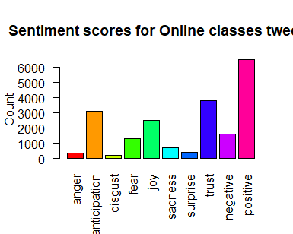

**Sentiment scores of Nike**

**Figure1: Sentiment score of Nike**

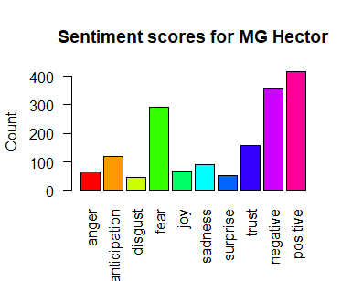

**Sentiment scores of Puma**

**Figure2: Sentiment score of Puma**

**Questions.2(a):** A brand that has helped us deliver delight to our soldiers at the border. Read about our many amazing sellers on [#AmazonStoryboxes](https://twitter.com/hashtag/AmazonStoryboxes?src=hash) and upload photos of them for a chance to win big! [#IAmAmazon](https://twitter.com/hashtag/IAmAmazon?src=hash).

Why Amazon have this sort of post, how this post can help Amazon? (5 Marks)

**Questions.2(b):** Instagram analytics plays an important role in e-commerce for retrieving the useful information of a product or service. Customer Analysis has become the key function of social media analytics. How the customer analytics on social media is utilizes in order to improve business decision making? (**5 marks)**

**Questions.3(a).** The I&B ministry has now decided to set up a social media communication hub and deploy executives to monitor online content across each of India’s 716 districts. The monitoring mechanism, once in place, will be able to read, contextualise and respond to content in most Indian and foreign languages across India, and will get a “360degree view of the customers by integrating customer relationship management data with social profiles. The platform will personalize the responses on the basis of customer loyalty and past behaviors and also help industry to find out the influencers basis attributes like follower count.Explain the concept of influencers, followers count and how this platform would help Government. **(5 Marks)**

**Questions.3(b).** Ananta Hospital is a new hospital started in Udaipur (Raj). The hospital needs to promote themselves on various social media platforms like LinkedIn, Facebook and Instagram. They want to measure, analyze and understand metrics on their social networks to provide them meaningful insights. Explain different social metrics, which they will get, and how they would utilize these insights in generating awareness among their target customers. (**10 marks).**

**Questions.4.** If a website owner has given you the detailed report of google analytics, how would you help him to plan for higher ROI as well as higher uses views on the website? Comment**. (5 marks)**

**Suggested Answers:**

Q1. The new entrant has to understand the sentiment of existing players so that they can plan their promotional strategy. We have to consider the various sentiments which contributes to positive and negative sentiments of the existing brands.

Q2(a): These post is come under social posts; this will create very positive attitude towards the brand. Needs to explain some branding opportunities by utilizing this cause.

Q2(b): If we are able to know the sentiment of our customers on the social media platform, we can able to know about our target customers and this way we can plan our promotion with respect to the target customers.

Q3(a): Influencers in social media are people who have built a reputation for their knowledge and expertise on a specific topic. They make regular posts about that topic on their preferred social media channels and generate large followings of enthusiastic, engaged people who all are interested them to read their views.

Follower count: Having lots of followers means the opportunity to interact with more people and gather feedback on the account and the posts. This creates more opportunities than ever before. Followers count in Twitter is the total number of people following an individual on Twitter.

By getting this information Government can identify some common people not always the celebrities which can be used to endorse various government missions. As social media is part and parcel of our lives, so these influencers can be utilized to motivate normal public.

Q3(b): Various social media metrics are:

Hits

User sessions

Page Tracking

Page Tagging

Session Time out

Bounce Rate

Needs to explain above mentioned social metrics in terms of Ananta hospitals.

Q4: By analyzing various google analytics reports we can find out detailed information about target customers like geographical location, gender, age, which device they are using, from which links they are visiting our website, by getting the analysis done on these parameters we can find out the best possible customers and we can plan to convert them as well.