**JAIPURIA INSTITUTE OF MANAGEMENT, INDORE**

**PGDM**

**FIFTH TRIMESTER (Batch 2019-21)**

**END TERM EXAMINATION, JAN-2021**

|  |  |  |  |
| --- | --- | --- | --- |
| Course Name | **Web Analytics and Social Media** | Course Code | **IT503** |
| Max. Time | **2 hours** | Max. Marks | **40** |

**INSTRUCTIONS:**

All questions are compulsory.

**Questions.1:** The sentiment analysis of MG Hector and Honda City car is given below, comment on the sentiment score. **(10 Marks)**

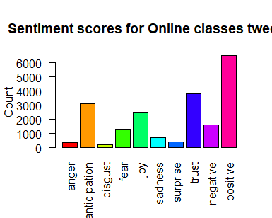

**Sentiment scores of Honda**

**Figure1: Sentiment score of Honda**

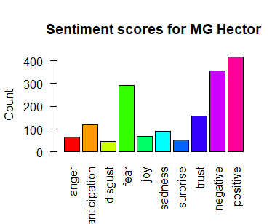

**Figure2: Sentiment score of MG Hector**

**Questions.2:** As per the given Excel sheet(data_ecomm), please find below mentioned data**.**

**(10 Marks)**

1. Which country is highest and lowest in terms of monetary spending, please mention the amount of spending as well.
2. Is there is any relation between recency rank and amount (monetary spending). Comment
3. Explain the customer segment in different countries.
4. Customers in Italy are more frequent buyers as compare to United Kingdom. Is this statement being True or False.
5. The customer total life time spending is any relation with residing country.

**Questions.3(a):** HDFC Bank uses purchase history, social media analytics to offer credit cards to customers, how this procedure would reduce the credit card defaulters in future. **(5 Marks)**

**Questions.3(b):** ABC consultancy is deals with SAT preparation, please explain which social media platform they will use to promote their organization, justify your answer by taking certain assumptions. **(5 marks)**

**Questions.4(a).** The I&B ministry has now decided to set up a social media communication hub and deploy executives to monitor online content across each of India’s 716 districts. The monitoring mechanism, once in place, will be able to read, contextualise and respond to content in most Indian and foreign languages across India, and will get a “360degree view of the customers by integrating customer relationship management data with social profiles. The platform will personalize the responses on the basis of customer loyalty and past behaviors and also help industry to find out the influencers basis attributes like follower count.Explain the concept of influencers, followers count and how this platform would help Government. **(5 Marks)**

**Questions.4(b).** When we looked at LinkedIn data, we found that in the last five years in entire globe, there has been an increase in HR professionals who list analytics skills and keywords on their profiles. In tech-software, there are over nine employees leveraging analytics in HR on average compared to six at the average finance company. HR data analytics can help answer many of the critical concerns CHROs must deal including workforce diversity, geolocation decisions, hiring strategy, competitive benchmarking, workforce planning, and employer branding. Comment. (**5 marks)**

**Suggested Answers:**

Q1. In this question you have to explain the reason for positive and negative sentiments related to MG Hector and Honda City, the new entrant and already established brand. We have to consider the various sentiments which contributes to positive and negative sentiments**.**

Q2. All the questions would be solved by excel formulae or Pivot Table.

Q3(a): By getting some insights from social media and past transactions through PayZapp app Using analytics and artificial intelligence helps in building better profile of individuals and it can act as a replacement in the absence of hardcore credit. They can identify the social media image from his spending.

Q3(b): SAT is the exam given by Class XII students to take admission in US universities for doing their graduation, as our target group is in the age group of 16-17 so Instagram is one of the prominent social media platform which can be utilized for the same.

As parents are also very important stakeholder, so we can have the promotion on LinkedIn as well.

Q4(a): Influencers in social media are people who have built a reputation for their knowledge and expertise on a specific topic. They make regular posts about that topic on their preferred social media channels and generate large followings of enthusiastic, engaged people who all are interested them to read their views.

Follower count: Having lots of followers means the opportunity to interact with more people and gather feedback on the account and the posts. This creates more opportunities than ever before. Followers count in Twitter is the total number of people following an individual on Twitter.

By getting this information Government can identify some common people not always the celebrities which can be used to endorse various government missions. As social media is part and parcel of our lives, so these influencers can be utilized to motivate normal public.

Q4(b): Decisions based on numbers are always more strong as compare to instinct based decisions. Lot many decisions are taken by HR which is based on past data like performance appraisal, talent acquisition, recruitment based on various geographical locations. At many times we have to plan recruitment but how many to recruit from where to recruit is always difficult to decide. We can use data of people retiring, people resigning, new operation unit or new branch opened, new product launched, all these data would give some fair idea about number of recruitment as well as location of recruitment.