**JAIPURIA INSTITUTE OF MANAGEMENT, INDORE**

**PGDM**

**FIFTH TRIMESTER (Batch 2019-21)**

**MID TERM EXAMINATION, DECEMBER-2020**

|  |  |  |  |
| --- | --- | --- | --- |
| Course Name | **Data Visualization** | Course Code | **IT 501** |
| Max. Time | **1 hour** | Max. Marks | **20** |

**INSTRUCTIONS:**

1. It is Moodle based exam to be conducted as per the schedule.
2. Attempt all questions.(Part A,B and C)
3. Write the answer in the space provided on Moodle. Be brief and adhere to the word limits

**Part A (Max. Marks 8)**

1. **Use the principles of Data visualization to do the critical analysis of the data visuals in the given case: (word Limit -200 words)**

Note: Critical analysis may include:

(a)***Context***

***(b)    Visual used***

***(c)    Clutter***

***(d)    Gestalts principles***

***(e)    Pre-attentive attributes etc.***

Case: World Energy Demand

Source: Economist

According to the World Energy Outlook (published by the International Energy Agency) global energy demand rise by a third by 2035. While rich countries will not see much demand increases, annual growth rates of 2-3% are expected in South-East Asia, India, Brazil and the Middle East. China will account for 40% of the growth until 2025. After then India will overtake it to become the single biggest source of increasing demand. Oil will remain the largest single source of energy, though total energy consumption will decline from 31% to 27% by 2035. Coal’s share will fall, natural gas will outstrip both oil and coal combined.

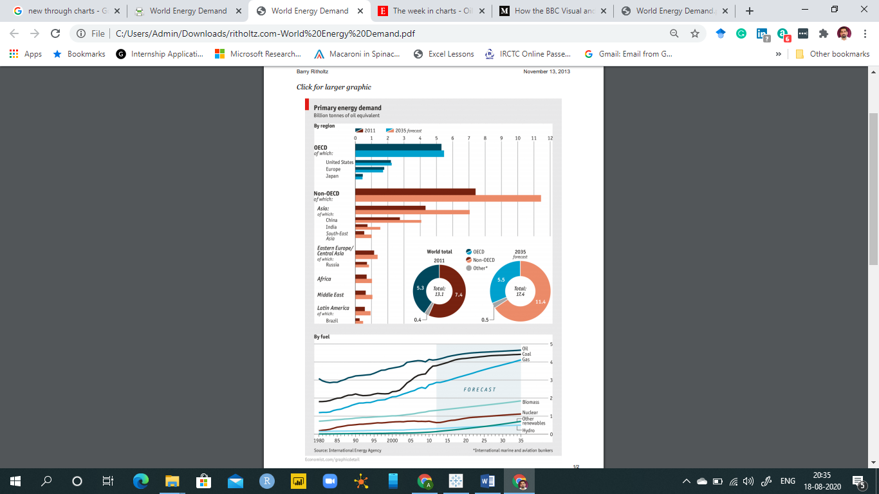

**Part B (Max. Marks 8)**

**Note: Attempt any two (Max marks: 2 X 4 marks each =8 Marks).**

1. **What is wrong or misleading with the following graphs. Suggest the corrections also. (Word limit: 50 word each)**

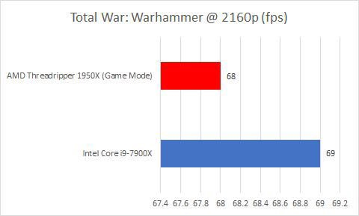

**(b)**

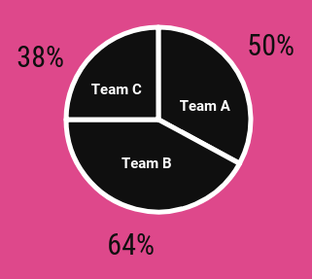

©

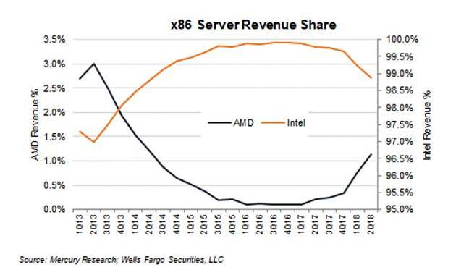

**(d)**

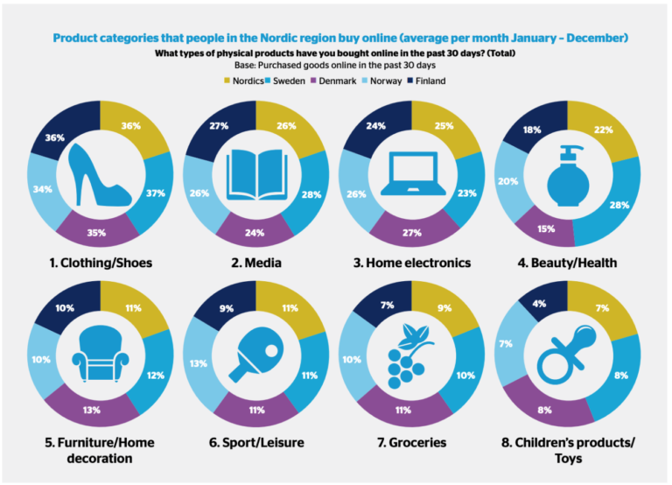

**(e)**

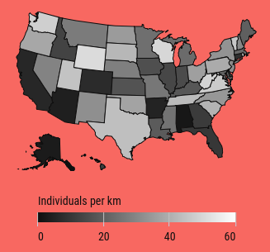

**Part C (Max. Marks 4)**

1. **You are participating in a placement process in your institute. The recruiter asks you to tell about the learnings of your summer internship project.**

Write a **3-minute story** in the form of a write up (within 100 words) about the answer you are going to tell.