 | JAIPURIA INSTITUE OF MANAGEMENT, INDORE  Post Graduate Diploma in Management (Batch 2024-26)
Course Title: Machine Learning, (Course Code: 40827)
End-Term Examination, Term - IV (October 2025)
Time Duration: 2 Hours Total Marks: 40

General Instructions:
- Answer the questions as directed. The break-up of the marks is given wherever necessary.
- Marks against each question is indicated to its right.
- Answer all the questions of a ‘Section/Question’ at one place in continuation.
- Answers should be brief and to the point.
- Do not write on the question paper except your roll number.
- Save all codes and outputs in a jupyter notebook and name the file as RollNo_FullName. Save two files, one in ipynb format and another in your main copy (MS Word File) with screenshots of codes and outputs and submit both.
- Number your answers carefully in jupyter notebook as per the question as well in the answer sheet.
- Coding part for Questions 1, 2, 3 and 4 must be answered in jupyter notebook and any inferences from these questions must be answered in your MS Word answer sheet. Remaining questions also must be answered in MS Word answer sheet.
- This is an open-code exam. Generalized codes are provided in a randomized format.
- Name your word file as RollNO_FullName.

SECTION – A

- You are provided with a dataset sales_data.csv containing monthly sales of a retail business.
The dataset includes the following variables:
  - Sales (in lakhs)
  - Advertising_Spend (in lakhs)
  - Discount (in %)
  - Competitor_Price (in ₹)
  - Footfall (in thousands)

- Build an appropriate machine learning model using python with Sales as the dependent variable and all the other variables as independent variables. Print the model summary. (3 Marks)
Note: Do not split the data to train and test set. Consider the entire dataset for training. EDA is NOT required. Normalization, missing value treatment etc. should NOT be done. The task is only to build the prediction model.

- Using your model, predict the Sales when Advertising_Spend = 14.0 lakhs, Discount = 10%, Competitor_Price = 104, and Footfall = 15.0 (in thousands) and report the prediction. (1 mark)

- You are tasked with analyzing “Salary” column in dataset1.csv. When you plot the distribution, you notice several points far away from the majority of the data. You need to remove the extreme data points and store the cleaned data in a new data frame “Cleaned_Data” and print the number of rows of the dataframe “Cleaned_Data”.
(2 marks)

- Explore whether Department affects Promotion in dataset2.csv. (2 marks)

- You have multiple variables (Var1–Var8) and a target variable (Target) in dataset3.csv. Decide which variables to include in a predictive model to predict “Target”. (2 marks)

- What does the following figure indicate about the machine learning model? (1 Mark)
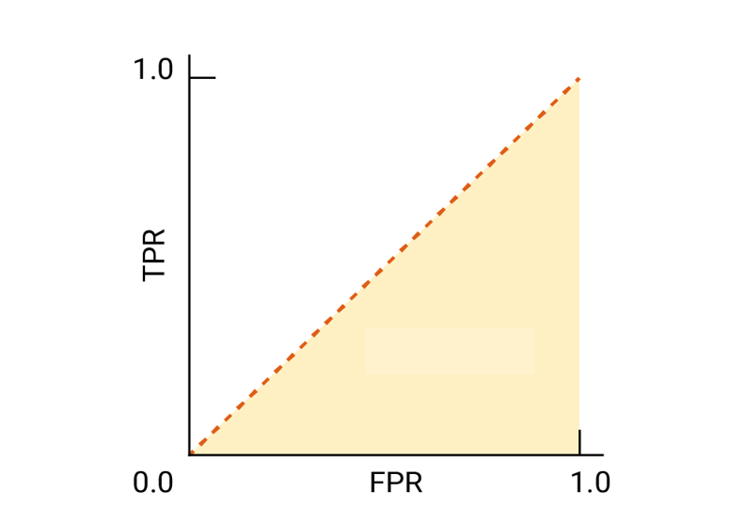

- A retail dataset has the target variable Sales_Category (classified as High or Low).
The entropy of the target variable is found to be 0.998.
After checking two possible splits, the following entropies were calculated:
Entropy after splitting on Discount = 0.762
Entropy after splitting on Footfall = 0.891
Decide which attribute should be chosen for the split (2 marks)

- Which threshold amongst A, B, C would you choose for maximizing precision and why? (1Mark)
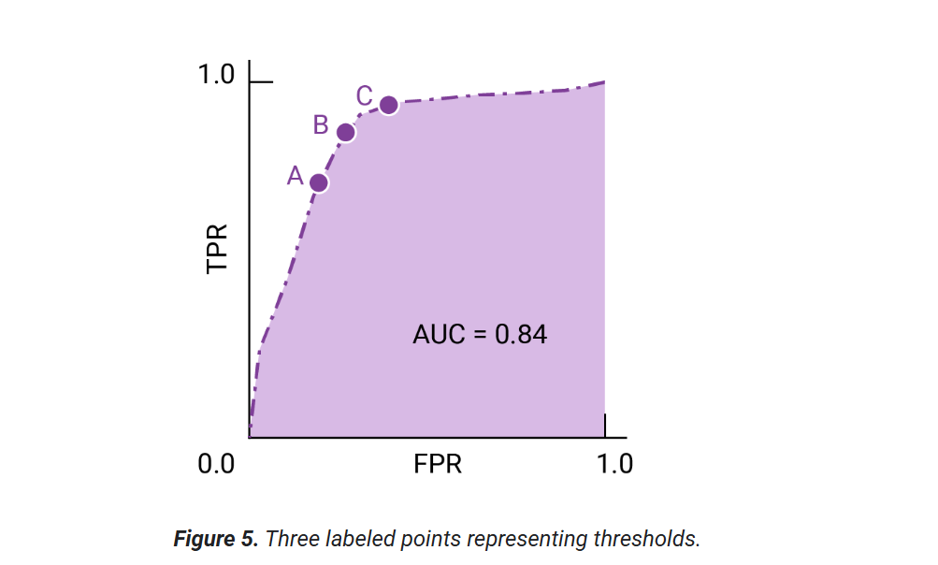

- A sample training data snippet (dataset: employee.csv) is shown below:
Age | Years_Experience | Department | Education_Level | Salary
25 | 2 | Sales | Bachelor | 32000
30 | 5 | HR | Master | 45000
40 | 12 | IT | PhD | 70000
35 | 8 | Sales | Bachelor | 56000
50 | 20 | IT | Master | 90000

The analyst took the following steps only after collecting this training data to predict salary using all other variables as independent variables:
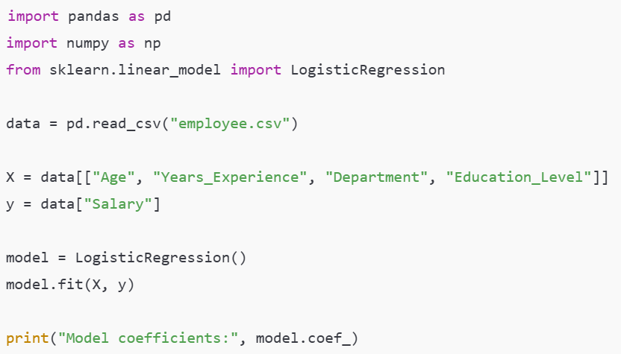

Identify two major conceptual mistakes made by the analyst (1 mark)

SECTION – B

- A hospital uses patient data (age, blood pressure, cholesterol levels, genetic history, genetic markers) to predict whether a patient is at risk of heart disease using a kNN model.
Variables & Their Ranges
- Age: 20 – 80 years
- Blood Pressure (Systolic): 90 – 200 mmHg
- Cholesterol Level: 100 – 400 mg/dL
- Genetic Markers (e.g., number of high-risk alleles): 0 – 10

    - If one patient has extremely rare but severe symptoms, would a small k or large k help classify correctly? Why? (2 marks)

    - If most patients in the dataset are healthy, how does class imbalance affect predictions when k is large? (2 marks)

    - How would feature scaling (normalizing cholesterol vs. genetic markers) change the nearest neighbor’s distances? (1 marks)

- A retail bank wants to decide whether to approve personal loans for new applicants.
They have collected the following data about past applicants:
- Age (numeric)
- Income (numeric)
- Credit Score (numeric)
- Owns a House (Yes/No)
- Number of Existing Loans (numeric)
- Loan Approved (Yes/No)
Now, the bank wants a model that is easy for loan officers to interpret, where the decision process can be explained step-by-step to a customer (e.g., “Your loan was rejected because your income is below ₹30,000 and your credit score is under 600”). Which machine learning approach would you recommend, and why? Explain with details. (2.5 marks)

- A Naïve Bayes model is trained to diagnose whether a patient has Pneumonia (Yes/No) using the following features:

    - Fever (Yes/No)
    - Cough (Yes/No)
    - Chest Pain (Yes/No)
    - Shortness of Breath (Yes/No)
    - X-ray Abnormality (Yes/No)
The model predicts:
Patient A → Probability of Pneumonia = 0.80
Patient B → Probability of Pneumonia = 0.40
In reality, both patients have Pneumonia.

Explain why Naïve Bayes might underperform in this situation. Propose an alternative model that could perform better for this dataset, justifying your choice (2.5 marks)

- Answer the following using the results from the model summary of model built on sales data in question 1 of section A:
  - What is the impact of unit changes in Advertising_Spend on Sales and explain whether it is statistically significant at the 5% level. (1 marks)
  - What is the mean sales given other variables are zero? (1 marks)
  - How well the model explains sales variation. (1 marks)
  - “Discount has no significant impact on Sales”. Conclude if the statement is valid
(1 mark)
  - Based on the results, identify which predictor has the strongest impact on sales, which predictors appear insignificant, and whether the company should focus more on increasing advertising or offering discounts to boost sales or be concerned on competitor prices. Justify your answer using the output. (2 marks)

- Your hotel chain is experiencing:
- Low occupancy rates during weekdays (50% compared to 80% on weekends)
- High churn rate of loyalty program members (only 40% renew their membership after one year)
You have access to:
- Guest demographics (age, location, purpose of visit)
- Historical booking data (day of week, booking channel, lead time)
- Loyalty program data (membership tier, spend, points redeemed)
- Guest feedback ratings
Using the 5-step conceptual framework for applying ML to business problems, develop a solution approach. Your answer should include:
- Business Problem Definition – State what you want to predict or classify.
- Data Needed & Features – Identify at least 5 key data variables you would use.
- ML Techniques and Model Selection – Explain which ML technique(s) and model you would apply and why.
- Actionable Strategy – Describe the business actions or interventions you would take using model insights.
- Impact Measurement – Specify which KPIs you will measure to track success and how they relate to business goals (5 marks)

- A manufacturing company uses sensors on its production line to detect defective products before packaging.
Key Consideration: Inspecting or discarding a product that is actually fine is costly and slows down production.
Should the classifier have a better recall or precision in this case? Justify (1 mark)

- A retail chain wants to predict whether a customer will buy a new product based on past purchase history. Is it a supervised or unsupervised learning problem? Which model will you choose, classification or regression, for the problem? Reason your choices (1 mark)

- A company builds a Multiple Linear Regression model to predict monthly sales (Y) using:
X₁​: TV Advertising Spend and X₂​: Digital Advertising Spend
After checking the data, they find X₁ and X₂​ have a correlation of 0.96. Why this model is not a good choice? (1 mark)
- You are studying the effect of loyalty program membership on signing up for premium membership using logistic regression model. The logistic regression coefficient for Loyalty_Program_Member (Yes=1) is 1.5. Interpret this coefficient. (1 mark)

